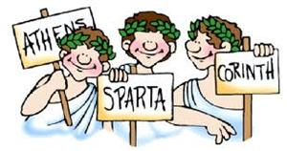
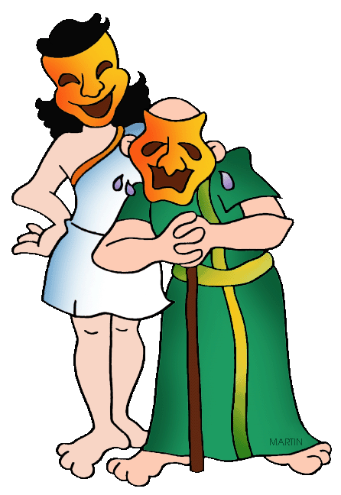
Vivaldi Class
Who Let the Gods Out!
How did a volcano change the course of history?
Our theme is history based. We will be learning all about the Ancient Greeks.
English  As readers we will:  - Read whole books to improve our comprehension skills  - Skim and scan effectively to retrieve information  - Explain meanings of words in context  - Infer feelings through actions, dialogue and description  - Find similarities and differences between different versions of myths we read  - Compare and contrast moods of characters within myths. | Class Information  If you would like to pass a message to a member of the year 6 team or have any queries, please write in your child’s planner or email:  year6@swainhouse.bradford.sch.uk  PE is on Thursdays.  Please ensure your child comes to school in the correct PE kit.  Please make sure your child has a water bottle in school.  Important dates:  Year 6 spring assessment weeks are week commencing Monday 22nd January 2024.  Year 6 Greek Workshop is Wednesday January 17th 2024. | History:  - Say when the Greek era was and the influence they had on modern society.  - Understand how the Greeks lived and how a natural disaster changed their history.  - Learn about the different Greek Gods and Goddesses  - Compare and contrast different sources  Art:  - Understand how to analyse a famous artist.  - Understand how to find meaning in paintings and artwork.  - Apply out own interpretations of famous pieces of artwork.  DT:  - To design a steady hand game  - To assemble electronics and create a steady hand game  - Research and analyse a range of children’s toys  Science:  - Label components of circuits.  - Draw symbols for electrical components.  - Draw series and parallel circuits  - Investigate how voltage effects bulbs and buzzers.  R.E – Practices: Why are certain people, places and times sacred?  French – We will be learning vocabulary for when we are out and about, directions, clothes and places around town.  Computing –  - Understand what variables are and why they are used in programs. Improve a game by using these variable and create our own project that uses variables.  - Understand how to use formulas to create and interpret data on spreadsheets.  PE – We will be learning the rules and skills involved with tag rugby and netball and playing competitive games.  PSHE – We will be learning how to keep safe online, understanding our emotional needs and about drugs  Music –  - We will listen and appraise music  - Learn about the interrelated dimensions of music  - Perform and share our music with others
As writers we will:
- Write a range of text types for a variety of audiences
- Write more complex and cohesive paragraphs
- Use a range of punctuation marks accurately
- Improve our work through editing carefully
- Develop the formation of our joined handwriting
- Use our knowledge of spelling patterns to improve our work
Proofread for spelling and punctuation errors.
Maths  - Add and subtract unlike fractions  - Multiply and divide fractions  - Add and subtract mixed numbers  - Interpret and represent data in graphs and charts  - Understand, calculate and simplify ratio problems. | Homework  Please remind your child to complete their homework books weekly, as well as practising their spellings and times tables every week on TT Rockstars.

