Matisse Class
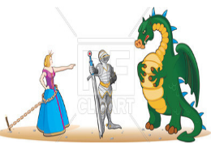
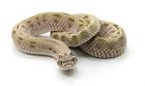

Our theme this term is called “Continents and Castles”
This is mainly a geography and history theme.
English  As readers we will:  • Read stories with a familiar setting and retell them through drama.  • Be thinking about characters and settings.  • Read non-fiction books about castles.  • Practise and use our phonics to read new words and sentences. | Class Information  Please ensure your child keeps the correct P.E. kit in school for Street Dance on Tuesdays.  Please can you ensure all items of clothing are labelled with your child’s name.  If you have any queries please do not hesitate to come and speak to us. We are always happy to help! | As scientists we will:  - Investigate materials and their properties  - Carry out scientific investigations  As geographers we will:  - Learn about the continents and oceans of the world.  - Where castles were built in the UK and use maps to locate them.  - Compare Skipton in the UK and Cusco in South America  As historians we will:  - Learn about why castles were built in the past  - Learn about the Norman Invasion in 1066.  - Learn about the parts of a castle and who might have lived in them in the past.  RE- Our question to discuss will be “What does it mean to belong to a church or mosque?”  PSHE- We will learn about keeping ourselves safe  Design and Technology – Designing and making Easter puppets  Art and design – Sculpture and 3D Paper play
As writers we will:
- Practise forming all our letters correctly especially capital letters.
- Write sentences using capital letters correctly.
- Use our phonics knowledge to improve our spelling.
- Use all the information we have found out in our English work to write facts.
- Using ed and ing correctly
- Recognising and beginning to use s and es as a suffix for plurals.
Maths  As mathematicians we will:  - Looking at numbers 0 -5.  - Recognise, compose, decompose and manipulate 2D and 3D shapes.  - Numbers 0-10 | Homework  Homework this year will be a little different.  Spellings will be given out every Friday, to be learnt at home for a spelling test the following Friday.  There will be no homework books sent home, instead, we would like you to focus on Lexia, Numbots and reading. Log in details can be found in your child’s reading record book.  Further information will be sent out later this week.  Read with your child at least 3 times a week. Remember to write a comment and sign their Reading record – this is part of our homework policy and will be part of their pupil mentoring form. | How could you help your child at home?  Talk about what they have learned in school.  Read a range of stories at home and ask questions about what you have read.  Learn to count forwards and backwards to 50.  Talk in your family about how shops have changed.  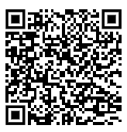  Don’t forget to practice your maths passport facts.  You can find all the objectives on our school website. Here is a link to the page:

