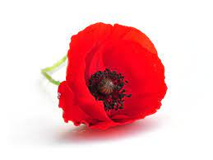
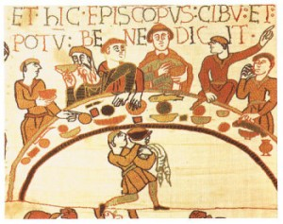
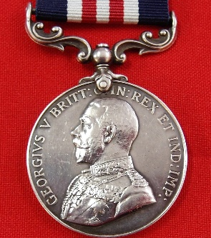
Jacqueline Wilson Class
Autumn 2 – Bradford Remembers
English  As readers we will:  Read whole books to improve our comprehension skills.  Use drama to explore characters’ feelings.  Develop our vocabulary by “borrowing” author’s words.  Write poetry and diaries this half term.  Increase our understanding of grammar. | Class Information  PE will be in school on a Tuesday.  Wednesday we go swimming. Make sure your child has their swimming costumes/shorts, a towel and a snack for the bus. They may also bring goggles and swimming caps.  Please make sure your child has a full water bottle to use in school. | History  In our theme:  We are learning about the First World war with a focus on the Bradford Pals. We are looking at what women did during war time and the roles they played.  As Scientists - We will learn about electricity and how to build a simple circuit with a switch.  Computing – We will be learning all about audio media. We will be recording, editing and producing our own sound media.  French – We will be learning days of the week, colours, counting to 20, naming countries, likes and dislikes.  P.E - We will be learning netball, swimming skills and dance routines.  R.E. – We will be learning all about Hannukah.
As writers we will:
Use a range of punctuation marks accurately.
Enrich our word choice by using “borrowed” words.
Improve our work through editing carefully.
Develop the formation of our joined handwriting.
Use our knowledge of spelling patterns to improve our work.
Writing diary entries and letters from an Anglo-Saxon warrior perspective, write Haiku and performance poems.
Meet our writing targets to improve our writing.
Maths  As mathematicians we will:  Understand perimeter.  Work on our arithmetic skills.  Learn multiplication facts for times tables 2-12. | Resources  If you have any objects, books or information that might help us with our theme we would love to know about them! | How could you help your child at home?  Encourage your child to talk about the learning they have been doing at school.  Ensure they complete their homework to the best of their ability.  Maths Passports: Ensure your child works on the objectives that they require to move to the next continent.  Give opportunities for your child to practise their handwriting and spellings.  Practise reading with expression.
Homework
Homework is given out every Friday; it is usually a spellings, TT Rockstars and reading. This should be completed in their homework books and returned to school by the following Wednesday. Read with your child at least three times per week. Remember to write a comment and sign their reading record at least once a week. Times tables are incredibly important to all aspects of maths, please remember that we have home access to Times Tables Rockstars, if you need your child’s password, please ask the class teacher. Links to other good websites for times table practise can be found on the school website.
