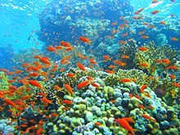
Our theme this half term is called
Elm Class
Our World and Beyond
In this theme, we will be learning about the solar system
In Literacy we will be:  - Reading fiction and non-fiction books about the solar system  - Predicting, discussing and answering questions about characters and story events  - Practising and using our phonics knowledge to read new words, captions and sentences  - Practising forming our letters correctly using the  - tripod grip  - Writing labels and captions for pictures | Class Information  Please continue to share your child's reading book with them at least 3 times a week. Remember to leave a comment and sign their Reading record. The time you spend listening to your child read is invaluable and makes a huge difference to their progress.  Snack money this half term is £3.50. Please pay  a member of the Reception team.  (This can be paid in full or 50p per week.) | In our theme lessons we will be learning all about the planet Earth and dinosaurs.  We will be learning about the following things:  - Space and the names of different planets  - What life is like in space  - Ways of travelling to space and on the moon  - Name and order the planets.  - Which planet is nearest to the sun and which is the furthest away?  - Learn about Tim Peake’s time in space  - Learn about the moon and what would it be like to visit the moon  - Exploring astronauts/ first moon landing
In Mathematics we will be learning about:

- Subitising – to recognise the number of small objects in a group without counting
- Composition – how numbers are made
- Comparison
- Counting, ordinality, cardinality





This module is all about teaching children the importance of gratitude. It looks at a number of elements of gratitude including:
- The wheel of gratitude
- Building self-esteem
- Who in our lives we appreciate

Our Core books this half term are:  - ‘Traction Man’ by Mini Grey  - ‘The Mega Magic Hair Swap’ by Rochelle Humes  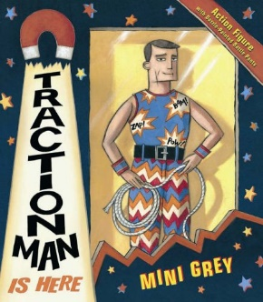  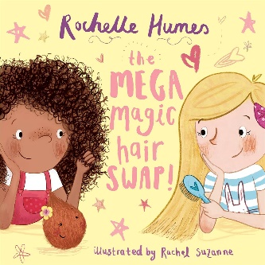 | In PSHE we will be learning about  - Looking after my special people  - Looking after my friends  - Being helpful at home and caring for our classroom  - Caring for our world  - Looking after money (1): recognising, spending, using  - Looking after money (2): saving money and keeping it safe | How could you help your child at home?  - Encourage your child to talk to you about what they have learned at school  - Look at pictures and books of space and talk about what can be seen  - Support your child in writing their full name independently  - Go on a winter walk and talk about the seasonal changes  - Log on to PhonicsPlay.co.uk with your child and practise Phase 3 activities
