Swain House Primary School

Great Oak Nursery
Admission Policy

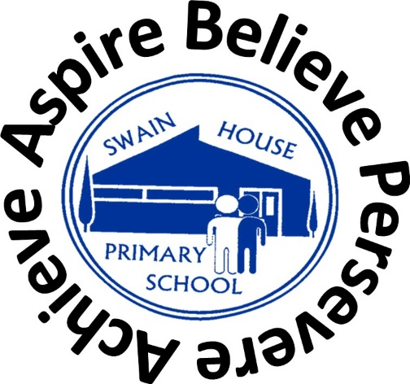

Autumn 2023

- This policy was discussed, reviewed and agreed by all staff on Autumn 2023
- This policy, including any amendments will be reviewed again in Autumn 2024

Swain House Primary School is a community school, which seeks to serve the needs of the local community. Applications are therefore welcomed from all sections of the community. Parents may telephone the school or visit in person to register their child on the waiting list for the Nursery. Admissions are not based on aptitude or ability.

The government funds up to 570 hours of free childcare per year for all 3 and 4 year olds until they go to full-time school. This works out as 15 hours a week if your child takes up the childcare during term time, or you could choose to take fewer hours over more weeks in the year.

Child’s 3rd birthday is between: | When your child can take their place
1 January to 31 March | The beginning of Summer term on or after 1 April
1 April to 31 August | The beginning of Autumn term on or after 1 September
1 September to 31 December | The beginning of Spring term on or after 1 January

All children age 3 and 4 years are entitled to the funded hours, there are no additional eligibility criteria.

Children will be admitted to Nursery having taken into account the following criteria (which is the same as the City of Bradford MDC’s admissions policy for reception):

- Looked after children and all previously looked after children, including those children who appear (to the admissions authority) to have been in state care outside of England and ceased to be in state care as a result of being adopted

- Children who have exceptional social or medical needs, supported by a written recommendation from the child’s paediatrician/consultant or professional from Children’s Services. The letter must explain why the school is the only suitable school to meet the child’s needs and why no other school could provide the appropriate support for the child

- Sisters and brothers of children living at the same address, who are at present on roll at the school, and will still be attending the school at the time of admission

- All other children

We will endeavour to accommodate emergency placements requested by social services or other outside agencies if vacancies are available.

Nursery provides fifty places in the morning and fifty in the afternoon. Some of these places will be offered to the children eligible for 30 hours.

Further information regarding eligibility for 30 hours free childcare please click on the link https://www.bradford.gov.uk/children-young-people-and-families/looking-for-childcare/30-hours-free-childcare/

Parents will be notified by letter if their child has been offered a place in the Nursery and asked to come into school to complete the admissions form.

Arrangements will be made for new children to visit Nursery before they formally start. Children are invited to attend stay and play sessions in the Nursery room in the half term prior to them starting.

Nursery children who are on extended holidays or out of the country for some time will be taken off the register after the agreed return date. Therefore this may result in reserved places being lost.

Please note:
The offer of a place at a nursery class attached to a primary school does not guarantee the child a place in the reception class at the same school. A fresh application will be required in accordance with the criteria for admission to reception classes.

