Year 4 Autumn 1 words
accident | believe | strange | reign | interest
 | various | possible | grammar
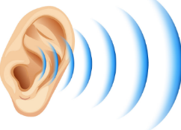
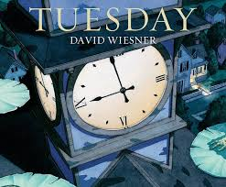
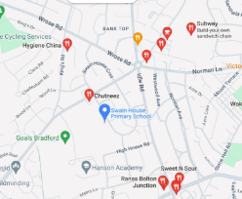
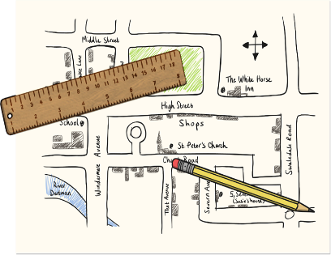
Geography:
We will use fieldwork to observe, measure, record and present the human and physical features in the local area using a range of methods, including sketch maps and digital technologies.

In Science:

We will…
-identify how sounds are made, associating some of them with something vibrating
-recognise that vibrations from sounds travel through a medium to the ear
-find patterns between the pitch of a sound and features of the object that produced it
-find patterns between the volume of a sound and the strength of the vibrations that produced it
-recognise that sounds get fainter as the distance from the sound source increases

Our other learning:
In Computing we will be focusing on computing systems and networks.
In R.E we will describe different festivals and understand the reasons for each one
In PSHE we will be learning about feelings and what makes a healthy relationship with others.
In PE we will developing our swimming skills.
In DT we will be making a slingshot car.

In Maths:

We will be exploring place value ensuring that the children have a clear understanding of the value of each digit.
We will be revising the children’s knowledge of addition and subtraction.
There will be a focus on applying number facts and learning and applying times tables facts.

How can you help your child at home?
Encourage them to talk about the learning they have been doing at school.
Practise number facts and all times tables.
Listen to them read and ask them about the text.
Help them to practise their weekly spellings.

If you have any queries, please contact the Year 4 team.
In English:

We will be studying ‘Tuesday’ by David Wiesner and later using the film clip ‘Dragon Slayer’ as stimuli for our learning.

As readers we will be...
- responding by asking questions
- sequencing events
- responding with drama
- retrieving and inferring from pictures
- empathising with characters

As writers we will…
- use expanded noun phrases, powerful verbs and adverbs to describe characters’ appearance and movement.
- draft and write a sequel to a story
- use a range of punctuation, including speech punctuation
- organise our work using paragraphs
- proofread and edit our work

How could you help your child at home?
Please read with your child at home and sign their Reading Journal weekly when you have done so.
TT Rockstars will really help your child with their timestables and is a fun way to learn and take part in challenges with friends.

Proud to be from Bradford: Marvellous Maps
Homework

Maths
As Year 4 are tested for the national Multiplication Tables Check in June, it is essential that your child practises their tables to 12 x 12. Logging onto Times Table Rock Stars will help your child learn their tables and improve their recall. Please ask staff if your child needs help logging on.
English
Your child will receive a list of spellings on a Friday to practise. They will be tested on these words the following Friday.
Please listen to your child read (either their school book or a book of their choice) and sign their reading record at least once a week.

PE Kit
This half term, children will need their swimming kits every day. School will dry the towels and swimwear every day. They will be sent home for washing on Fridays.

J K Rowling Class

