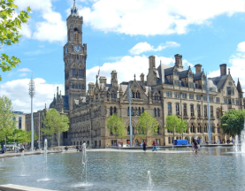
Beethoven Class
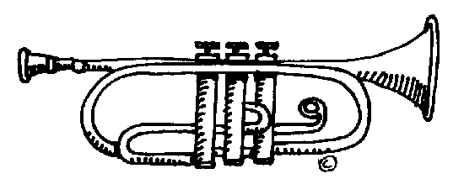

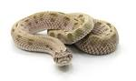
From Settlement to City – how did Bradford change over millennia?
In this topic we will be learning about how Bradford went from a small settlement to a large city.
English  As readers we will read Room 13 and:  Discuss a variety of texts and compare characters and settings.  Answer retrieval questions about the texts we read.  Use clues from the text to answer inference questions about the text we read.  Recap and practise sequencing events form texts we read. | Class Information  Beethoven class teacher is Miss Brow and our teaching assistant is Miss Bostock.  If you would like to pass a message to a member of the year 6 team or have any queries, please write in your child’s planner or email:  Year6@swainhouse.bradford.sch.uk  We are reading on our Reading Planet scheme. Please read with your child three times a week and write this in their planner. | Topic  As historians and Geographers we will be able to:  Locate Bradford on a UK map  Compare rural and urban areas in Bradford  Understand how and when Bradford’s population increased  Explain how the Leeds and Liverpool Canal and River Aire was used for trade.  As scientists we will:  Be learning about the circulatory and respiratory systems.  Computing – We will be learning about E-safety, programming websites and sending and receiving data packets.  PE – We will be learning to play Frisbee and about why health and fitness is important and how to keep our bodies healthy.  R.E. We will explore one key question this half term. What do you believe about God?  PSHE – We will be learning about me and my relationships.  French – We will be learning about French speaking countries and the animals that live in them.  Art – We will be using photography to create collages.
As writers we will:
Write complex and interesting sentences and
paragraphs.
Focus on the basic skills of joined and fluent handwriting, spelling and use of punctuation.
Enrich our word choice by using “borrowed” words and
our words of the week.
Improve our work through editing carefully.
Use a dictionary to check and correct spelling errors.
Maths  As mathematicians we will learn to:  Identify the value of digits in numbers up to 10 million  Read and write numbers up to ten million  Multiply and divide by 10, 100 and 1000  Use written methods for addition, subtraction, division and multiplication.  Recall times tables and maths facts quickly. | Reminders  Please ensure your child brings a full water bottle to school every day.  Please remind your child to complete their homework in their homework as well as practising their spellings and playing TT Rockstars every week.  PE will be on Fridays. We will have dance on a Tuesday. Pupils in Year 6 need to arrive at school in their PE kit. Please ensure they have the correct kit in school. | How could you help your child at home?  Ensure they complete their homework to the best of their ability.  Ensure your child learns “off by heart” the times tables and number facts so they can achieve the continent/planet they are working on.  Give opportunities for your child to practise their handwriting and spellings.  Listen to your child read at least 3 times a week.  Whilst reading, ask your child questions about the text.  English  As readers we wil  Improve our reading skilsl thorough learning new  • To read two stories that deal with themes of overcoming worries and facing fears  • To compare and describe characters  • To write a letter  • To write an extended story  How could you help your child at home?  Read and talk about stories.  Talk about the characters in a story and describe their appearance and how they behave.  Look at how letters are written.
