Swain House Primary School

Attendance Policy



September 2026

This policy will be reviewed in September 2027

Contents:

Statement of intent

- Aims
- Legislation and guidance
- Roles and responsibilities
- Definitions
- Attendance expectations and strategies for promoting attendance
- Recording attendance
- Authorised and unauthorised attendance
- Reducing persistent and severe absence
- SEND and health-related absence
- Lateness and punctuality
- Leave during lunch times
- Monitoring and analysing absence
- Working with parents to improve attendance
- Staff training
- Monitoring and review

Appendices
1. Attendance and punctuality expectation letters
2. Attendance Codes
3. Half-termly attendance letters

Statement of intent

Swain House Primary School believes that in order to facilitate teaching and learning, good attendance is essential. Pupils cannot achieve their full potential if they do not regularly attend school.

We understand that barriers to attendance are complex, and that some pupils find it harder than others to attend school; therefore, we will continue to prioritise cultivating a safe and supportive environment at school, as well as strong and trusting relationships with pupils and parents.

We take a whole-school approach to securing good attendance, and recognise the impact that our efforts in other areas – such as the curriculum, behaviour standards, bullying, SEND support, pastoral support, and the effective use of resources such as pupil premium – can have on improving pupil attendance.

We are committed to:
- Promoting and modelling high attendance and its benefits
- Ensuring equality and fairness for all
- Ensuring this attendance policy is clear and easily understood by staff, pupils and parents
- Intervening early and working with other agencies to ensure the health and safety of our pupils
- Building strong relationships with families to overcome barriers to attendance
- Ensuring parents follow the framework set in section 7 of the Education Act 1996, which states that the parent of every child of compulsory school age shall cause them to receive efficient full-time education suitable to their age, ability and aptitude, and to any SEND they may have, either by regular attendance at school or otherwise
- Regularly monitoring and analysing attendance and absence data to identify pupils or cohorts that require more support
- Regularly inform parents about their child’s levels of attendance, absence and punctuality
- Ensuring that parents are aware of the benefits that regular attendance at school can have for their child educationally, socially and developmentally
- Regularly monitoring and analysing attendance and absence data to identify pupils or cohorts that require more support.

1. Aims
This policy aims to show our commitment to meeting our obligations with regards to school attendance, including those laid out in the statutory guidance on Working together to improve school attendance from the Department for Education (DfE). We aim to achieve this through our whole-school culture and ethos that values good attendance, which includes:
- Setting high expectations for the attendance and punctuality of all pupils
- Promoting good attendance and the benefits of good attendance
- Reducing absence, including persistent and severe absence
- Ensuring every pupil has access to the full-time education to which they are entitled
- Acting early to address patterns of absence
- Building strong relationships with families to make sure pupils have the support in place to attend school
We will also promote and support punctuality in attending lessons.

2. Legislation and guidance
This policy is based on the DfE’s statutory guidance on Working together to improve school attendance and School attendance parental responsibility measures. The guidance is based on the following pieces of legislation, which set out the legal powers and duties that govern school attendance:
- Part 6 of the Education Act 1996
- Part 3 of the Education Act 2002
- Part 7 of the Education and Inspections Act 2006
- The School Attendance (Pupil Registration) (England) Regulations 2024
- The Education (Penalty Notices) (England) (Amendment) Regulations 2013
- The Equality Act 2010
It also refers to:
- School census guidance
- Keeping Children Safe in Education
- Mental health issues affecting a pupil's attendance: guidance for schools
- Ofsted’s 2025 framework toolkit

3. Roles and responsibilities

The Governing Body has overall responsibility for:

- Ensuring that the school sets high expectations of all school leaders, staff, pupils and parents/carers
- Making sure that school leaders fulfil expectations, statutory duties and comply with the law on school attendance
- Making sure the school has high aspirations for all pupils, but adapts processes and support to pupils’ individual needs
- Monitoring attendance figures for the whole school and repeatedly evaluating the effectiveness of the school’s processes and improvement efforts to make sure they are meeting pupils’ needs
- Where the school is struggling with attendance, working with school leaders to monitor a comprehensive action plan to improve attendance
- Making sure all staff receive adequate training on attendance as part of the regular continued professional development offer, so that staff understand:
- Making sure dedicated training is provided to staff with a specific attendance function in their role, including in interpreting and analysing attendance data
- Holding the Headteacher to account for the implementation of this policy

The Headteacher (Designated Senior Leader Responsible for Attendance) is responsible for:
- The overall strategic approach to attendance in school
- Setting a clear vision for improving and maintaining good attendance
- Analysing attendance data and identifying areas of intervention and improvement (in conjunction with LMT). Report to Governors half termly
- The day-to-day implementation and management of this policy and all relevant procedures across the school
- Appointing a member of staff to the Attendance Officers role
- Ensuring all parents are aware of the school’s attendance expectations and procedures
- Ensuring that every pupil has access to full-time education and will act as early as possible to address patterns of absence
- Monitor the impact of any implemented attendance strategies
- Working with the parents/carers of pupils with special educational needs and/or disabilities (SEND) to develop specific support approaches for attendance for pupils with SEND, including where school transport is regularly being missed, and where pupils with SEND face in-school barriers
- Creating intervention or reintegration plans in partnership with pupils and their parents/carers
- Delivering targeted intervention and support to pupils and families
- Communicating the school’s high expectations for attendance and punctuality regularly to pupils and parents/carers through all available channels
- Sharing information from the school register with the local authority, including:

  - Notifying the local authority when a pupil’s name is added to or deleted from the school admission register outside of standard transition times
  - Providing the local authority with the details of pupils who fail to attend school regularly, or who have been marked with an unauthorised absence for a continuous period of 10 school days
  - Providing the local authority with the details of pupils who the school believes will miss 15 days consecutively or cumulatively because of sickness

Staff are responsible for:
- Following this policy and ensuring pupils do so too
- Ensuring this policy is implemented fairly and consistently
- Modelling good attendance behaviour
- Where designated, taking the attendance register at the relevant times during the school day

The Attendance Officers (Pastoral Team) are responsible for:
- Monitoring attendance and the impact of interventions
- Benchmarking attendance data to identify areas of focus for improvement
- Communicating with parents with regard to attendance
- Leading a compassionate approach when listening to parents and pupils regarding barriers to attendance
- Following up on incidents of persistent poor attendance
- Enforcing attendance through statutory interventions in cases of persistent poor attendance where other supports have not succeeded
- Advising the Headteacher when to issue fixed penalty notices
- Informing the LA of any pupil being deleted from the admission and attendance registers
- Liaising with the LA Education Safeguarding Attendance Officer where there are concerns around attendance

The school’s Attendance Officers are Sarah Broadbent and Ellie Armitage, and can be contacted via the school office – 01274 639049 or via email - office@swainhouse.bradford.sch.uk

Pupils are responsible for:
- Attending school every day on time

Parents are responsible for:
- The attendance of their children at school
- Ensuring their child attends school on time
- Providing accurate and up-to-date contact details
- Providing the school with more than one emergency contact number
- Updating the school if their details change
- Promoting good attendance with their children
- Keep to any attendance contracts that they make with the school and / or Local Authority
- Ensure that, where possible, appointments for their child are made outside of the school day
- Notifying the school as soon as possible when their child has to be unexpectedly absent
- Seek support, where necessary, for maintaining good attendance, by contacting the school attendance team

4. Definitions

The following definitions apply for the purposes of this policy:

Absence:
- Arrival at school after the register has closed (9am)
- Not attending the registered school for any reason

Authorised absence:
- An absence for sickness for which the school has granted leave
- Medical or dental appointments which unavoidably fall during school time, for which the school has granted leave
- Religious or cultural observances for which the school has granted leave
- An absence due to a family emergency

Unauthorised absence:
- Parents keeping children off school unnecessarily or without reason
- Truancy during the school day
- Absences which have never been properly explained
- Arrival at school after the register has closed (9am) without reasonable explanation
- Absence due to shopping, looking after other children or birthdays
- Absence due to day trips and holidays in term-time which have not been agreed
- Leaving school for no reason during the day

Persistent absence (PA):
- Missing 10% or more of schooling across the year for any reason

Missing education
- Not registered at a school and not receiving suitable education in a setting other than a school

Severe absence
- Severe absence is defined as missing 50% or more of schooling across the year.

5. Attendance expectations and strategies for promoting attendance

The school has high expectations for pupils’ attendance and punctuality, and ensures that these expectations are communicated regularly to parents and pupils.

Pupils will be expected to attend school punctually every day they are required to be at school, for the full day.

The school day starts at 8.30am, and pupils will be in their classroom, ready to begin lessons at this time.

Registers will be taken as follows throughout the school day:
- The morning register will be marked by 8.40am. Pupils will receive a late mark if they are not in their classroom by this time
- The morning register will close at 9am. Pupils will receive a mark of absence if they do not attend school before this time
- The afternoon register will be marked in Reception and KS1 at 12.45pm and in KS2 at 1.15pm. Pupils will receive a late mark if they are not in their classroom by this time
- The afternoon registers will close at 1pm for Reception and KS1 and 1.30pm for KS2. Pupils will receive a mark of absence if they are not present

Pupils will be encouraged to communicate any concerns related to attendance and absence as soon as possible to the relevant member of staff.

School regularly sends out attendance letters, highlighting the importance of good attendance and punctuality and how this is linked to good progress and achievement. Whole school attendance and punctuality letter is sent out on the first day of each academic year and attendance and punctuality expectation reminder letters and also sent out at the beginning of each half term – see Appendix 1.

School culture and rewards
At Swain House primary School, we believe that excellent attendance is the essential foundation for a pupil’s attainment, wellbeing, and wider life chances. Attendance is not a discrete administrative task; it is an integral part of our school’s vision, values, and ethos.
We celebrate good attendance and punctuality in the following ways –
- Weekly Attendance and punctuality for each class will be shared in the Friday Well Done assembly and the class with the best attendance and punctuality (EYs and KS1 and KS2 separately) will be celebrated
  - Attendance - the class with the best attendance will receive a trophy and an extra playtime pass for the following week
  - Punctuality – all classes with 0 lates will receive a 10 min extra-playtime pass for the following week
- Pupils with 100% attendance and 0 lates for the week, will be entered into a draw to win a £5 Amazon voucher (one voucher for Early Years/KS1 and one for KS2)
- Half termly attendance treat organised for pupils who have had 100% attendance in the previous half term
- Special celebratory breakfast for pupils who achieve 100% attendance for the year
- Whole school and class attendance and punctuality shared during the Headteacher assembly every Monday morning.
- Termly letters sent to parents to remind them about the importance of good attendance and punctuality
- All classrooms share their weekly attendance and punctuality on the classroom doors so it can be celebrated by visitors to the class

6. Recording attendance

Attendance register
The school uses SIMs to keep attendance registers to ensure they are as accurate as possible and can be easily analysed and shared with the appropriate authorities.

Designated staff members will take the attendance register at the start of each school day and at the start of the afternoon session.

This register will record whether pupils are:
- Present
- Attending a place other than school
- Absent
- Absent – unable to attend due to unavoidable causes
Any amendment to the attendance register will include:
- The original entry
- The amended entry
- The reason for the amendment
- The date on which the amendment was made
- The name and position of the person who made the amendment

The school will use the national attendance codes to ensure attendance and absence are monitored and recorded in a consistent way – see Appendix 2.

When the school has planned in advance to be fully or partially closed, the code ‘#’ will be used for the relevant pupils who are absent. This code will also be used to record year groups who are not due to attend because the school has set different term dates for different years, e.g. induction days.

Pupils receiving remote education due to illness or exceptional circumstances will be marked in the register with a specific code (e.g., code Y6 or other appropriate code) rather than general absence, where applicable.

All amendments made to the attendance register will include the original entry, the amended entry, the reason for the amendment, the date of amendment and the name and role of the person who made the amendment.

We will keep every entry on the attendance register for 6 years after the date on which the entry was made.

Unplanned absence
Parents will be required to contact the school office via telephone before 8.30am on the first day of their child’s absence – they will be expected to provide an explanation for the absence and an estimation of how long the absence will last, e.g. one school day. We will mark absence due to physical or mental illness as authorised, unless the school has a genuine concern about the authenticity of the illness.

Where the absence is longer than 2 days, or there are doubts about the authenticity of the illness, the school will ask for medical evidence, such as a doctor’s note, prescription, appointment card or other appropriate form of evidence. We will not ask for medical evidence unnecessarily.

If the school is not satisfied about the authenticity of the illness, the absence will be recorded as unauthorised and parents will be notified of this in advance.

Where any pupil we expect to attend school does not attend, or stops attending, without reason, the school will:

- Call the pupil’s parent on the morning of the first day of unexplained absence to ascertain the reason. If the school cannot reach any of the pupil’s emergency contacts, a message will be left, asking parents to contact school
- Identify whether the absence is approved or not if contact made
- Call the parent on each day that the absence continues without explanation, to make sure proper safeguarding action is taken where necessary. On the 3rd day, if school have not made contact, a home visit will be conducted. If absence continues, the school will consider involving the Education Safeguarding Attendance Officer. If there are other services already involved with the family, a home visit may be conducted earlier
- Where appropriate, offer support to the pupil and/or their parents to improve attendance
- Identify whether the pupil needs support from wider partners, as quickly as possible, and make the necessary referrals
- Provide the LA with the names and addresses of any pupils that school believe will miss 15 days consecutively or cumulatively because of sickness and have been recorded with code I. This is to help school and the LA agree any provision needed to ensure continuity of education for pupils who cannot attend school because of health needs

In the case of Persistent absence (PA), arrangements will be made for parents to speak to the Attendance Officers. The school will inform the LA, on a half-termly basis, of the details of pupils who fail to attend regularly, or who have missed 10 school days or more without authorisation.

If a pupil is a PA (attendance below 90%) they will be considered for referral to the Education Safeguarding Team. The Education Attendance Welfare Officer and school staff will then begin a programme of monitoring and support.

Where a pupil has not returned to school following a leave of absence school will follow the DfE Working Together to Improve Attendance and Children Missing Education guidance. DfE’s guidance on Children Missing Education sets out the expectations for schools and local authorities in respect of making reasonable efforts to find out a pupil’s location and circumstances.

Planned absence
Illness and healthcare appointments

Parents will be expected to make medical or dental appointments outside of school hours wherever possible. Where this is not possible, parents will be expected to obtain approval for their child’s absence to attend such appointments as far in advance as is practicable. Parents will be responsible for ensuring their child misses only the amount of time necessary to attend the appointment. Attending a medical or dental appointment will be counted as authorised as long as the pupil’s parent/carer notifies the school in advance of the appointment where possible. Parents are asked to show school confirmation of the appointment.

7. Authorised and unauthorised absence

Approval for term-time absence
The Headteacher will allow pupils to be absent from the school site for certain educational activities, or to attend other schools or settings.

The Headteacher will only grant a leave of absence in exceptional circumstances on a case-by-case basis. As a leave of absence will only be granted in exceptional circumstances, it is unlikely a leave of absence can be granted due to a family holiday. Leave of absence will not be granted for a pupil to take part in protest activity during school hours.

The school considers each application for term-time absence individually, taking into account the specific facts, circumstances and relevant background context behind the request.
Any request should be submitted as soon as it is anticipated and, where possible, at least 2 weeks before the absence.

A leave of absence online form must be completed here - Term-Time Child/children Absence Request Form. The Headteacher may require evidence to support any request for leave of absence.

Other valid reasons for authorised absence include (but are not limited to):
- Illness (including mental-health illness) and medical/dental appointments
- Religious observance – where the day is exclusively set apart for religious observance by the religious body to which the pupil’s parent(s) belong(s). If necessary, the school will seek advice from the parent’s religious body to confirm whether the day is set apart
- Parent(s) travelling for occupational purposes – this covers Roma, English and Welsh gypsies, Irish and Scottish travellers, showmen (fairground people) and circus people, bargees (occupational boat dwellers) and new travellers. Absence may be authorised only when a traveller family is known to be travelling for occupational purposes and has agreed this with the school, but it is not known whether the pupil is attending educational provision
- If the pupil is currently suspended or excluded from school (and no alternative provision has been made)

Other reasons the school may allow a pupil to be absent from the school site, which are not classified as absences, include (but are not limited to):
- Attending an offsite approved educational activity, sporting activity or visit or trip arranged by the school
- Attending another school at which the pupil is also registered (dual registration)
- Attending provision arranged by the Local Authority
- If there is any other unavoidable cause for the pupil not to attend school, such as disruption to travel caused by an emergency, a lack of access arrangements, or because the school premises are closed

Sanctions
The school will always seek to work in partnership with pupils, parents and carers to improve attendance and remove barriers to attendance. Support and early intervention will be considered in the first instance wherever appropriate. Where attendance does not improve, or where support is not appropriate, the school may work with the local authority to consider the use of legal interventions and sanctions on a case-by-case basis.
Penalty Notices
A penalty notice may be issued where a child of compulsory school age has unauthorised absence from school and the relevant legal threshold has been met. Penalty notices may be issued by the LA or other authorised officers in accordance with relevant legislation and the LA’s Code of Conduct.
Before requesting or issuing a penalty notice, the school and local authority will consider the individual circumstances of the case, including:
- Whether the national threshold has been met (10 sessions of unauthorised absence within a rolling period of 10 school weeks)
- Whether a penalty notice is the most appropriate tool to improve attendance in the individual case
- Whether support has been offered and engaged with, or whether further support should be provided
- Whether another legal intervention would be more appropriate
- Whether the school's duties under the Equality Act 2010 affect the appropriateness of issuing a penalty notice
A penalty notice may also be issued where a parent allows their child to be present in a public place during school hours during the first five days of a suspension or exclusion, without reasonable justification and where the parent has been notified of this requirement.
Each parent who is liable for the offence may be issued with a separate penalty notice.
The payment must be made directly to the local authority. If payment is not received within the statutory timescale, the local authority will determine whether to prosecute or take other appropriate action.
First penalty notice: £80 if paid within 21 days, increasing to £160 if paid within 28 days.
- Second penalty notice issued to the same parent in respect of the same child within three years: £160, payable within 28 days
- A third penalty notice cannot be issued to the same parent in respect of the same child within three years of the first notice. Alternative legal intervention may be considered instead

Notices to Improve
Where the national threshold has been met and support is appropriate, but has not been engaged with or has not secured improved attendance, the local authority may issue a Notice to Improve in accordance with its local Code of Conduct.
A Notice to Improve will:
- Explain the pupil's attendance record and the concerns identified
- Remind parents of their legal responsibilities regarding school attendance
- Set out the support offered and available to the family
- Specify the period during which attendance must improve, normally between 3 and 6 weeks
- Explain what improvement is required and the possible consequences if attendance does not improve
Bradford Council Legal Action
In addition to the national framework, Bradford Council may consider direct prosecution through the Magistrates' Court in accordance with its local Code of Conduct where circumstances warrant this approach. This may include cases involving a continuous period of unauthorised leave of 20 school days (40 sessions) or more.
Further information can be found on Bradford Council's attendance and penalty notice webpages.
Legal Intervention
The school will allow appropriate time for support and attendance interventions to have an impact. Where attendance does not improve despite support and intervention, the school may work with the local authority to consider further action, including:
- Formal meetings with parents and relevant support services
- Parenting contracts or parenting orders where appropriate
- Education Supervision Orders
- Referral to Children's Social Care where safeguarding concerns are identified
- Penalty notices where appropriate and in accordance with the local authority Code of Conduct
- Prosecution under the Education Act 1996 where other interventions have not secured regular attendance

Education Supervision Orders (ESOs)
An Education Supervision Order (ESO) may be considered where other interventions have not been successful and where formal legal intervention is required to support improved school attendance. An ESO places a child under the supervision of the local authority while allowing parents to retain parental responsibility.
Once an ESO is granted, the local authority supervisor may require actions intended to improve attendance, which may include:
- Attendance at support meetings
- Participation in parenting programmes
- Engagement with support services
- Educational or other specialist assessments where appropriate
- Regular review meetings involving the pupil, family and professionals supporting the case
Failure to comply with an ESO may result in further legal action.

8. Reducing persistent and severe absence

Persistent absence is where a pupil misses 10% or more of school, and severe absence is where a pupil misses 50% or more of school. Reducing persistent and severe absence is central to the school’s strategy for improving attendance.

The school will:
- Use attendance data to find patterns and trends of persistent and severe absence
- Consider potential safeguarding issues and, where suspected or present, address them in line with Keeping Children Safe in Education
- Hold regular meetings with the parents of pupils who the school (and/or local authority) considers to be vulnerable or at risk of persistent or severe absence, or who are persistently or severely absent, to:
- Discuss attendance and engagement at school
- Listen, and understand barriers to attendance
- Explain the help that is available
- Explain the potential consequences of, and sanctions for, persistent and severe absence
- Review any existing actions or interventions
- Provide access to wider support services to remove the barriers to attendance, in conjunction with the local authority, where relevant
- Consider alternative support that could be put in place to remove any barriers to attendance and re-engage these pupils. In doing so, the school will sensitively consider some of the reasons for absence
- Implement sanctions, where necessary
- Work with the LA Education Attendance Safeguarding Team to implement programmes of monitoring and support if needed

If a pupil is a Persistent Absentee, they will be considered for referral to the Education Safeguarding Team. The Education Attendance Welfare Officer and school staff will then begin a programme of monitoring and support.

9. SEND and Health-Related Absences
The school recognises that pupils with Special Educational Needs and Disabilities (SEND), physical health needs, medical conditions, or mental health difficulties may face additional barriers to attendance. The school is committed to working proactively with pupils, parents/carers and external agencies to understand and remove these barriers, enabling pupils to access their education and achieve positive attendance outcomes. The school will be particularly mindful of pupils whose attendance is affected by SEND, mental health or physical ill health and will provide appropriate support and reasonable adjustments to meet their individual needs.
The school will work closely with available support services, including School Nursing Services, Mental Health Support Teams (MHSTs), Educational Psychology Services and other relevant external agencies. Referrals will be made where appropriate, and the school will work collaboratively with all professionals involved to ensure a coordinated approach to attendance support.
In line with the SEND Policy and Supporting Pupils with Medical Conditions Policy, the school will make reasonable adjustments for disabled pupils and those with additional needs. These adjustments will take account of any Education, Health and Care Plan (EHCP), Individual Healthcare Plan (IHP), risk assessment or other agreed support plan. The school will seek specialist advice and support where necessary to ensure barriers to attendance are identified and addressed effectively.
Where concerns arise that a pupil's attendance is being affected by emotional wellbeing or mental health difficulties, the school will work in partnership with the pupil, parents/carers and relevant professionals to identify contributory factors and agree appropriate support. Where a mental health concern also presents a safeguarding concern, staff will inform the Designated Safeguarding Lead (DSL) immediately and follow the procedures set out in the Child Protection and Safeguarding Policy.

Pupils Unable to Attend Due to Health Needs
Where a pupil is unable to attend school for an extended period because of a physical or mental health condition, the school will:
- Notify the Local Authority where a pupil is expected to miss more than 15 school days of education due to health needs
- Provide relevant information about the pupil's educational needs, current attainment and programme of study to support alternative provision
- Maintain regular contact with the pupil and their family during the period of absence
- Ensure the pupil remains informed about school activities, events and opportunities where appropriate
- Encourage the pupil to maintain social connections with peers where possible
- Plan and support a successful reintegration into school when the pupil is able to return

Attendance Support for Pupils with SEND and Health Needs
Where attendance is affected by SEND, disability, physical health, emotional wellbeing or mental health needs, the school may develop an individual Attendance Support Plan. The plan will be created in partnership with the pupil, parents/carers and any relevant professionals and will clearly identify:
- The barriers affecting attendance
- Agreed support strategies and reasonable adjustments
- Actions and responsibilities for all parties
- Expected outcomes and success measures
- Review dates to monitor progress and evaluate impact
Support strategies may include:
- Regular meetings with parents/carers and relevant professionals
- Review of reasonable adjustments and support arrangements
- An Early Help Assessment and coordinated multi-agency support where appropriate
- Access to internal or external specialist support services
- Access to a pastoral support plan or wellbeing intervention
- Provision of a quiet or safe space during social times where required
- A planned "time-out" arrangement to support emotional regulation
- Access to the school's Hub or other designated support provision
- Temporary flexible attendance arrangements, such as adjusted start or finish times, where appropriate
- A phased return to school following a prolonged absence
- Small-group or individual support programmes
- Bespoke interventions tailored to the individual needs of the pupil
- A temporary part-time timetable in exceptional circumstances only, where it is in the pupil's best interests, agreed with parents/carers, regularly reviewed and supported by a clear plan for return to full-time education
The school will regularly review the effectiveness of all support measures and continue to work collaboratively with pupils, families and partner agencies to secure improved attendance, inclusion and educational outcomes.

10. Lateness and punctuality

A pupil who arrives late:
- Before the register has closed (9am) will be marked as late, using the appropriate code (L)
- After the register has closed will be marked as absent, using the appropriate code (U)

It is important that pupils are punctual so that they do not miss out of the beginning of each school day. This time can be important because information is often given out which allows for the smooth running of the day and helps pupils feel part of the school community.

- The school opens at 8.30am and pupils should be in school at this time
- All entrances with the exception of the main school entrance are closed at 8.40 am
- It is essential that pupils are ready for registration at 8.40 am
- Pupils arriving after this time will have to report to the office where their names will be entered into the ‘late book’ for safety reasons and monitoring of attendance

To improve punctuality, we have implemented the following strategy:
- When pupils are late twice in a half term their parents are informed through a ‘late letter’
- If they are late again, they will be required to attend a punctuality discussion with a member of the Pastoral Team or Leadership Team and parents will be contacted to discuss any support that school can offer
- For all other subsequent lates within the half term, families will be referred to Local Authority Attendance Safeguarding Team

11. Leave during lunch times

Parents may be permitted to take their child away from the school premises during lunch times with permission from the Headteacher – it is at the Headteacher’s discretion as to whether a pupil will be allowed to leave the premises.

Parents will submit a written request, outlining the reasons for their child to leave the premises during lunch time – this request will be submitted to the Headteacher. The Headteacher will consider the request and will contact the parent for a discussion regarding any concerns, as well as the timely return of their child at the end of lunch time and their child’s behaviour when not on the school premises.

If a pupil does not return for afternoon registration, the attendance team will contact parents / carers to establish why the pupil has not returned to school.

12. Monitoring and analysing attendance data

The school will monitor attendance and absence data (including punctuality) weekly, half-termly, termly and yearly across the school and at an individual pupil, year group and cohort level. Specific pupil information will be shared with the DfE on request. The school has granted the DfE access to its management information system so the data can be accessed regularly and securely.

The school will:
- Look at weekly attendance and attendance to date for the whole school, year group and groups of children at the Leadership Team meeting
- Look at historic and emerging patterns of attendance and absence, and then develop strategies to address these patterns
- Analyse attendance and absence data weekly to identify pupils or cohorts that need additional support with their attendance, this analysis is used to provide targeted support to these pupils and their families
- If a child’s attendance drops below 93%, the Bradford Education Safeguarding Team will contact families to identify if there are any barriers to the child attending school. This is a preventative measure to support families from becoming a persistent absentee
- If a pupil’s attendance drops below 90% at the end of a half term they are classed as a persistent absentee. The school Attendance Team will work with Bradford Education Safeguarding Team to issue families with the relevant attendance letters
- Report individual pupil attendance at the end of each half term and issue relevant letters (See description of letters below) to families with an attendance print-out for the half term (See Appendix 3)

The Governing Body will review attendance data at each Full Governing Body meeting. (Six times per year)
The school will also benchmark its attendance data against local, regional and national level data to identify areas of success and areas for improvement, and will share practice which has been shown to be effective with other schools.

Half termly Attendance letters
We send 5 different letters from school regarding attendance at the end of the half term

Letter 1 - Children who have 100% attendance. This is a 'well done' letter explaining how pleased we are with the child's attendance.
Letter 2 - Children who have attendance at 95% or above (yellow and green). This is a 'well done' letter for achieving yellow or green for attendance so far this year.
Letter 3 - Children who have attendance between 90% to 94.9%. This letter explains why attendance above 95% is so important and offers support to the families to increase the child's attendance.
Letter 4 - Children who have attendance at 90% or below and have previously been referred to the Education Safeguarding Team for attendance below 90% and there has been an improvement. This letter explains that we are pleased to see there has been an improvement, but attendance still needs to improve. We will monitor the child's attendance and if it hasn't improved before Easter, they will be referred to the Education Safeguarding Team again and they will put actions in place.
Letter 5 - Attendance letter for children who have SEND or medical needs. This letter will inform parents of the child's attendance and ask them to contact school if we can support with attendance or punctuality.

Any other child who has attendance at 90% or below and hasn't been previously referred to the Education Safeguarding Team and improved their attendance, will receive a letter from this team and not school.

We share our daily attendance data with the DfE. Specific pupil information will be shared with the DfE on request. Data will be collected each term and published at national and local authority level through the DfE's school absence national statistics releases. The underlying school-level absence data is published alongside the national statistics. The school will benchmark its attendance data at whole school, year group and cohort level against local, regional, and national levels to identify areas of focus for improvement, and share this with the Governing Body.

13. Working with Parents to Improve Attendance
The school believes that strong partnerships with parents/carers are essential to promoting good attendance. The school will work collaboratively with families to build positive and respectful relationships, recognising that parents/carers play a key role in ensuring their child attends school regularly and benefits from a full-time education. Open, honest and supportive communication will be maintained with pupils and their families to promote a shared understanding of the importance of attendance and the expectations of school life.
The school will ensure that parents/carers are aware of their legal responsibility to secure their child's regular attendance at school and will provide clear information about attendance expectations, attendance procedures and the support available where difficulties arise. Parents/carers will be regularly informed about their child's attendance, punctuality and absence levels and will be encouraged to work in partnership with the school to address any concerns at an early stage.
Where concerns about attendance emerge, the school will seek to identify and understand the barriers affecting attendance as early as possible. Staff will listen to and work with pupils and parents/carers to understand the reasons for absence and agree appropriate support. The school recognises that every pupil's circumstances are different and will take a supportive, whole-family approach when considering individual needs and barriers.
Where attendance is at risk of becoming irregular, persistent or severely absent, the school will work with the pupil, parents/carers and relevant professionals to develop an Attendance Support Plan where appropriate. The plan may identify:
- Attendance barriers and contributing factors
- Agreed support strategies and interventions
- The responsibilities of the school, family and pupil
- Expected outcomes and review arrangements
- Referrals to additional services where appropriate
The school will always seek to understand the underlying causes of absence and will prioritise support before considering legal intervention. Support may include Early Help assessments, pastoral support, SEND support, mental health support, family support services or referrals to relevant external agencies.
Where barriers to attendance relate to the pupil's experience in school, such as bullying, friendship difficulties, SEND needs, anxiety, safeguarding concerns or other wellbeing issues, appropriate staff, including the Headteacher, Designated Safeguarding Lead (DSL), SENDCO or pastoral staff, will work together to address these concerns and support improved attendance.
Where barriers are linked to circumstances outside school, the school will work with parents/carers and partner agencies to provide appropriate support. This may include liaising with Children's Social Care, Health Services, Early Help Services, the Local Authority, Mental Health Support Teams and other relevant professionals. The school will share information appropriately and work collaboratively to remove barriers and improve attendance outcomes.
Where support has not been successful, has not been engaged with, or is not appropriate to the circumstances, the school will work with the Local Authority to consider whether formal interventions are required in line with statutory attendance guidance. Any such action will be taken in accordance with relevant legislation and guidance and will remain focused on securing the pupil's regular attendance and educational welfare.

13. Staff Training
The school recognises that promoting good attendance is the responsibility of all staff and that early identification and intervention are key to preventing patterns of absence from becoming established. The school will ensure that all staff receive appropriate attendance training as part of their induction and ongoing professional development. Attendance training will be regularly reviewed to reflect current statutory guidance, local priorities and emerging attendance issues.
Training will ensure that staff understand:
- The importance of regular school attendance and its impact on pupils' educational achievement, wellbeing, safeguarding and future outcomes
- The school's attendance expectations, procedures and responsibilities
- The legal requirements relating to attendance, absence and the maintenance of attendance registers
- The importance of building positive relationships with pupils and families to promote attendance
- That absence is often a symptom of wider needs or barriers and that staff should seek to understand and address the underlying causes of poor attendance
- How to identify pupils who may be at risk of persistent or severe absence and the importance of early intervention
- The barriers to attendance that may be experienced by pupils with SEND, medical needs, mental health difficulties, safeguarding concerns, family difficulties or other vulnerabilities
- The school's graduated approach to attendance support, including Attendance Support Plans and Early Help processes where appropriate
- The school's procedures for working with external agencies and local authority services to support pupils and families
- Their role in accurately recording attendance information and reporting concerns promptly
All staff will receive training to ensure they understand that poor attendance, persistent absence and unexplained absence may be indicators of safeguarding concerns. Staff will know how to identify potential risks, record concerns and report them in line with the school's Child Protection and Safeguarding Policy and safeguarding procedures.

14. Monitoring and review

Attendance and punctuality will be monitored throughout the year. The school’s attendance target is 95%.

This policy will be reviewed annually by the Headteacher and Full Governing Body. The next scheduled review date for this policy is September 2027.

Any changes made to this policy will be communicated to all relevant stakeholders.
Appendix 1 – Attendance and punctuality expectation letters

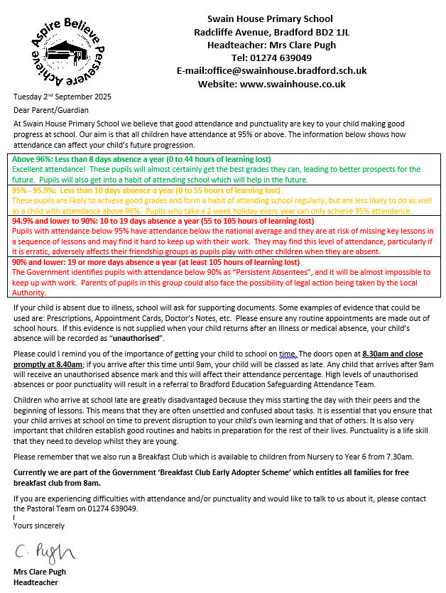

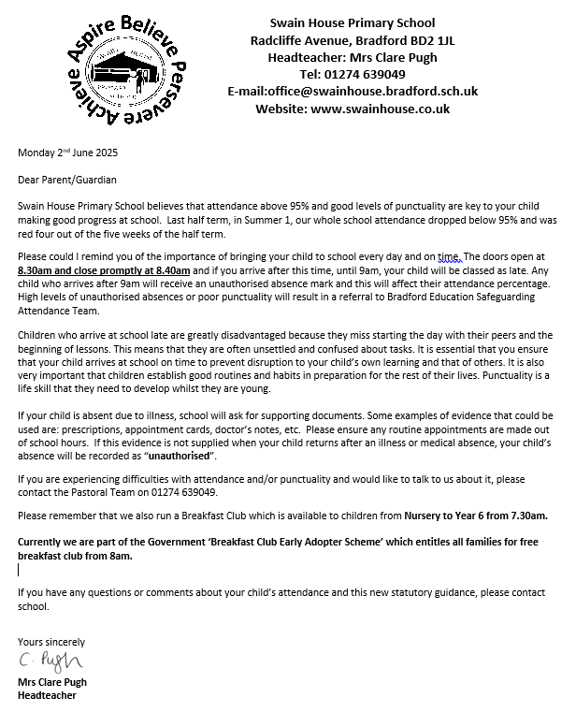

Appendix 2 – Attendance codes
The following codes are taken from the DfE’s guidance on school attendance

Code | Definition | Scenario
/ | Present (am) | Pupil is present at morning registration
\ | Present (pm) | Pupil is present at afternoon registration
L | Late arrival | Pupil arrives late before register has closed
Attending a place other than the school
K | Attending education provision arranged by the local authority | Pupil is attending a place other than a school at which they are registered, for educational provision arranged by the local authority
V | Attending an educational visit or trip | Pupil is on an educational visit/trip organised or approved by the school
P | Participating in a sporting activity | Pupil is participating in a supervised sporting activity approved by the school
W | Attending work experience | Pupil is on an approved work experience placement
B | Attending any other approved educational activity | Pupil is attending a place for an approved educational activity that is not a sporting activity or work experience
Absent – leave of absence
C1 | Participating in a regulated performance or undertaking regulated employment abroad | Pupil is undertaking employment (paid or unpaid) during school hours, approved by the school
M | Medical/dental appointment | Pupil is at a medical or dental appointment
J1 | Interview | Pupil has an interview with a prospective employer/educational establishment
S | Study leave | Pupil has been granted leave of absence to study for a public examination
X | Not required to be in school | Pupil of non-compulsory school age is not required to attend
C2 | Part-time timetable | Pupil is not in school due to having a part-time timetable
D | Dual registered | Pupil is attending a session at another setting where they are also registered
C | Exceptional circumstances | Pupil has been granted a leave of absence due to exceptional circumstances
Absent – other authorised reasons
T | Parent travelling for occupational purposes | Pupil is a ‘mobile child’ who is travelling with their parent(s) who are travelling for occupational purposes
R | Religious observance | Pupil is taking part in a day of religious observance
I | Illness (not medical or dental appointment) | Pupil is unable to attend due to illness (either related to physical or mental health)
E | Suspended or excluded | Pupil has been suspended or excluded from school and no alternative provision has been made
Absent – unable to attend school because of unavoidable cause
Q | Lack of access arrangements | Pupil is unable to attend school because the  local authority has failed to make access arrangements to enable attendance at school
Y1 | Transport not available | Pupil is unable to attend because school is not within walking distance of their home and the transport normally provided is not available
Y2 | Widespread disruption to travel | Pupil is unable to attend because of widespread disruption to travel caused by a local, national or international emergency
Y3 | Part of school premises closed | Pupil is unable to attend because they cannot practicably be accommodated in the part of the premises that remains open
Y4 | Whole school site unexpectedly closed | Every pupil absent as the school is closed unexpectedly (e.g. due to adverse weather)
Y5 | Criminal justice detention | Pupil is unable to attend as they are:  - In police detention  - Remanded to youth detention, awaiting trial or sentencing, or  - Detained under a sentence of detention
Y6 | Public health guidance or law | Pupil’s travel to or attendance at the school would be prohibited under public health guidance or law
Y7 | Any other unavoidable cause | To be used where an unavoidable cause is not covered by the other codes
Absent – unauthorised absence
G | Holiday not granted by the school | Pupil is absent for the purpose of a holiday, not by the school
N | Reason for absence not yet established | Reason for absence has not been established before the register closes
O | Absent in other or unknown circumstances | No reason for absence has been established, or the school isn’t satisfied that the reason given would be recorded using one of the codes for authorised absence
U | Arrived in school after registration closed | Pupil has arrived late, after the register has closed but before the end of session
Administrative codes
Z | Prospective pupil not on admission register | Pupil has not joined school yet but has been registered
# | Planned whole-school closure | Whole-school closures that are known and planned in advance, including school holidays

Appendix 3 – Half-termly attendance letters

Letter 1
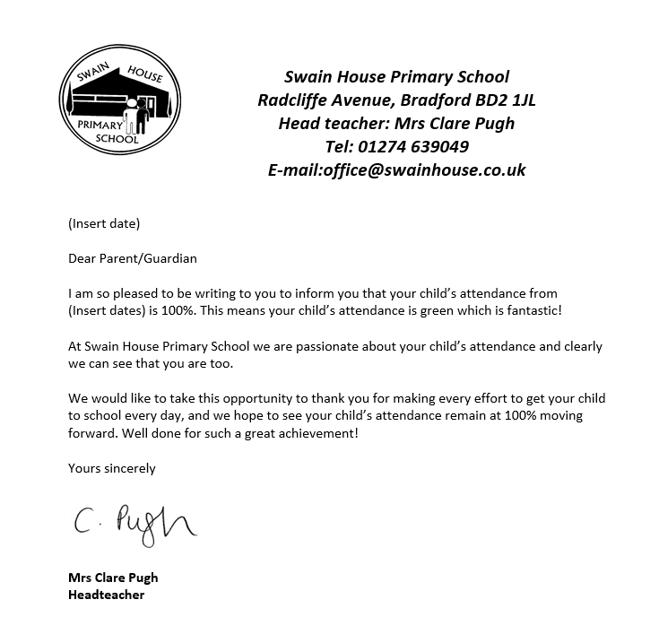

Letter 2


Letter 3
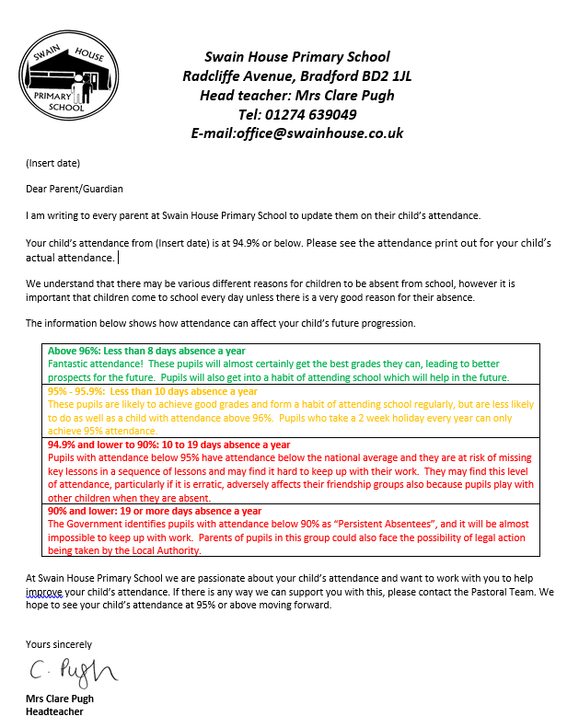

Letter 4
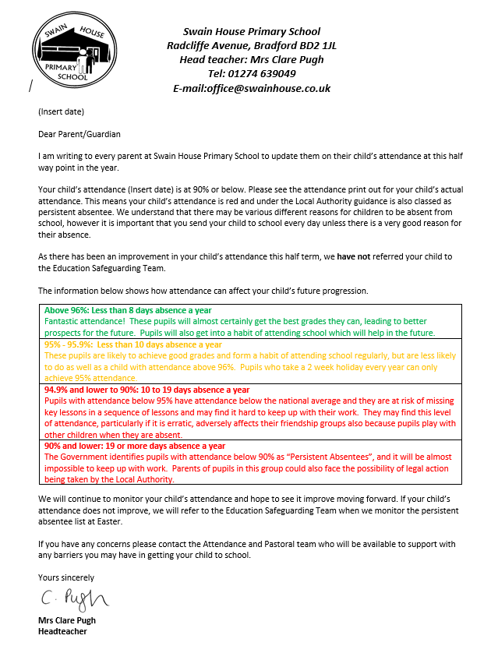

Letter 5


