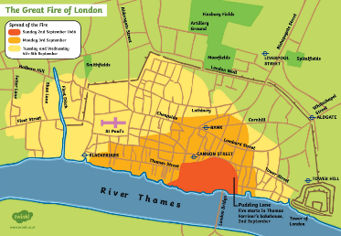
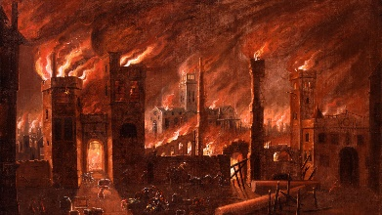
Kadinsky class
M

Our focus this half term is The Great Fire!
English  As readers we will:  - Read traditional tales and retell them through drama.  - Hot seat a character from a story.  - Be thinking about characters and settings.  - Read non-fiction books about plants, trees and flowers.  - Practise and use our phonics to read new words and sentences. | Class Information  Please ensure your child keeps the  correct P.E. kit in school.  Spellings are handed out every Friday and the children will be tested on the Friday of the following week. Please aim for 100%.  Friday will be our class library day, remember to bring your book! | History:  We will be learning about the Great Fire of London.  - What happened and how do we know?  - How shall we rebuild London after the Great Fire?  As scientists we will:  • Observe and compare different plants.  • Learn about what plants need to grow.  • Learn to investigate our ideas.  • Learn to write about what we have found out.  Computing – digital writing  Develop understanding of the different aspects of using a computer to create text and change text.  PHSE - Being My Best  Includes keeping healthy -Growth Mindset-goal setting  RE- Who brought messages about God and what did they say?  DT – Plan, design, make and evaluate our own fruit smoothies.
As writers we will:
- Practise forming our letters correctly using Letter Join.
- Write simple sentences for pictures.
- Write sentences using capital letters, full stops or exclamation marks or question marks.
- Use our phonics knowledge to improve our
spelling.
- Use all the information we have found out in our topic work to write our very own information books.
Maths  As mathematicians we will learn to:  - Explore numbers 0-10.  - Learn to use additive structures.  - Learn addition and subtraction facts within 10.  - Count in 1s, 2s, 5s and 10s.  - Problem solving activities.  - Know the value of a digit in a number.  - Use mathematical vocabulary to explain our understanding. | Resources  Please contact your child’s class teacher if you have any questions. | How could you help your child at home?  - Encourage your child to talk to you about what they  have learnt at school.  - Look at the plants and trees growing around us and talk about what they are called.  - Listen to different types of music.  - With your child, log on to Rocket phonics and read the books allocated to you.  - Allow your child to practise their reading skills independently by logging onto Lexia.

