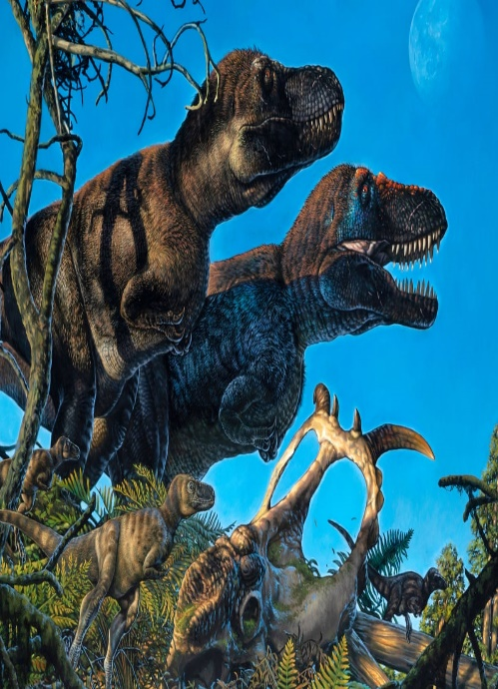
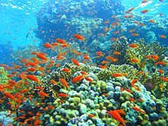
Our theme this half term is called
Willow Class
Our World and Beyond
In this theme, we will be learning about planet Earth and dinosaurs!
In Literacy we will be:  • Reading fiction and non-fiction books about the planet Earth, dinosaurs and space  • Predicting, discussing and answering questions about characters and story events  • Practising and using our phonics knowledge to read new words, captions and sentences  • Practising forming our letters correctly using the  tripod grip  • Writing labels and captions for pictures | Class Information  Please continue to share your child's reading book with them and sign their reading record at least once a week so your child can achieve yellow or green on their pupil mentoring sheet. The time you spend listening to your child read is invaluable and makes a huge difference to their progress.  Snack money this half term is £3.50. Please pay  a member of the Reception team.  (This can be paid in full or 50p per week.)  Please clearly label all your child's clothing. | In our theme lessons we will be learning all about the planet Earth and dinosaurs.  We will be learning about the following things:  • The planet Earth and why it is important to look after it  • The names of different dinosaurs and how long ago they lived  • Dinosaur bones and fossils  - Palaeontologists who discovered fossils and different dinosaurs- (Mary Anning)  - Compare the similarities and differences between the Earth when dinosaurs existed and the Earth now
In Mathematics we will be learning about:
- Subitising – To recognise the number of small objects in a group without counting
- Composition – How numbers are made
- Comparison
- Counting, ordinality, cardinality

Our Core books this half term are:  - ‘Barbara throws a Wobbler’ by Nadia Shireen  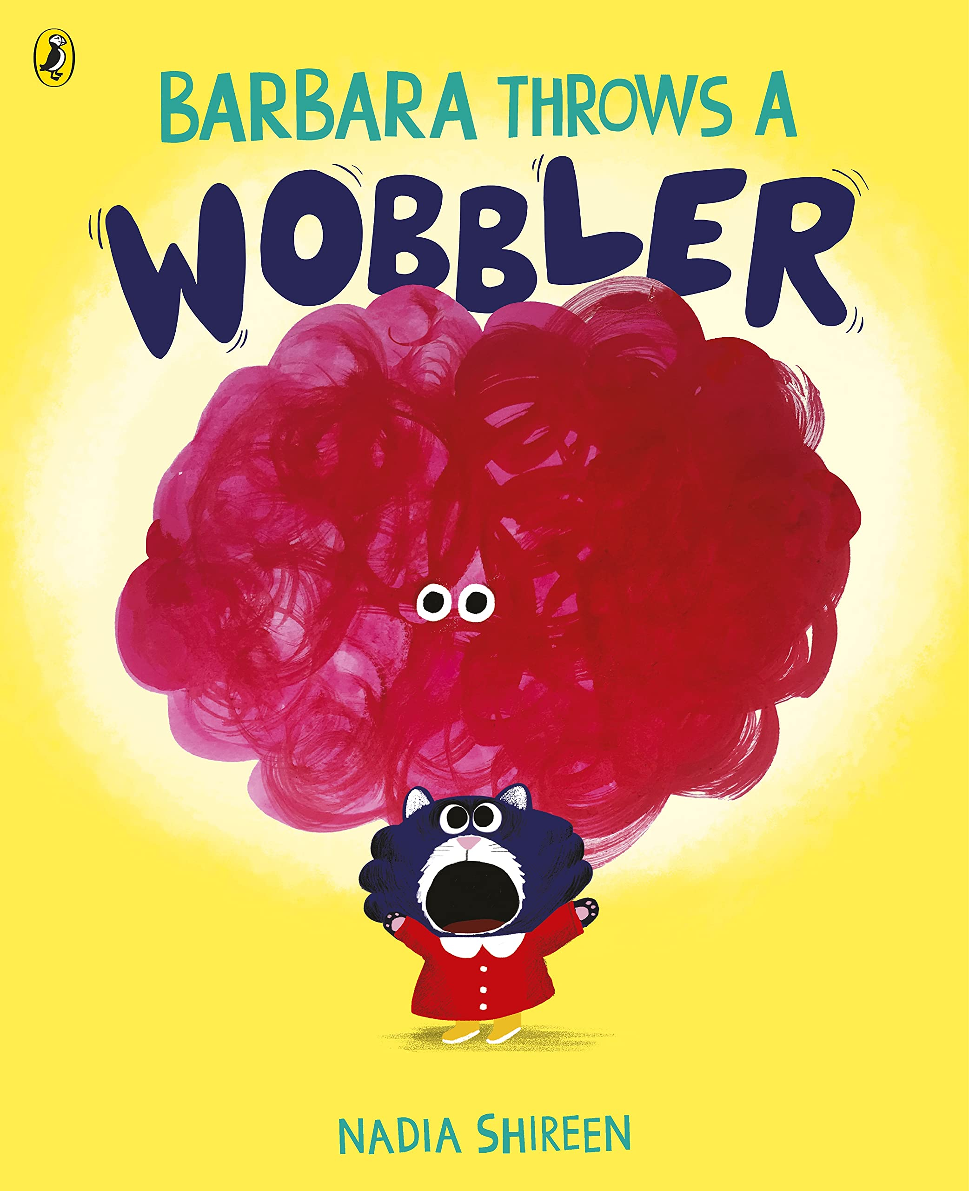  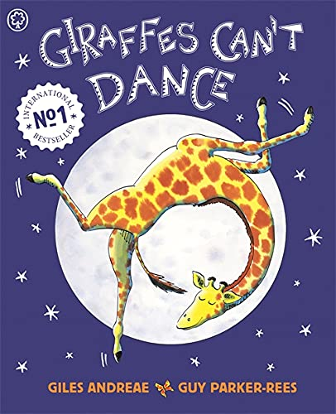  - ‘Giraffes can’t Dance’ by Giles Andreae | In PSHE we will be learning about:  • What is safe to go into our bodies  • Keeping safe indoors and outdoors  • Listening to my feelings  • Keeping safe online  • People who help keep us safe | How could you help your child at home?  • Encourage your child to talk to you about what they have learned at school  • Look at pictures and books of dinosaurs and talk about what can be seen  • Support your child in writing their full name independently  • Go on a winter walk and talk about the seasonal changes  • Log on to PhonicsPlay.co.uk with your child and practise Phase 3 activities

