**Core story books**

**Little Acorns Nursery**

**Autumn Term**

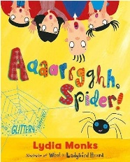 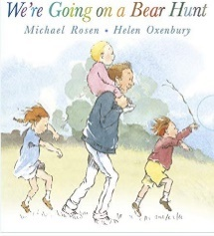 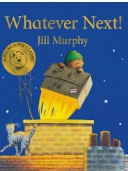 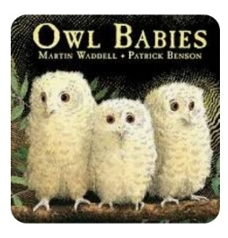

Aaaarrgghh Spider!

We’re Going On a Bear Hunt

Whatever Next!

Owl Babies

**Spring Term**

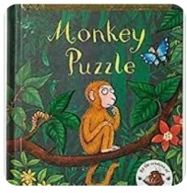 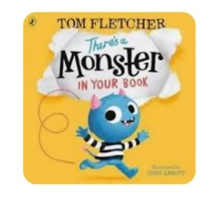 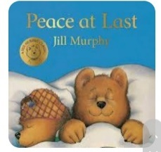 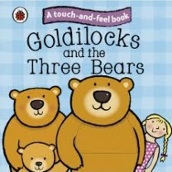

Monkey Puzzle

There’s a Monster In Your Book.

Peace at Last

Goldilocks and the Three Bears

**Summer Term**

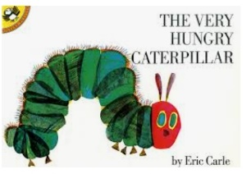 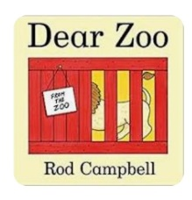 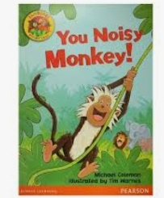 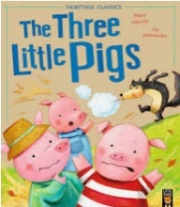

The Very Hungry Caterpillar

Dear Zoo

You Noisy Monkey!

The Three Little Pigs