Matisse Class
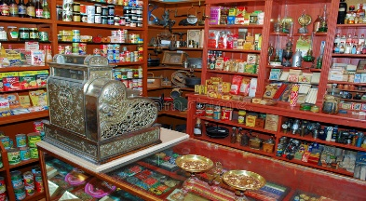
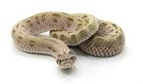

Proud to be from Bradford – Street Detectives
In this theme we will be learning about how shops have changed and looking at our local area.
English  As readers we will:  •Read stories and re-tell them through drama and we will be thinking about the characters and describing what we see  •Read non-fiction books about places and about seasonal change  •Practise and use our phonics to read new words and sentences | Class Information  PE will be on Mondays this term.  Please ensure your child keeps the correct P.E. kit in school.  Please can you ensure all items of clothing are labelled with your child’s name.  If you have any queries please do not hesitate to come and speak to us. We are always happy to help! | As geographers we will:  •Learn that Bradford is a city  •Learn that a map is a representation of a place  •Learn to draw a simple map  •Understand what a ‘bird’s eye view’ is.  As historians we will:  Learn about what is different and the same about shops in the recent past and look at changes in shopping in the recent past creating a human timeline.  As scientists we will learn about:  •Learn to investigate our ideas  •Use our senses to observe  •Notices the changes in the seasons by observing a tree growing in our school grounds  In RE we will be looking at:  Which books and stories are special?
As writers we will:
• Practise forming our upper and lower case letters correctly
• Write labels and captions for pictures
• Write simple sentences using capital letters and full stops
• Use our phonics knowledge to improve our spelling
Maths  As mathematicians we will learn to:  - that the value of a number refers to the quantity, or ‘howmanyness’ of things it represents  - to compare numbers using more or less  - that one number can be made up from two or more smaller numbers  - looking for and finding patterns  - what happens when shapes move, or combine with other shapes  - comparing different aspects such as length, weight and volume | Homework  Homework this year will be a little different.  Spellings will be given out every Friday, to be learnt at home for a spelling test the following Friday.  There will be no homework books sent home, instead, we would like you to focus on Lexia, Numbots and reading. Log in details can be found in your child’s reading record book.  Further information will be sent out later this week.  Read with your child at least 3 times a week. Remember to write a comment and sign their Reading record – this is part of our homework policy and will be part of their pupil mentoring form. | How could you help your child at home?  Talk about what they have learned in school.  Read a range of stories at home and ask questions about what you have read.  Learn to count forwards and backwards to 50.  Talk in your family about how shops have changed.  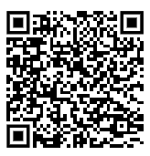  Don’t forget to practice your maths passport facts.  You can find all the objectives on our school website. Here is a link to the page:

