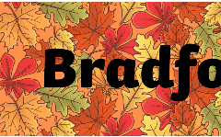
Lowry Class

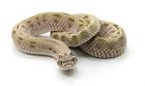
In this theme we will be learning about the Bradford Pals and World War One.
English  As readers we will:  Read non-fiction books, finding out new information.  Think about how we can answer questions using a book  to improve our comprehension skills.  Practise and use our phonics to read new words.  Read and discuss a variety of news stories looking at  big news questions and question words. | Class Information  PE will be on Tuesday – this half term we are continuing our street dance lessons.  Please ensure your child keeps the correct P.E. kit in school.  Please remember your book bag, reading book and water bottle every day.  If you have any queries please do not hesitate to come and speak to us. We are always happy to help! | Theme  As historians we will be:  Looking at World War One and how injured soldiers were treated. We will focus on the Bradford Pals and the nurse Edith Cavell.  As designers we will be:  Looking at different structures and designing and building our own monuments.  As scientists we will learn about:  The basic needs of animals and humans, including exercise and healthy eating. We will also be focusing on hygiene.  In RE we will be answering the big question:  How can we make good choices?  In other subjects:  Computing – We will be focussing on digital media.  PSHE – We will be focusing on valuing differences. What makes us who we are? How do we make others feel? When someone feels left out and acts of kindness.  Music – Learning the song: Ho Ho Ho and learning how to play notes on the glockenspiels and recorders.
As writers we will:
Write interesting sentences using full stops, capital letters and adjectives.
Use a range of conjunctions: and, but, because, when & if.
Become newspaper reporters writing our own news reports.
Work on finding and using verbs and adverbs.
Find and write questions using question words and the correct punctuation.
Use our phonics knowledge to improve our spelling.
Maths  As mathematicians we will:  Add three numbers.  Use “first, then, now” story to add three numbers.  Know that numbers can be added in any order.  Compare numbers and describe how many more or less there are in each set.  Add and subtract numbers fluently within 10.  Add and subtract numbers that bridge 10.  Learn how to work out the difference between numbers.  Solve addition and subtraction problems in a range of contexts | Homework  Spellings will be given out every Friday, to be learnt at home for a spelling test the following Friday.  There will be no homework books sent home, instead, we would like you to focus on Numbots, Lexia and reading. Log in details can be found in your child’s reading record book.  Further information will be sent out later this week.  Read with your child at least 3 times a week. Remember to write a comment and sign their Reading record – this is part of our homework policy and will be part of their pupil mentoring form. | 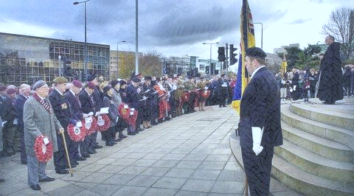  How could you help your child at home?  Read and talk about what they have learnt in school.  Read and talk about stories/books we are sharing.  Practise reading and phonics by using www.phonicsplay.co.uk. Just click on the free play option.  Research Edith Cavell. What else can you find out for our display?  Practise your child’s spellings daily and support with homework.  Practise number facts – number bonds for 5, 6, 7, 8, 9, 10 and 20.  Practise the 2, 5 and 10 times tables. Your child needs to know these by the end of the year.  Practise telling the time. By the end of Year 2, your child should be able to tell the time to the nearest 5 minutes.  Practise your letter formation – https://www.letterjoin.co.uk/

