Swain House Ted Room Topic Cycle
Autumn 1 | Autumn2 | Spring 1 | Spring 2 | Summer 1 | Summer 2
Busy Bodies  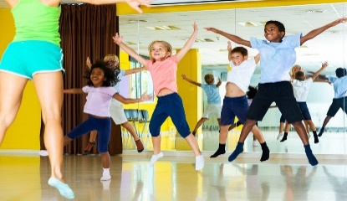 | Jurassic World  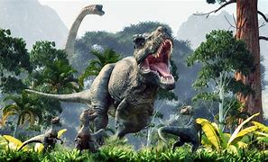 | 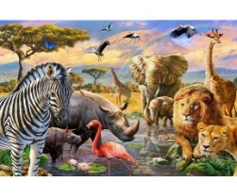  Animal Kingdom | How Does My Garden Grow  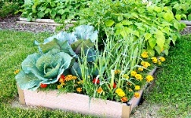 | People in My World   | Under the Sea  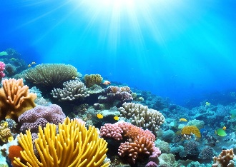
Focus Texts | Focus Texts | Focus Texts | Focus Texts | Focus Texts | Focus Texts
The Funny Bones – Janet & Allen Alhberg  Clothing of the World – Nancy Loewen  Health & My Body Series – Mari Shuh & Martha Rustad | Dinosaurs - Miles Kelly  Step inside Science Dinosaurs – Rob Lloyd Jones  Hello Fossils and Shells – Nina Chakrabarti  Dinosaurs - National Geographic | Variety of ‘That’s not my’ sensory books  National Geographic Kids, Animals | A Gift of the Sun by Dianne Stewart  Eco Girl by Ken Wilson Max  Life Cycles: from seed to sunflower by Camilla de la Bedoyere  That’s not my bee - Usbourne | Who’s In My Family? By Robie Haris  The Great Big Book of Families by Mary Hoffman  Find Out About Families (lift the flap) by Pat-a-Cake  All Kinds of Families – Sophie Henn  All About Families – Felicity Brooks | Boo! A Fishy Mystery by Kate Reeves  Tiddler by Julia Donaldson  Sea by Patricia Hegarty  Meet the Oceans – Caryl Hart  Look Inside Seas and Oceans – Megan Cullis
BSL – To know physical features sign related vocabulary  History – Changes within living memory (Royal family)  Science – Parts of the human body  Human & Physical Geography – Key human features – houses/homes  Design Technology –  Art – Craft techniques to make bodies and faces  Music – Moving to music  PE – Movement and dance  PSHCE – Understanding feelings and the signs for them (happy, sad) | BSL – Facial expressions for past/textures  History – Events beyond living memory- Dinosaurs  Science – animal groups (Reptiles and amphibians only)  Geographical Skills – Exploring fossils  Design Technology – Making dinosaurs (joining and finishing)  Art – Sculpting (dinosaurs) and printing (fossils)  Music – Moving to music  PE – Climbing  PSHCE – Understanding feelings and the signs for them | BSL – To know animal related sign vocabulary  History – Lives of significant people – David Attenborough  Science – Animal development / animal basic needs  Human & Physical Geography – Key human features - farms  Design Technology –  Art – Printing – animal prints  Music – African instruments  PE – Outdoor play  PSHCE – Understanding feelings and the signs for them | BSL – Spring signs (flower, warm, grow)  History –  Science – Growing plants/flowers  Human & Physical Geography – Soil / season and weather  Design Technology – Creating flowers using different textures/materials  Art – David Hockney Sunflowers  Music – Exploring the outdoor music area on the playground  PE – Outdoor Play  PSHCE – Understanding feelings and the signs for them | BSL – To know family related sign vocabulary  History – Changes Over Time (Babies/Old/Young)  Science – Growing  Human & Physical Geography – Locational Knowledge: Home & School  Design Technology – Building/Making Houses  Art – Materials (Creating faces)  Music – Tuned and un-tuned instruments  PE – Outdoor Play  PSHCE – Understanding feelings and the signs for them | BSL – To know sea creature/water/sea related sign vocabulary  History – Boats  Science – Grouping and classifying (animals on land or sea)  Human & Physical Geography – Use basic Geographical sign vocabulary (sea, sand, beach, weather)  Design Technology –  Art – Colour, pattern & texture  Music – Experimenting with sounds  PE – Outdoor Play  PSHCE – Understanding feelings and the signs for them

