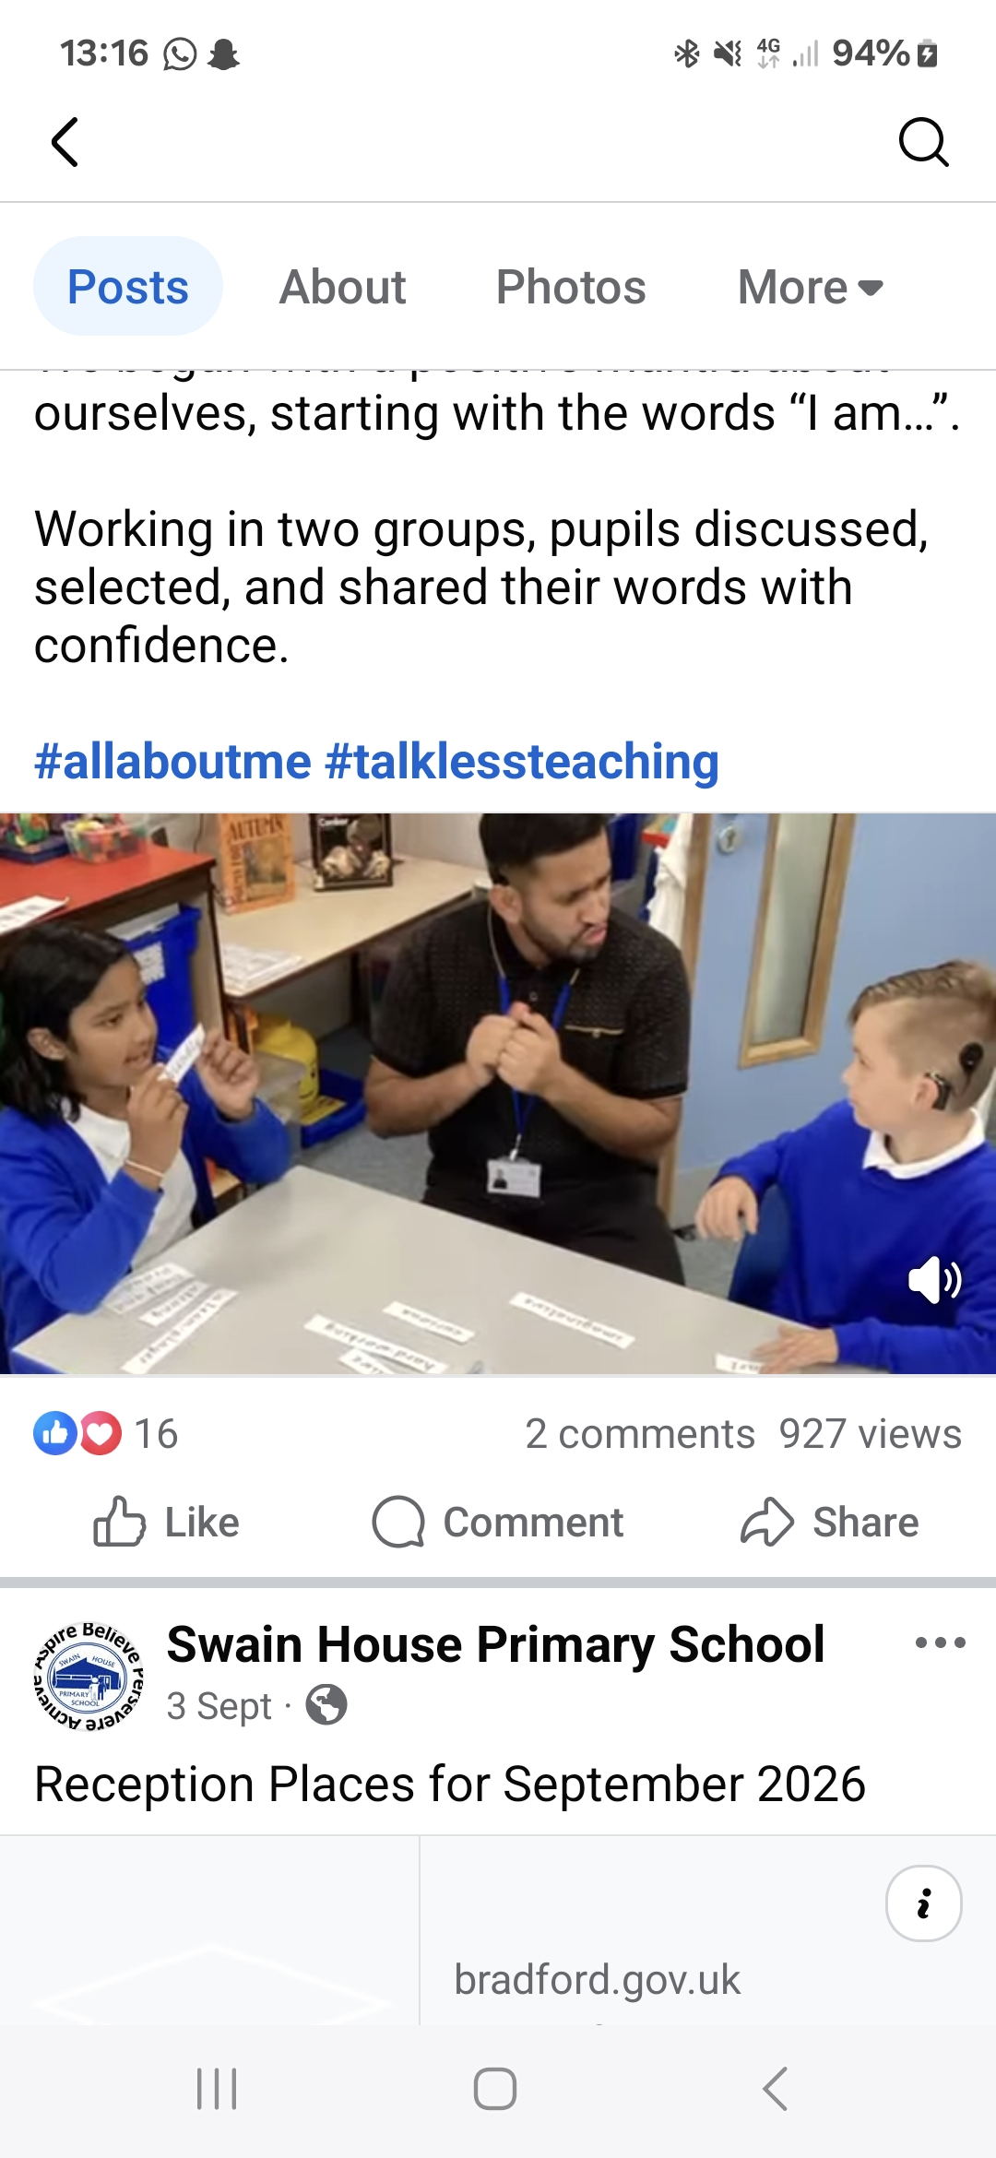
Swain House Primary School
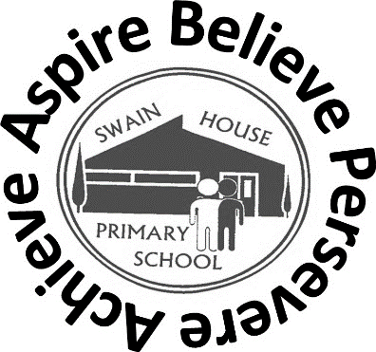

Resourced Provision Newsletter
21/10/2025

Malham

ff

swimming
Year 4 Residential trip to Malham went ahead and they all had a great time. They did not let the weather stop them from enjoying the activites.  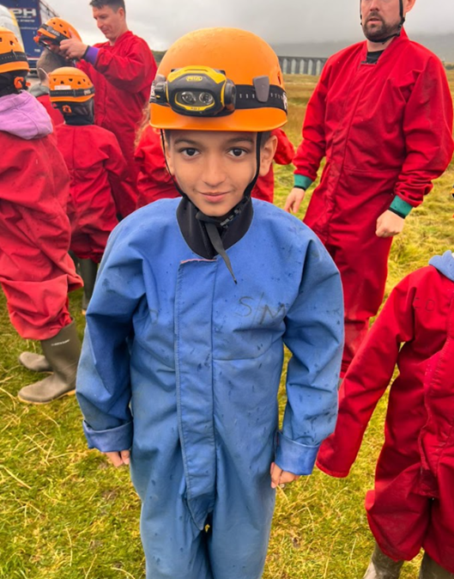  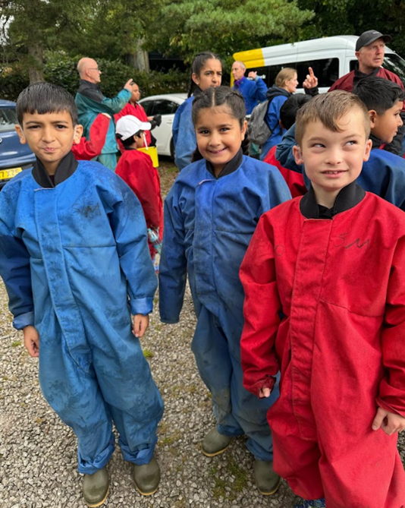  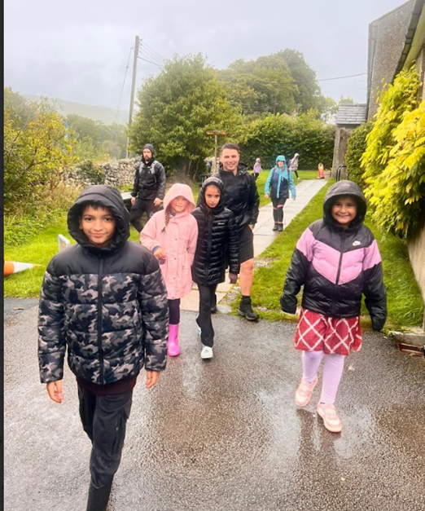  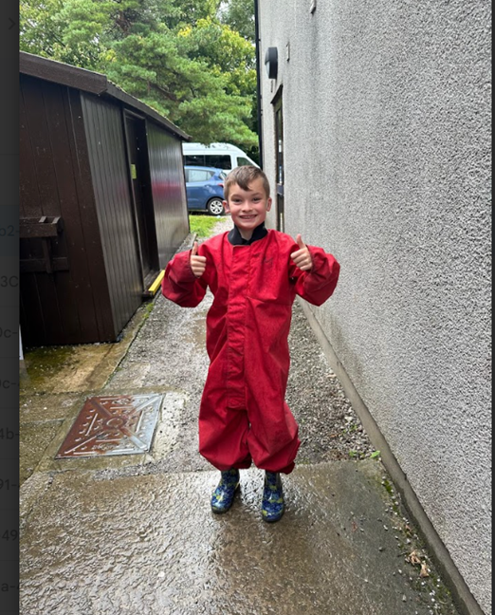 |  | Paul Whittaker RP Class (Years 4, 5 & 6) are ready for the new school year!  We began with a positive mantra about ourselves, starting with the words “I am…”.  Working in two groups, pupils discussed, selected, and shared their words with confidence.  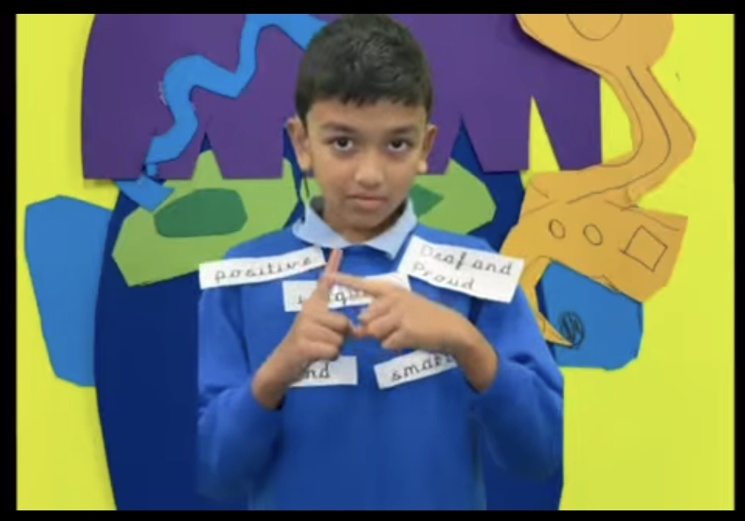  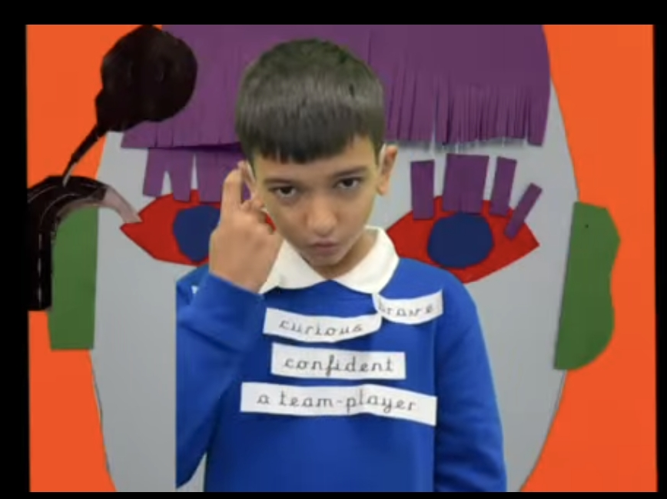
“Our vision is to provide high quality support for all Bradford children and young people using a collaborative approach through transformational learning experiences so that they can flourish and make excellent holistic progress and successfully transition to responsible citizens”

BSL level 1

Ms Robinson is very pleased to let you all know that the parents who were learning British sign language have completed and passed BSL Level one course at Swain House Primary school. Congratulations to them all. Well done.



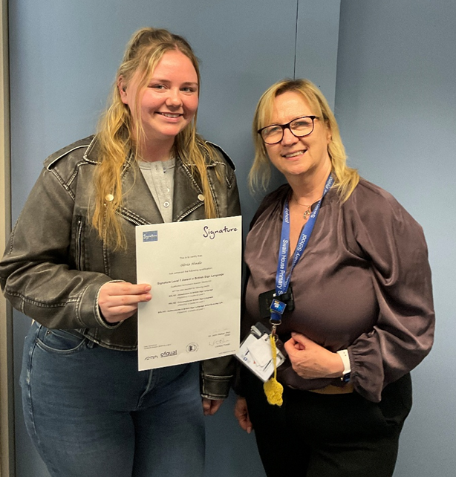  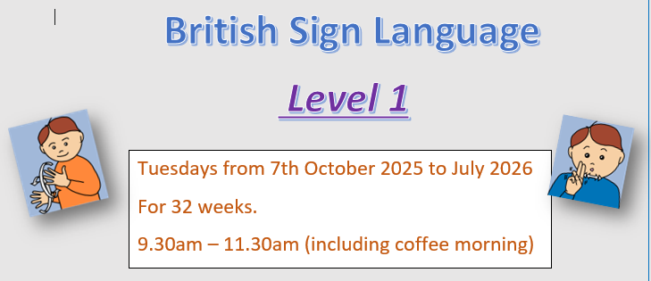 |  | 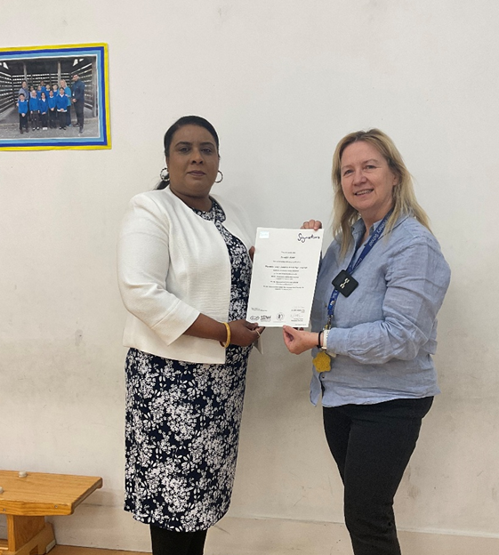 | 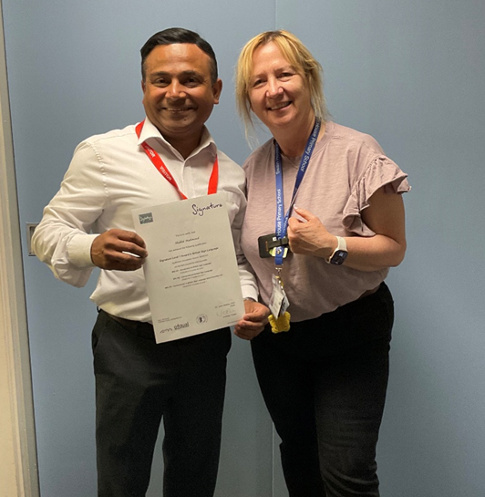  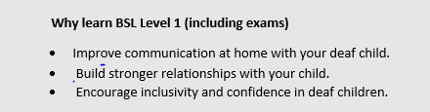  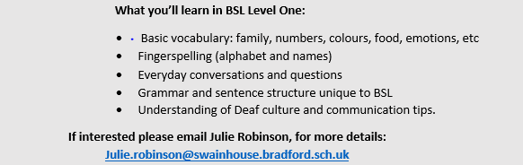
Science

The year 3/4 children in the RP have been enjoying their science topic on forces and magnets. They have been exploring magnets and finding different materials that are magnetic or non-magnetic. All the children enjoyed
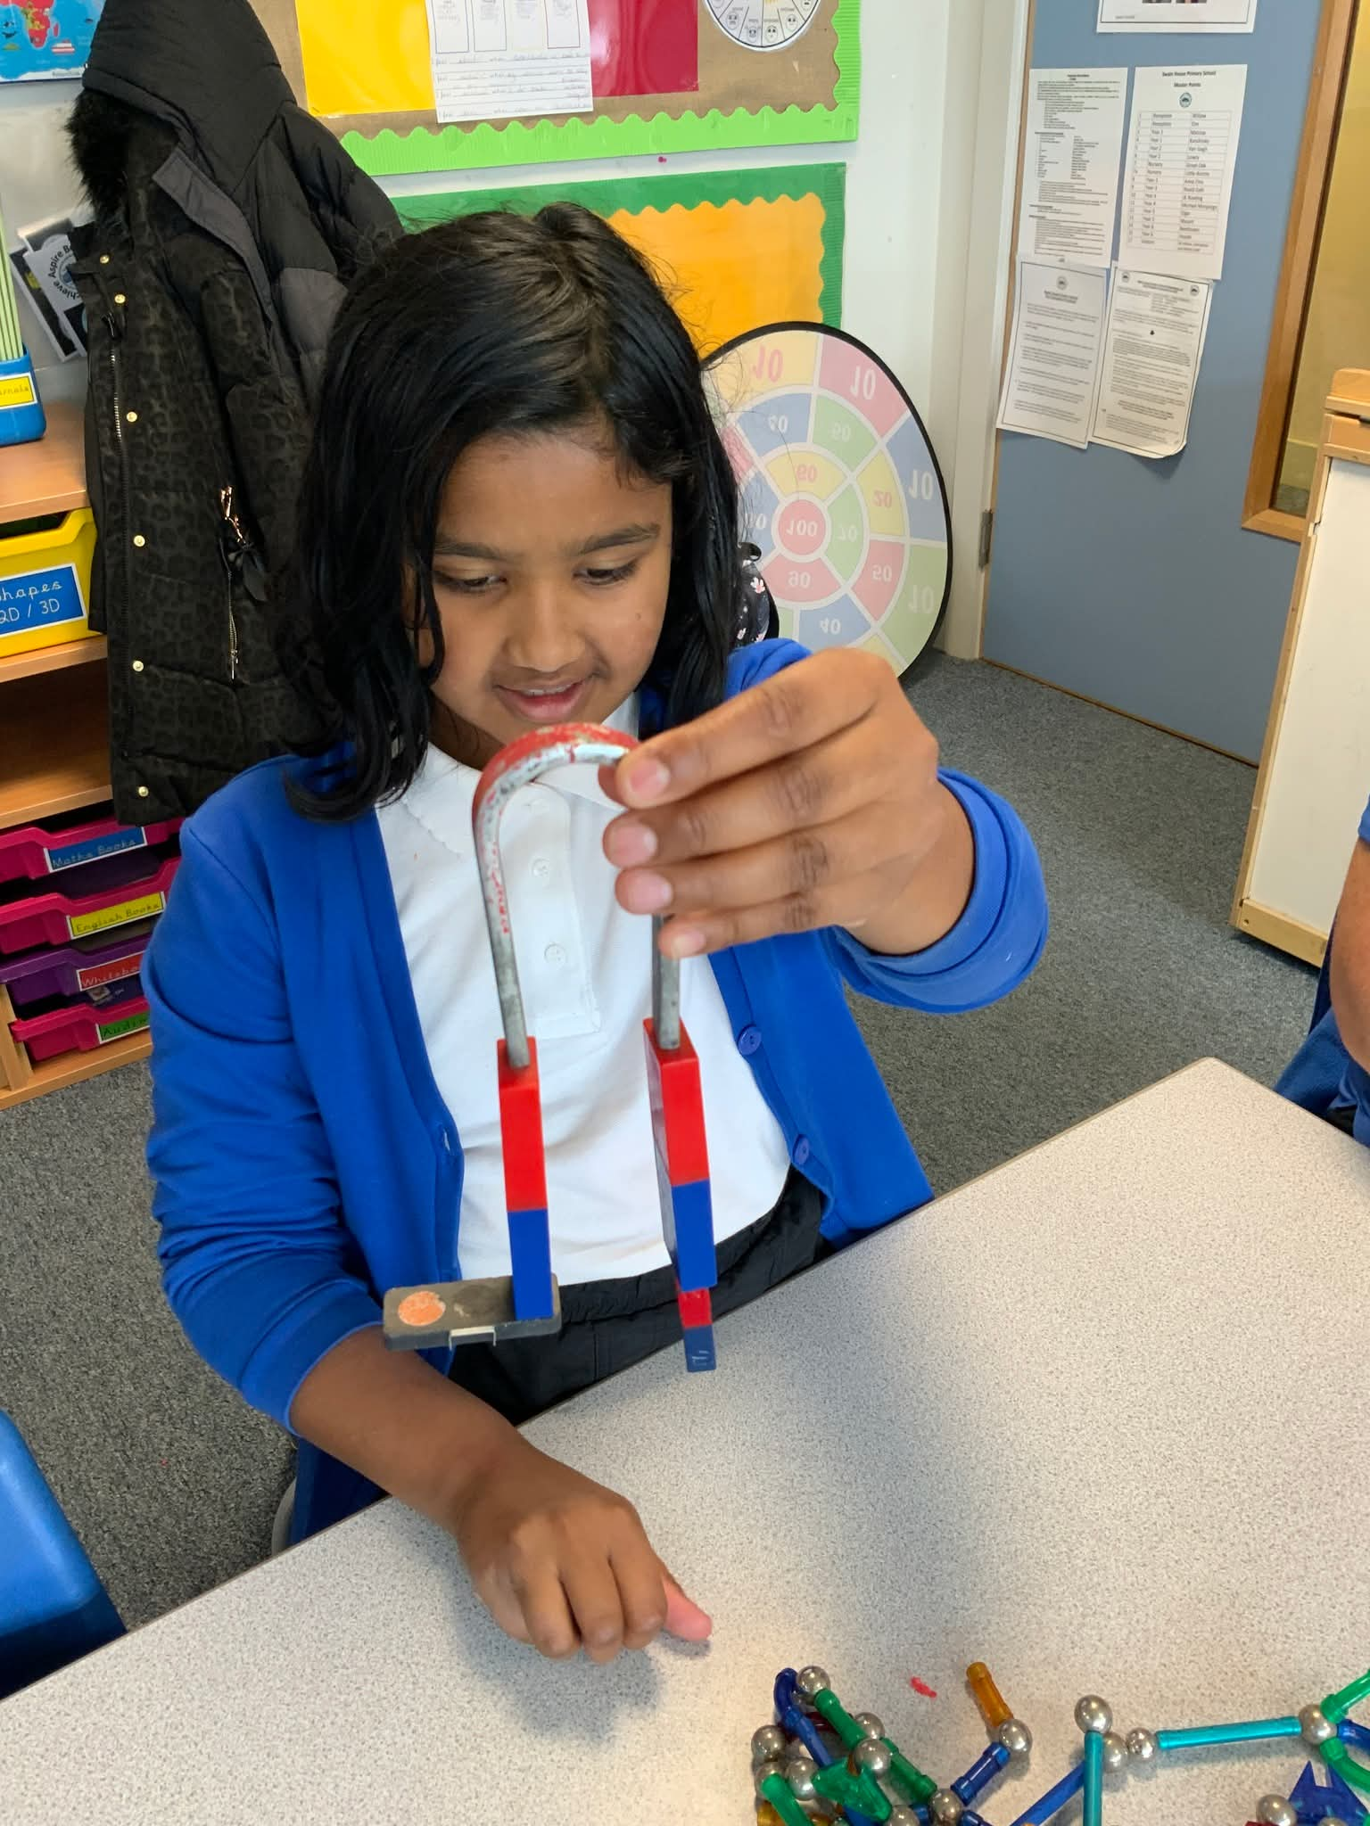
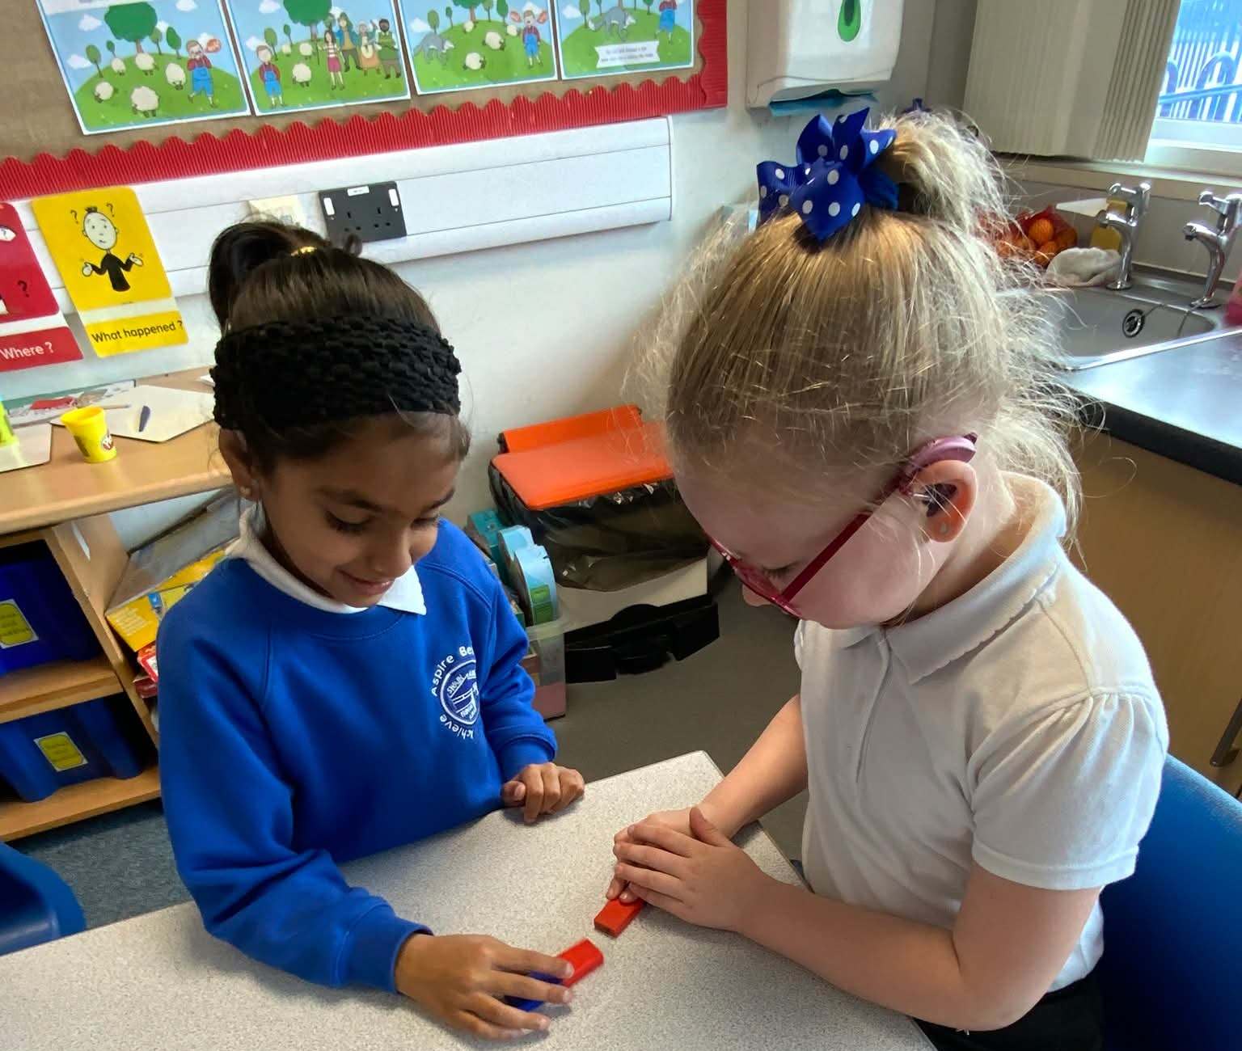
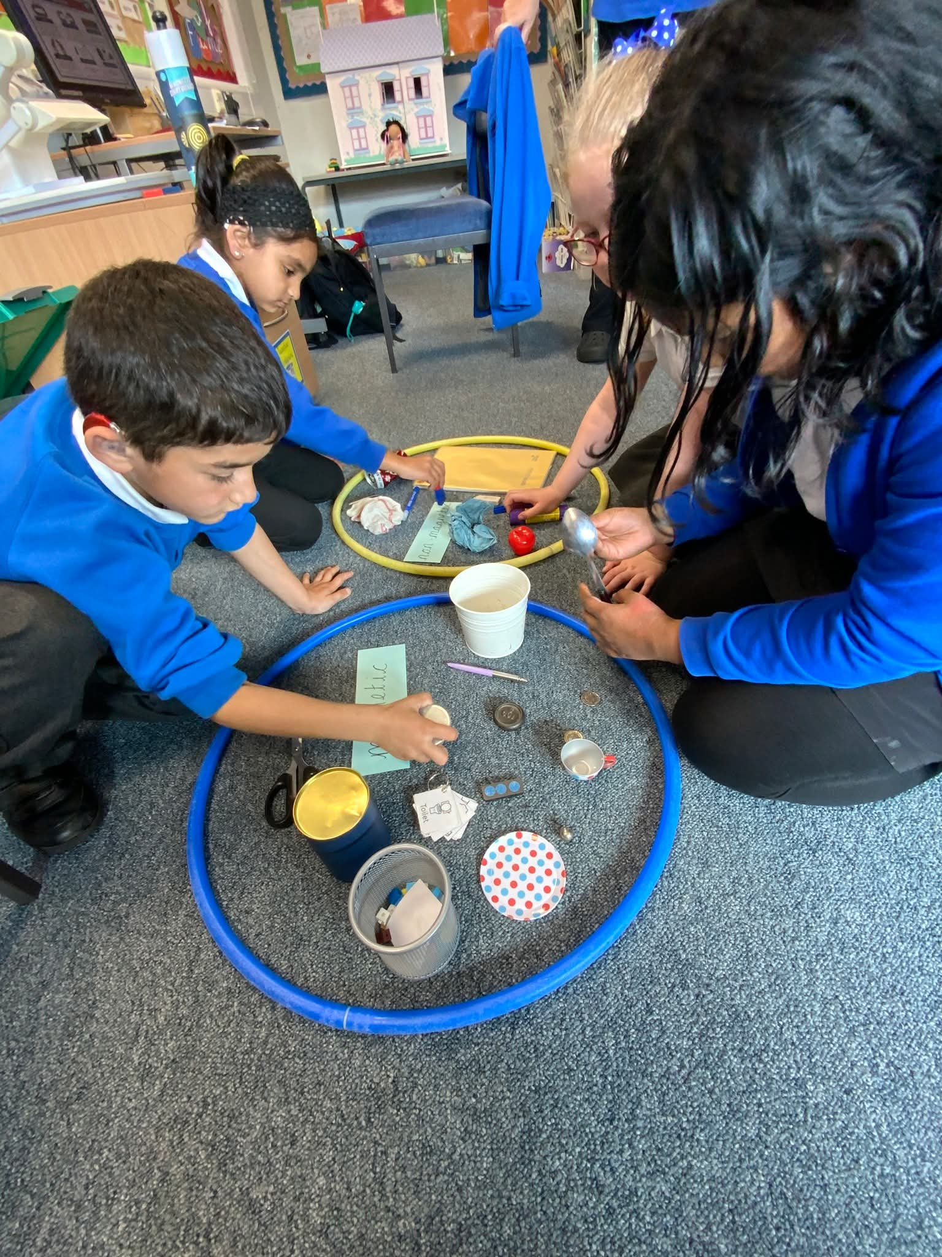
Another Headline Here | You can easily change the formatting of selected text in the document text by choosing a look for the selected text from the Quick Styles gallery on the Home tab. On the Insert tab, the galleries include that are designed to coordinate with the overall look of your document. You can use these galleries to insert tables, headers, footers, lists, cover pages, and other document
Bradford City Stadium Visit - 14th October 2025

Today, our Year 5 RP pupils joined their Year 5 mainstream peers for an exciting visit to Bradford City Stadium, organised by the Bradford City Community Foundation.

The tour lasted about an hour and included key areas such as the fire memorial, the changing rooms, the dugouts, and the boxes and suites.
During our visit, the children learned about the tragic fire in 1985 and reflected on how it affected the local community. It was an engaging and memorable learning experience for all.

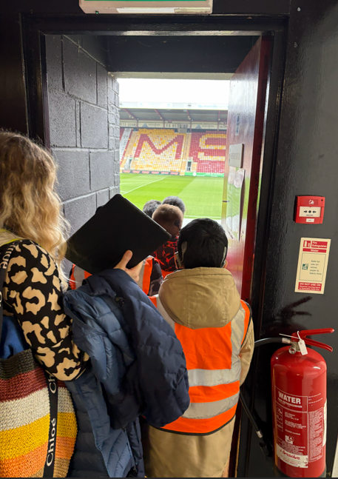
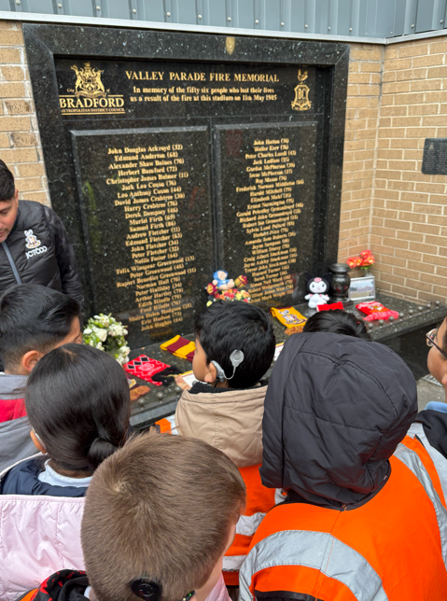

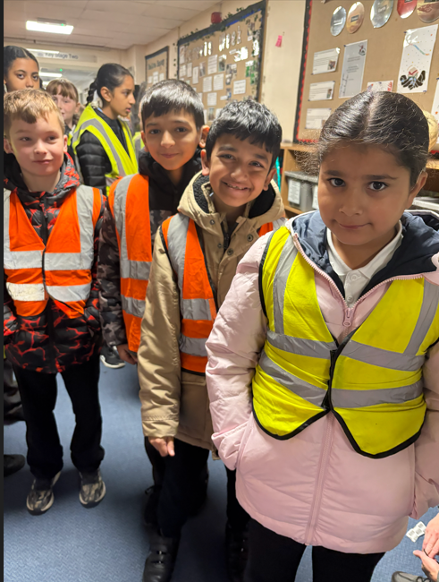

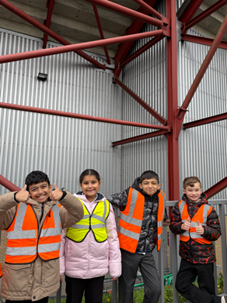

Upcoming events after half term holidays

Friday 14th November - Children in Need
Friday 21st November - Non Uniform Day - Bring a Bottle (shampoo, conditioner, condiments, alcohol etc)
Friday 28th November - Non Uniform - Bring chocolate
Friday 5th December - Xmas Fair 4.00-5.30pm
Thursday 11th December – Snow white pantomime Alhambra 2.00 – 4.00pm
Thursday 11th December - Xmas Jumper Day and Xmas Dinner
Friday 19th December - Bring a toy day, last day of school.

School will close on Thursday 24th October 2025
Schools will re-open on Monday 3rd November 2025

