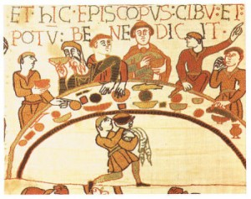
JK Rowling

Invaders and settlers.
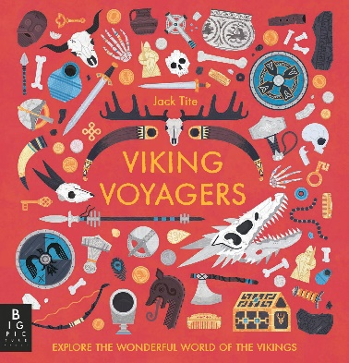  English  As readers we will:  Be reading Viking Voyagers to learn all about the Vikings!  Building our comprehension skills.  Learning to read aloud with confidence. | Class Information  On Wednesdays the children go swimming.  PE is on Tuesdays.  Please ensure your child keeps the correct P.E. kit in school all the time.  Please make sure your child has a water bottle to use in school.  Please contact your child’s class teacher if you have any questions. | As scientists we will learn about living things and their habitats.  As Historians we will learn: The Vikings.  As Geographers we will be learning about rivers in the UK.  Computing – we will be learning how to input data.  PE – we will be learning football skills.  R.E. - will explore the creation stories from Christianity, Judaism, Islam and Sikhism. It will consider how these stories have impacted upon the faiths in the past, and how relevant they are today.  French – We will be learning French instructions and how to retell a French story.  Music – composing and performing our own songs based on the song lean on me.
As writers we will:
Use a range of punctuation marks accurately.
Improve our work through editing carefully.
Develop the formation of our joined handwriting.
Use our knowledge of spelling patterns to improve our work.
Write a leaflet all about the Vikings and meet our writing targets to improve our writing.
Maths  As mathematicians we will be learning about:  Be able to divide and multiply numbers by 10 and 100  Use the method for long division.  Coordinates. | Resources  If you have any objects, books or information that might help us with our theme we would love to know about them! | How could you help your child at home?  Encourage your child to talk about the learning they have been doing at school.  Ensure they complete their homework to the best of their ability.  Allow your child to research either Henry VII or Henry VIII.  Ensure your child learns “off by heart“ their times tables and number facts so they can get their passports.  Give opportunities for your child to practise their handwriting and spellings.  Practise reading with expression and sign their planner at least once a week.
Homework
A new spelling rule is introduced each week. In addition to the spelling rule your child will be tested regularly on the Key Stage 2 word lists (a copy has been sent home, please request another if your child doesn’t bring it home).
Read with your child at least three times per week. Remember to write a comment and sign their Reading Record.
