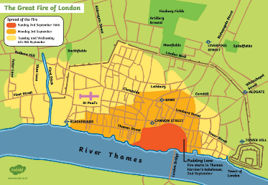
Kandinsky class
M

Our focus this half term is The Great Fire!
English  As readers we will:  - Read different stories and retell them through drama.  - Think about questions to ask a character.  - Be thinking about characters and settings.  - Read non-fiction books  - Practise and use our phonics to read new words and sentences. | Class Information  Spellings are handed out every Friday and the children will be tested on the Friday of the following week. Please aim for 100%.  Our PE lessons are every Wednesday.  Remember to come into school in your PE kit. | Geography:  We will be learning about different natural disasters based in Australia.  - To name and locate different places on a map  - To identify human and physical features  - Learn about similarities and differences of different countries  As scientists we will:  • Learn to identify different plants.  • Learn to different parts of a plant.  • identifying the different wild plants that grow in our wildlife area.  Computing – Programming animations  We will be introduced to on-screen programming through ScratchJr. We will explore the way a project looks by investigating sprites and backgrounds. We will use programming blocks to use, modify, and create programs. We will also be introduced to the early stages of program design through the introduction of algorithms  PHSE – Growing and changing – we will focus on getting help, becoming independent and body parts.  RE- How does what believers do show what they believe?  Art – Craft and design woven art.
As writers we will:
- Practise forming our letters correctly using Letter Join.
- Write simple sentences for pictures.
- Write sentences using capital letters, full stops or exclamation marks or question marks.
- Use our phonics knowledge to improve our
spelling.
- Use all the information we have found out in our topic work to write our very own information books.
Maths  As mathematicians we will learn to:  - Addition and subtraction facts within 10.  - Learn about numbers 0 to 20.  - Unitising and coin recognition.  - Count in 1s, 2s, 5s and 10s.  - Problem solving activities.  - Use mathematical vocabulary to explain our understanding. | Resources  Please contact your child’s class teacher if you have any questions. | How could you help your child at home?  - Encourage your child to talk to you about what they  have learnt at school.  - Look at the plants and trees growing around us and talk about what they are called.  - Listen to different types of music.  - With your child, log on to Rocket phonics and read the books allocated to you.  - Allow your child to practise their reading skills independently by logging onto Lexia.

