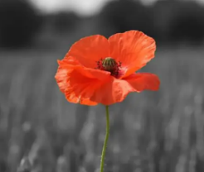
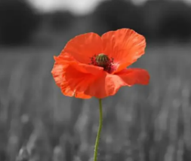
Roald Dahl Class
Bradford Remembers
What Was Life Like in the Trenches?
English  As readers we will:  Read whole books to improve our comprehension skills.  Use dictionaries and thesaurus to learn new vocabulary.  Be able to identify and use features of non-fiction texts.  Increase our understanding of grammar.  Practise and use our phonics to read unfamiliar words. | Class Information  PE will be on a Wednesday Please ensure your child keeps the correct P.E. kit in school all the time. Please make sure your child has a water bottle to use in school.  Homework  Maths  Each week children should log on and complete number facts and times tables practise on Numbots & Times Tables Rock Stars. Logins can be found inside your child’s reading record.  English  Your child will receive a list of spellings on a Friday to practise. They will be tested on these words the following Friday.  Please listen to your child read (either their school book or a book of their choice) regularly and sign their reading record at least once a week.  If you have any queries, please contact your child’s class teacher. | Theme  As historians we will study: an aspect of history or a site dating from a period beyond 1066 that is significant in the locality (Bradford Pals, Life in the Trenches)  As artists we will be:  improve our mastery of art and design techniques, including drawing, painting and sculpture with a range of materials  As scientists we will learn: how forces such as friction and magnetism work and the effect they have on different objects and surfaces.  Computing – we will use a range of techniques to create a stop-frame animation  PE – We will be learning how to play golf. Some children will take part in an inter school golf festival next half term.  R.E. – We will learn how the synagogue, the Torah scroll and Shabbat are important to Jewish people  Music – Learning the language of music through playing the glockenspiel.  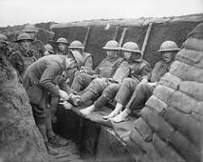  French – We are learning to say hello and goodbye, the colours, days of the week and to say how we are feeling.
As writers we will:
Write more complex and interesting sentences using a range of punctuation.
Enrich our word choice by “borrowing” authors words.
Plan what we are going to write about before we begin.
Improve our work through editing carefully.
Develop the formation of our joined handwriting.
Use our phonic knowledge to improve our spelling.
Consider characters’ thoughts and feelings.
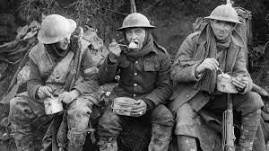
Write a setting description, a diary entry, a letter and a conversation.
Maths  As mathematicians we will learn to:  Count on from 100 crossing hundreds boundaries  Bridge 100 when adding or subtracting  Covert between mm, cm and meters  Represent three digit numbers in different ways  Compare and order three digit numbers  Count forwards and backwards in multiples of –  10, 100, 2, 20, 5, 50 and 25  Become familiar with measuring mass and volume | Resources  If you have any objects, books or information that might help us with our topic we would love to know about them!  If you have any talents or skills that may help us please share them to help us with our learning. | How could you help your child at home?  Encourage your child to talk about the learning they have been doing at school.  Ensure your child works on their Maths Passport objectives.  Listen to your child read and practise reading with expression.  Encourage your child to use Times Table Rock Stars.  English  As readers we wil  Improve our reading skilsl thorough learning new  • To read two stories that deal with themes of overcoming worries and facing fears  • To compare and describe characters  • To write a letter  • To write an extended story  How could you help your child at home?  Read and talk about stories.  Talk about the characters in a story and describe their appearance and how they behave.  Look at how letters are written.
