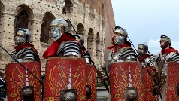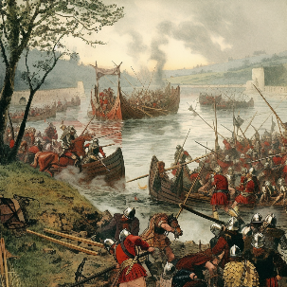

**Homework**

**Maths**

As Year 4 are tested for the national Multiplication Tables Check in June, it is essential that your child practises their tables to 12 x 12. Logging onto Times Table Rock Stars will help your child learn their tables and improve their recall. Please ask staff if your child needs help logging on.

**English**

Your child will receive a list of spellings on a Friday to practise. They will be tested on these words the following Friday.

Please listen to your child read (either their school book or a book of their choice) and sign their reading record at least once a week.

PE Kit

PE for Michael Morpurgo class will be on **Thursdays** and children can come to school in their PE kit on that day. Please ensure your child has the correct kit at all times.

**Remembrance Week**

**During the first week back, we will be focussing on Remembrance, particularly the role of women during the First World War.**

In English:

We will be reading ‘Escape from Pompeii’ by Christina Balit

As readers we will be...

- visualising settings

- responding with drama

- retrieving and inferring

- empathising with characters

As writers we will…

- use expanded noun phrases, powerful verbs and prepositions to describe settings

- write a descriptive retell of the story from the main character’s point of view.

- use a range of punctuation, including speech punctuation

- organise our work using paragraphs

- proofread and edit our work

*How could you help your child at home?*

Please read with your child at home and sign their Reading Journal weekly when you have done so.

TT Rockstars will really help your child with their timestables and is a fun way to learn and take part in challenges with friends.

In Maths:

We will be...

* continue to build our understanding of place value of numbers to 10,000
* practising all times tables with a particular focus on 3s, 6s and 9s.
* calculating perimeter
* practising our arithmetic skills

If you have any queries, please contact the class teacher, Mrs Taylor.

Our other learning:

In Computing, we will be learning all about audio media. We will be recording, editing and producing our own sound media.

In R.E, we will describe different festivals and understand the reasons for each one

In PSHE, we will be learning about valuing differences, negotiation and compromise.

In PE, we will learning and practising football skills.

In Art, we will be drawing and exploring proportion.

Revolutionary Romans – What Impact Did the Romans Have on Britain?

Michael Morpurgo Class

How can you help your child at home?

Encourage them to talk about the learning they have been doing at school.

Practise number facts and all times tables.

Listen to them read and ask them about the text.

Help them to practise their weekly spellings.

In History, we will…

Learn about The Roman Empire, its impact on Britain and the power of its army.

Learn about Julius Caesar’s attempted invasion in 55-54 BC.

Find out about successful invasions and conquests by Claudius and conquest, including Hadrian’s wall.

Learn about Boudicca and her resistance to the Roman army.

In Science:

We will…

Identify common appliances that run on electricity

Construct a simple series electrical circuit,

Recognise that a switch opens and closes a circuit

Recognise some common conductors and insulators, and associate metals with being good conductors.