Swain House Primary School

Great Oak Nursery
Admission Policy

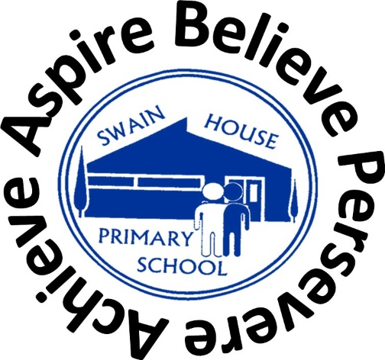

November 2024

Early Education for 3 and 4 year olds
Swain House Primary School is a community school, which seeks to serve the needs of the local community. Our Great Oak Nursery offers part-time and full-time funded places for 3 and 4 year olds.

We understand that making the decision to send your child to a nursery can be a big step for some parents and carers, and it is natural to have some concerns, but what are the benefits of sending your child to a nursery?
- Children develop quickly in their earliest years, and early education supports their development and overall wellbeing
- Research shows that good quality early education and childcare from an early age makes a real difference to how well a child does in the future.
- Early years and childcare settings are wonderful places for your child to learn, develop new skills, make new friends and have fun
- It will also free up your time to support you to take up training, start, or return to work, and support you to reduce your childcare bill

15 hours childcare
All families can get early education for their three or four year old for at least 15 hours a week from a school nursery, pre-school, day nursery, or childminder.

https://www.gov.uk/help-with-childcare-costs/free-childcare-and-education-for-3-to-4-year-olds

Children can access a 15 hour Nursery place the term after their 3rd birthday. You don't need to apply for funding, just find a childcare provider and they will support you to access your child's place.
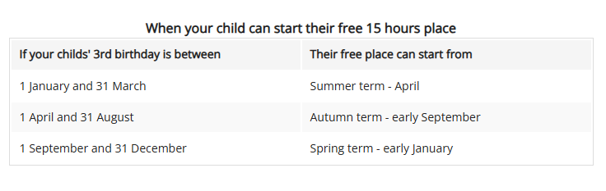

Children will be admitted to Nursery having taken into account the following criteria (which is the same as the City of Bradford MDC’s admissions policy for reception):

- Looked after children and all previously looked after children, including those children who appear (to the admissions authority) to have been in state care outside of England and ceased to be in state care as a result of being adopted

- Children who have exceptional social or medical needs, supported by a written recommendation from the child’s paediatrician/consultant or professional from Children’s Services. The letter must explain why the school is the only suitable school to meet the child’s needs and why no other school could provide the appropriate support for the child

- Sisters and brothers of children living at the same address, who are at present on roll at the school, and will still be attending the school at the time of admission

- All other children

We encourage any interested parents and/or carers to book a visit to Great Oak Nursery.
Parents may telephone the school or visit in person to register their child on the waiting list for the Nursery.

30 hours childcare
30 hours childcare is available to eligible working families of 3 and 4 year olds in England. This is an additional 15 hours on top of the 15 hours available to all parents of 3 and 4 year olds.

Parents can check their eligibility for 30 hours through the childcare calculator and apply for 30 hours and Tax-Free Childcare through the childcare service.

https://www.bradford.gov.uk/children-young-people-and-families/looking-for-childcare/30-hours-free-childcare/

If eligible, parents will receive an 11-digit eligibility code. Before a parent can take up a place they must bring their code, national insurance number and child’s date of birth so we can check that the code is valid.
Every three months parents will need to confirm that the details they entered on their application are up to date.
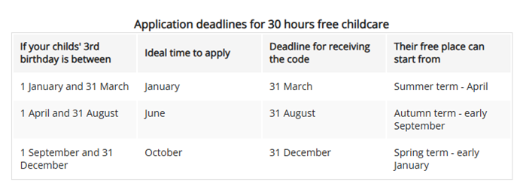

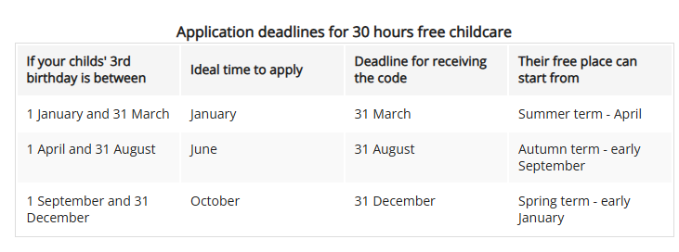

Parents will be notified by letter if their child has been offered a place in the Nursery and asked to come into school to complete the admissions form.

Arrangements will be made for new children to visit Nursery before they formally start. Children are invited to attend stay and play sessions in the Nursery room in the half term prior to them starting.

Nursery children who are on extended holidays or out of the country for some time will be taken off the register after the agreed return date. Therefore this may result in reserved places being lost.

Please note:
The offer of a place at a nursery class attached to a primary school does not guarantee the child a place in the Reception class at the same school. A fresh application will be required in accordance with the criteria for admission to Reception classes.

