

Reception Newsletter
June-July 2025 Summer Term 2
Theme  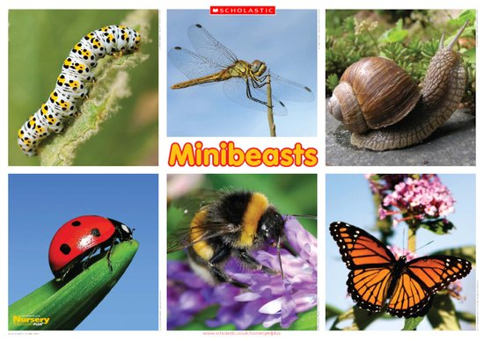  This half term our theme is:  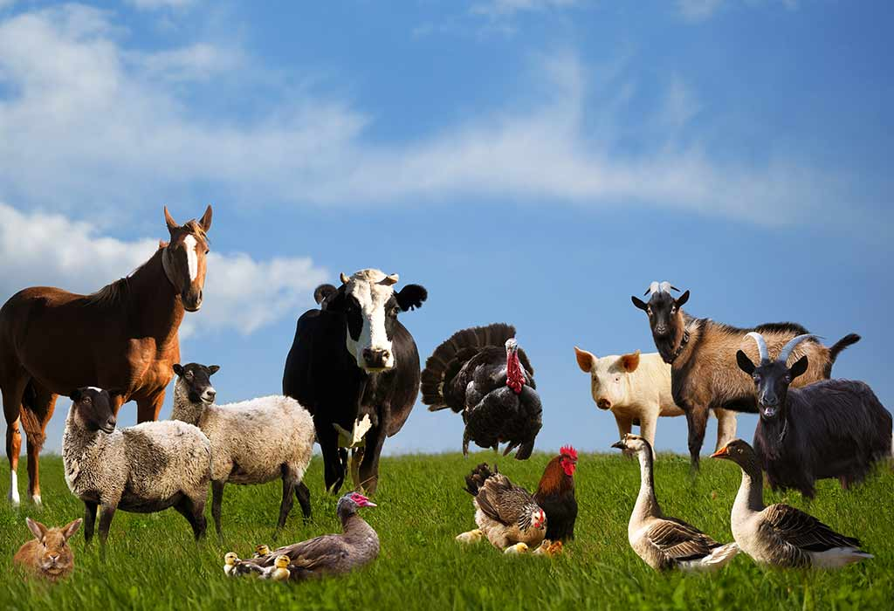  All Creatures Great and Small  In theme this half term we will be:  - Visiting a farm  - Exploring farm animals and their young  - Exploring minibeasts and their habitats  - Learning about the life cycle of a butterfly with special visitors in our class to support with this learning | Phonics and Maths  Phonics  In phonics this half term we will:  - Continue to develop our letter-sound correspondence of new and previously learned sounds including digraphs.  - Blend sounds in longer words in order to read them and start to read short phrases and sentences.  - Segment sounds in longer words and short phrases in order to spell and write them.  - Continue to develop our letter formation.  - Continue to use finger spaces consistently in our writing.  - Start to use capital letters at the start of our sentences and for names and full stops at the end  Maths  In Maths this half term we will:  - Continue to develop our counting and subitising skills within numbers to 10 using a rekenrek  - Continue to compare amount using appropriate mathematical language.  - Consolidate our learning of doubles within 10  - Consolidate our learning of odd and even numbers  - Continue to practise our number facts to pass our Maths Passport objectives.
Dates for The Diary  Weekly dates:  Monday – all books changed (please bring reading books and signed reading records in a bookbag)  Tuesday – PE (Please ensure your child has their P.E kit in school)  Wednesday – Well Done Bear to be returned (1 child each week)  Thursday – Show and Tell (this is for your child to share their achievements and experiences only- Please do not send toys)  Friday – Well Done Bear goes home (1 child each week)  Termly dates:  Monday 2nd June – school re-opens for Summer 2  Wednesday 4th June – Thornton Hall Farm trip  Thursday 19th June – Elm Class Assembly @ 2:30pm  Friday 27th June – Summer Fair @ 4-5:30pm  Thursday 3rd July – Willow Class Assembly @ 2:30pm  Friday 11th July – EYFS fun day @ 1:30-3pm  Monday 14th July- End of Year Reports given to parents  Thursday 17th July- Summer Disco 5-6:30pm  Friday 23rd May – school closes for summer holidays (re-opens Tuesday 2nd September) | Reminders and Contact Information  Enhancement fund (snack money):  Please give cash to a member of the Reception team in a named envelope  - £3.50 per half term or £20 for the year.  What your child needs in school:  A water bottle  Their school book bag (including reading book and reading record)  A spare change of clothing in a small bag to leave on their peg  A P.E kit in a small bag to leave on their peg  A pair of wellington boots to leave at school  A waterproof suit to leave on their peg    Please name all items to help prevent them being misplaced.  Contact  If you have any questions or concerns please speak to a member of the Reception team on the door at drop off or pick up times.  You can also email the Reception team at reception@swainhouse.bradford.sch.uk and a member of staff will get back to you as soon as possible.

