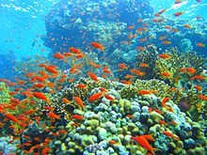  Our theme this half term is called  Elm Class  All Creatures Great and Small  Extreme Habitats |  | 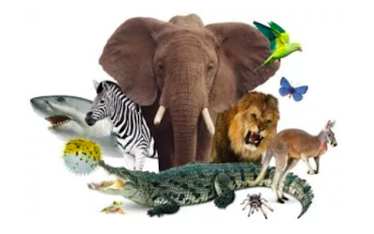
In Literacy we will be:  • Reading fiction and non-fiction books about animals from hot and cold climates  • Predicting, discussing and answering questions about characters and story events  • Practising and using our phonics knowledge to read new words, captions and sentences  • Practising forming our letters correctly using the  tripod grip  • Writing captions and sentences for pictures | Class Information  Please continue to share your child's reading book with them and sign their reading record at least once a week so your child can achieve yellow or green on their pupil mentoring sheet. The time you spend listening to your child read is invaluable and makes a huge difference to their progress.  Snack money this half term is £3.50. Please pay  a member of the Reception team.  Any homework will be sent on a Friday and we ask it is returned on the following Wednesday.  Please clearly label all your child's clothing. | In our theme lessons we will be learning about animals from hot and cold climates  We will be learning about:  • Hot and cold places and which animals live there  • Maps and how to use them to locate where animals from  Africa, Antarctica and the Arctic live  - Comparing where we live in Bradford with Africa/ Antarctica and the Arctic  How could you help your child at home?  • Encourage your child to talk to you about what they have learned at school  • Look at pictures and books of animals and talk about what they can see  • Support your child in writing their full name independently  • Go on a Spring walk and talk about the seasonal changes  • Encourage your child to share their reading book at home and read together at least 3 times a week  - Play some of the games shown on the phonics PowerPoint on the website.  (www.ictgames.com/literacy and PhonicsPlay  - Practise forming numbers to 10
Our Core books this half term are:
- ‘What the Ladybird Heard’ by Julia Donaldson
- ‘Elmer’ by David McKee

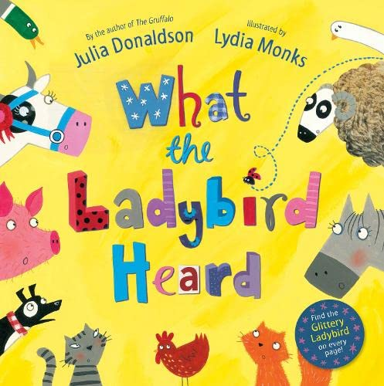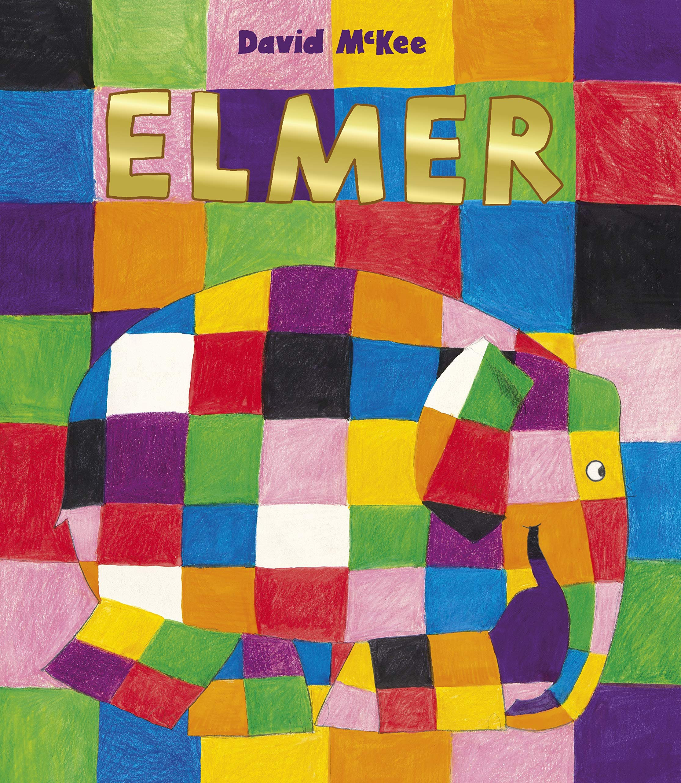

In PSHE we will be learning about:

• Bouncing back when things go wrong
• Healthy eating
• Getting a good night’s sleep
• Keeping our body healthy
• Keeping our mind healthy

In Numeracy we will be learning about:
- Subitising beyond 5 – To recognise the number of objects in a group without counting
- Composition of numbers to 10– How numbers are made
- Comparison of numbers- which number is more/ less
- Counting, ordinality, cardinality

