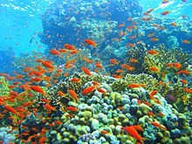  Our theme this half term is called  Elm Class  All Creatures Great and Small |  | 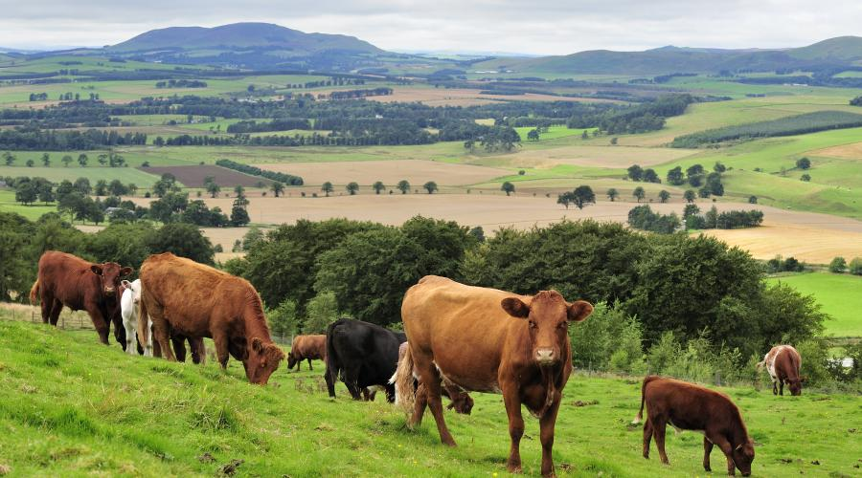
In Literacy we will be:  • Reading fiction and non-fiction books about farm animals and minibeasts  • Predicting, discussing and answering questions about characters and story events  • Practising and using our phonics knowledge to read new words, captions and sentences  • Practising forming our letters correctly using the  tripod grip  • Writing captions and sentences for pictures | Class Information  Please continue to share your child's reading book with them and sign their reading record at least once a week so your child can achieve yellow or green on their pupil mentoring sheet. The time you spend listening to your child read is invaluable and makes a huge difference to their progress.  Snack money this half term is £3.50. Please pay  a member of the Reception team.  Any homework will be sent on a Friday and we ask it is returned on the following Wednesday.  Please clearly label all your child's clothing. | In our theme lessons we will be learning about animals that live on the farm and minibeasts  We will be learning about:  - Farm animals and their young  • The life cycle of a chicken,  • How our chicks hatch and grow  • Minibeasts and their habitats  • Life cycle of a butterfly  How could you help your child at home?  • Encourage your child to talk to you about what they have learned at school  • Look at pictures and books of animals and talk about what they can see  • Support your child in writing their full name independently  • Go on a Summer walk and talk about the seasonal changes  • Encourage your child to share their reading book at home and read together at least 3 times a week  - Play some of the games shown on the phonics PowerPoint on the website.  (www.ictgames.com/literacy and PhonicsPlay  - Practise forming numbers to 10
Our Core books this half term are:
- ‘Handa’s Surprise’ by Eileen Browne
- ‘Monkey puzzle’ by Marta Altés

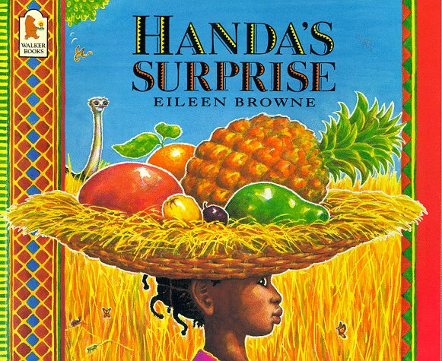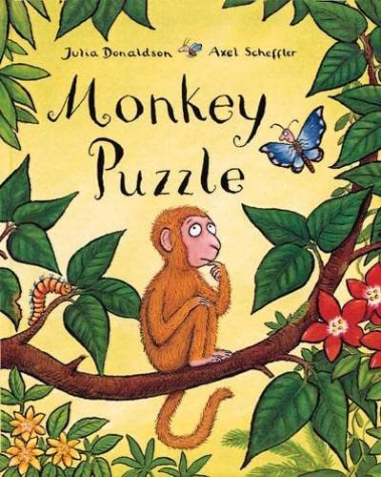
In PSHE we will be learning about:
- Seasons
- Life stages - plants, animals, humans
- Life Stages: Human life stage - who will I be?
- Getting bigger
- Me and my body - girls and boys

In Numeracy we will be learning about:
- Subitising – To recognise the number of objects in a group without counting
- Composition of numbers to 10– How numbers are made
- Comparison of numbers- which number is more/ less
- Counting, ordinality, cardinality
- Patterns within numbers to 10- evens and odds, double facts, and how quantities can be distributed equally

