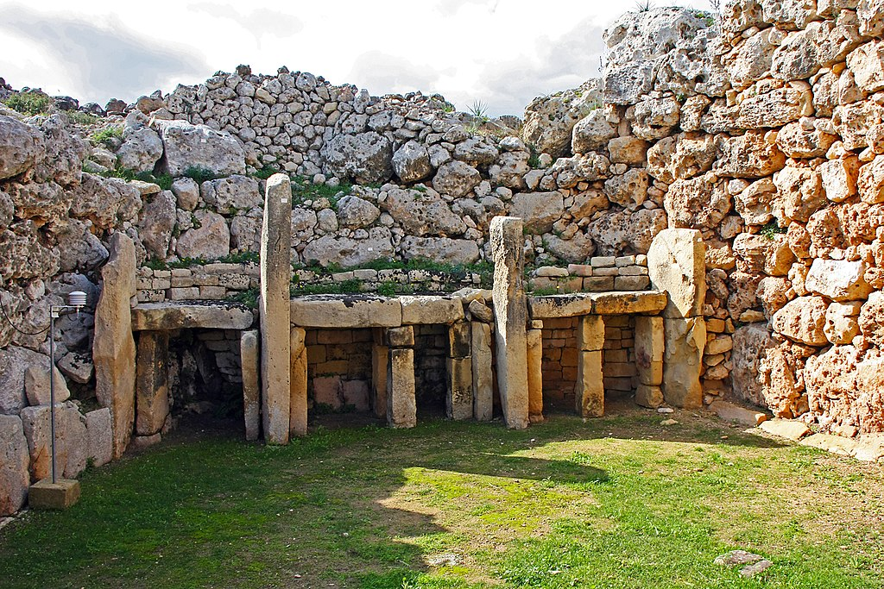
Roald Dahl Class

We are continuing with our theme ‘How did Early People go from Surviving to Thriving?’
This half term we will be looking more closely at the Bronze Age and Iron Age.
English  As readers we will:  Make predictions about a text  Read whole books to improve our comprehension skills.  Use dictionaries and thesaurus to learn new vocabulary.  Be able to identify and use features of non-fiction texts.  Increase our understanding of grammar.  Practise and use our phonics to read unfamiliar words. | Class Information  P.E will be on a Wednesday this half term.  Please ensure your child keeps the correct P.E. kit in school all the time and that all items are labelled.  Please make sure your child has a water bottle to use in school.  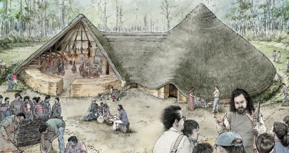  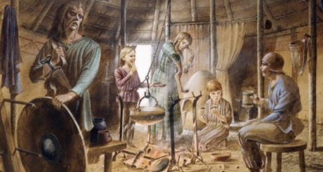 | Theme  As historians we will learn:  About the changes from the Stone Age to the Iron Age  As designers we will be:  Researching, designing and creating our own wearable technology.  As scientists we will learn to:  Understand that we need light to see and that darkness is the absence of light  Understand that light is reflected from different surfaces  Explain how shadows are formed  Investigate how the size of a shadow changes  Computing –We will be learning to use branching databases  PE – We will be developing flexibility, strength, technique, control and balance in gymnastics  R.E. – We will be learning what spirituality is and how people experience it  Music - Begin to recognise styles, find the pulse, recognise instruments and listen to and discuss other dimensions of music.  French – We are learning to say the days of the week, to count to 20 and to say the names of countries.
As writers we will:
Use our phonic knowledge to improve our spelling.
Use paragraphs with subheadings.
Use conjunctions in our writing.
Improve our work through careful editing.
Develop the formation of our joined handwriting.
Write a non-chronological report and an encyclopaedia entry.
Maths  As mathematicians we will learn to:  Practise our x2, x5, x10, x3 x4 and x8 times tables and division facts.  Use partitioning methods to add and subtract mentally.  Use a written method to add and subtract. | Resources  If you have any objects, books or information that might help us with our topic we would love to know about them!  If you have any talents or skills that may help us please share them to help us with our learning. | How could you help your child at home?  Encourage your child to talk about the learning they have been doing at school.  Ensure your child works on their Passport objectives (these can be found in the back of their homework book).  Give opportunities for your child to practise their handwriting and spellings.  Practise reading with expression.  Listen to your child read their Bookshelf Passport book.  English  As readers we wil  Improve our reading skilsl thorough learning new  • To read two stories that deal with themes of overcoming worries and facing fears  • To compare and describe characters  • To write a letter  • To write an extended story  How could you help your child at home?  Read and talk about stories.  Talk about the characters in a story and describe their appearance and how they behave.  Look at how letters are written.
Homework
Homework will be sent home every Friday and should be returned to school by the following Wednesday. Please read with your child each week and write a comment and sign their Reading Record.

