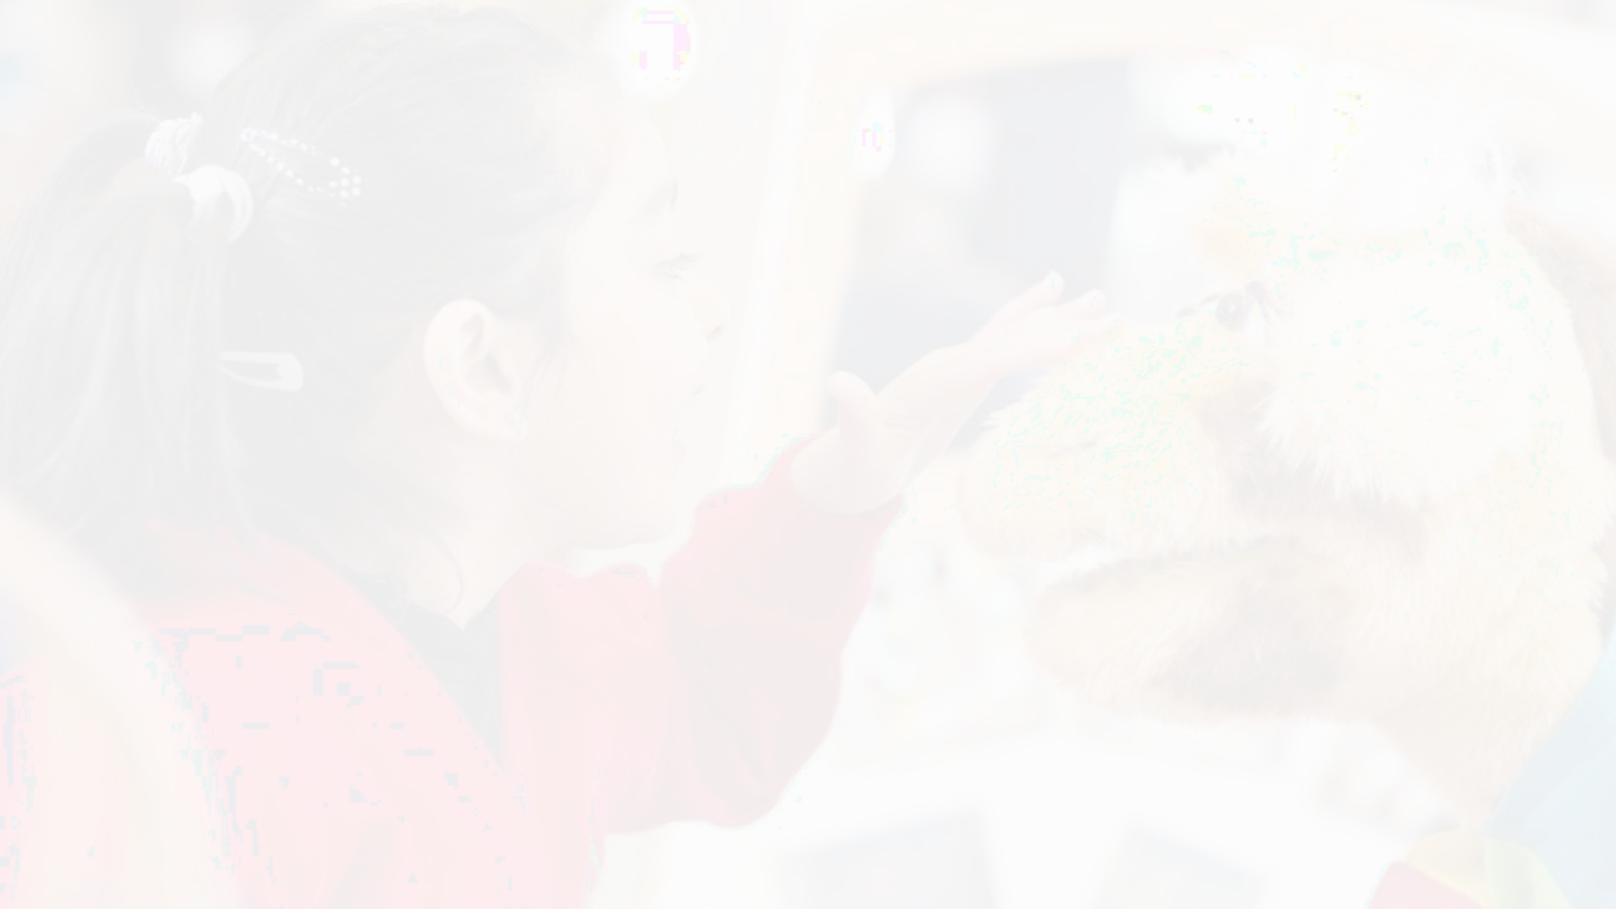
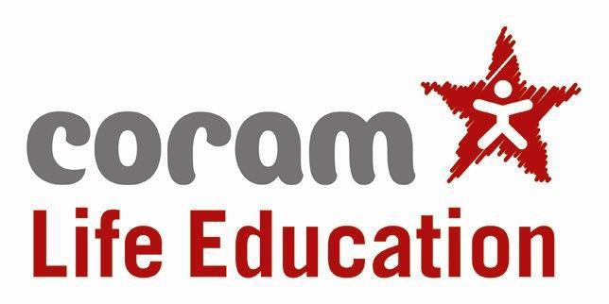
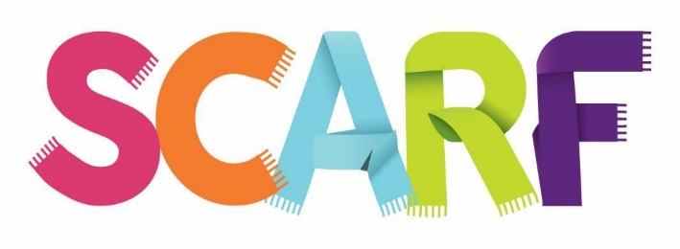


Coram Life Education
Helping Children Make Healthy Choices

coramlifeeducation.org.uk

@CoramLifeEd

@CoramLifeEducation

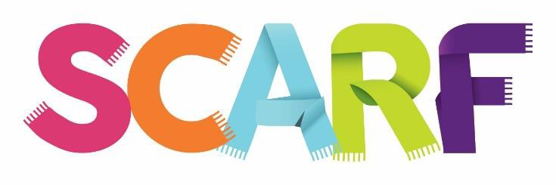

What is Relationships Education?

Relationships Education in primary schools should teach the fundamental building blocks and characteristics of positive relationships, with particular reference to friendships, family relationships, and relationships with other peers and adults. At Coram Life Education we believe that children should learn about relationships as well as the emotional, social and physical aspects of growing up, human sexuality and sexual health, in an age-appropriate way. This goes beyond learning about relationships, to include puberty, how a baby is conceived and born, body ownership, and safeguarding. Although we refer to our resources as our Relationship Education programme, they also include elements of Health Education as well as non-statutory sex education. Therefore we often refer to the content as RSE: Relationships and Sex Education.

Our RSE lessons are a key part of SCARF – our programme and resources for schools which provides much more than a PSHE scheme of work. SCARF provides the framework for a whole- school approach to improving children’s wellbeing and attainment, based on the five SCARF values of safety (S),caring (C),achievement (A), resilience (R) and friendship (F).

Our Relationships and Sex Education resources help children and young people to be safe, healthy and happy as they grow, and in their future lives. Delivered as part of PSHE (England) RSHP (Scotland) or Science, they help schools meet their current SMSC development, safeguarding, and emotional wellbeing requirements, as well as ensuring that they meet the requirements of the DfE Primary Relationships, Sex and Health Education Curriculum, and National Curriculum Science from 2020. In the following pages you will see how our programme builds each year, introducing each theme in an age-appropriate way.

© Copyright Coram Life Education SCARF resources Editable version V1.3

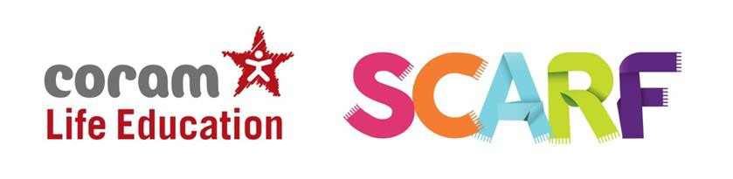

Reception content
- Seasons and change
- Life stages in plants, animals and humans
- Where do babies come from?
- Getting bigger
- Me and my body
- Looking after my special people
- Looking after my friends

Sample Learning Activities
- Role-play how you can help your special people at home
- Read a book together about getting bigger
- Using the pairs cards, match up the baby animal with its adult equivalent
- Invite a midwife in to talk about her job
- Draw pictures of a friend. At the bottom of the picture write how they look after that friend or how their friend looks after them

Year 1 content

Extending learning from Reception
New content includes:
  - Our special people
  - Caring behaviour
  - Respecting others
  - Safe touch
  - Unsafe secrets
  - Friendship
  - Communication
  - Bullying
  - Boundaries
  - Privacy including naming genitals
  - Feelings

Sample Learning Outcomes
- Recognise and name some of the qualities that make a person special to them
- Identify simple qualities of friendship
- Identify things they could do as a baby, a toddler and can do now
- Explain the difference between appropriate and
inappropriate touch
- Identify who they can talk to if they feel uncomfortable about any secret they are told, or told to keep
- Identify parts of the body that are private

Year 2 content

Extending learning in Y1
New content includes:
  - How my behaviour (positive or
negative) affects others
  - Becoming more independent
  - Keeping themselves and others safe
  - Growing from young to old and how people’s needs change

Sample Learning Outcomes
- Identify some of the ways that good friends care for each other
- Know and use words and phrases that show respect for other people
- Explain where someone could get help if they were being upset by someone else’s behaviour
- Identify situations in which they would need to say 'Yes', 'No', 'I'll ask', or 'I'll tell', in relation to keeping themselves and others safe.
- Identify the types of touch they like and do not like

Year 3 content

Extending learning in Y2
New content to include:
  - Change including bereavement
  - Images in the media
  - Protecting personal information online
  - Different types of relationships
  - Healthy and unhealthy relationships (friendships)
  - Discrimination and its consequences
  - Understanding risk
  - Making informed choices
  - Resisting pressure

Sample Learning Outcomes
- Explain some of the feelings someone might have when they lose something important to them
- Recognise and describe appropriate behaviour online as well as offline
- Identify when it is appropriate or inappropriate to allow someone into their body space
- Recognise who they have positive healthy
relationships with
- Recognise that repeated name calling is a form of bullying

Year 4 content

Extending learning in Y3
New content to include:
  - Body changes in puberty – boys and girls taught separately about the changes to their bodies
  - Conflicting emotions
  - Good and not so good feelings
  - Marriage and other relationships
  - Consequences of our actions
  - Recognise and challenge stereotypes
  - Pressures to behave in an unacceptable, unhealthy or risky way

Sample Learning Outcomes
- Understand and explain why puberty happens
- Suggest reasons why young people sometimes fall out with their parents
- Discuss the reasons why a person would want to be married, or live together, or have a civil ceremony
- Define what is meant by 'being responsible‘
- Understand and identify stereotypes, including those promoted in the media
- Understand that we can be influenced both positively and negatively

Year 5 content

Extending learning in Y4
New content to include:
  - Body changes and feelings during puberty
  - Changing feelings and the effect on those we live with
  - Unhealthy relationships
  - Risky behaviour
  - Using social media safely
  - Types of bullying including homophobic
  - Keeping personal information private online

Sample Learning Outcomes
- Identify some products that they may need during puberty and why
- Recognise some of the feelings associated with feeling excluded or ‘left out’
- Identify what things make a relationship unhealthy
- Explore and share their views about decision making when faced with a risky situation
- Recognise that people aren’t always who they say they are online
- Recognise that some people can get bullied because of the way they express their gender
- Know how to protect personal information online

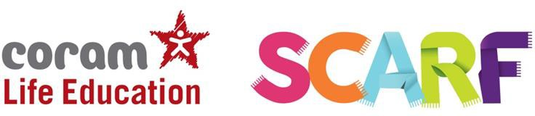

Year 6 content

Extending learning in Y5 New content to include:
  - Body image
  - Sharing images online
  - Forced marriage
  - Conception, reproduction & birth
  - HIV

Sample Learning Outcomes
- Recognise that photos can be changed to match society's view of perfect
- Explore the risks of sharing photos and films of themselves with other people directly or online
- Describe ways in which people show their
commitment to each other
- Know a variety of ways in which the sperm can fertilise the egg to create a baby
- Explain how HIV affects the body’s immune system

