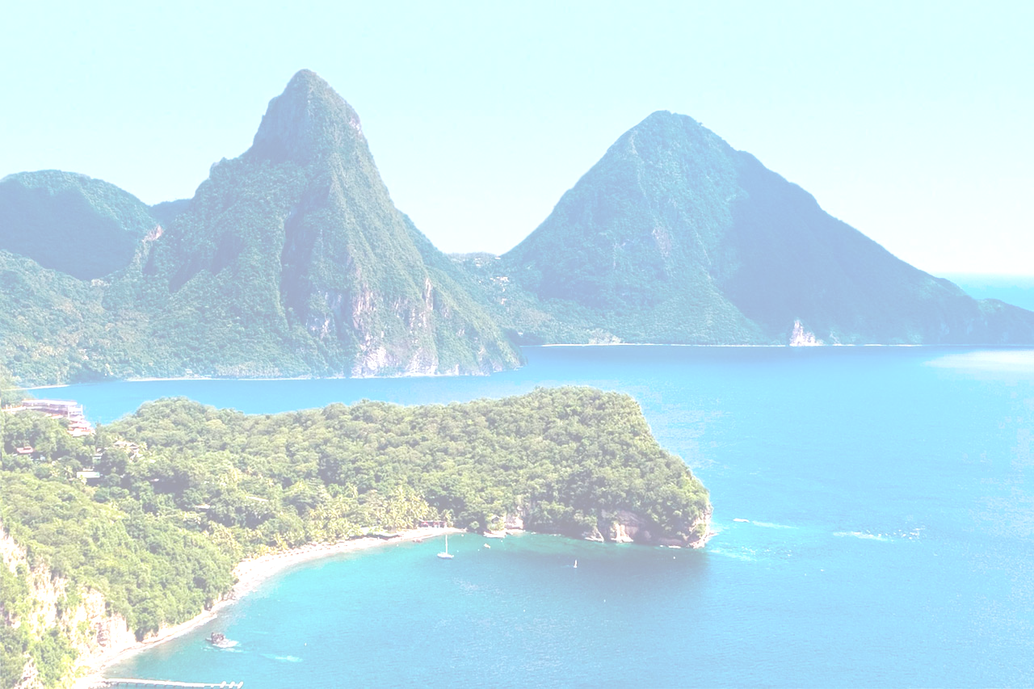
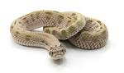
Down in the Carribean
Lowry Class
In this topic, we will be learning about St Lucia, including plants and animals.
English  As readers we will be:  Learning new spelling patterns and rules.  Reading non-fiction books, thinking about their features and creating our own.  Building our reading stamina and comprehension skills – using different question stems. Who? How? Where? Why? When?  Working on our fluency – the aim is to read 90 words a minute!  Developing our love for reading and comprehension skills. | Class Information  PE will be on a Monday. We will be focusing on cricket.  Please ensure your child keeps the correct P.E. kit in school – hopefully we will be doing more PE outside!  Please make sure your child has a water bottle, with their name on, to use in school.  On warm days, please ensure your child is wearing sun cream and has a sun hat with them.  Please speak to any of the Year 2 staff if you have any questions – we are always here to help. | Topic  As Geographers we will be: using world maps, atlases and globes to locate places. We will be thinking about continents, countries and oceans. We will be looking at human and physical features of a place using aerial maps. We will be identifying seasonal and daily weather patterns of a hot place.  As scientists we will learn about: different types of plants and what they need to grow. We will be finding out about different types of plants in our local area and in the rainforest of St Lucia.  In other subjects we will be:  Computing – Understanding what algorithms are, how they are implemented as programs on digital devices and that programs execute by following precise instructions. We will be creating and de-bugging simple programs and use logical reasoning to predict the behaviour of simple programs.  Art – We will be focusing on sculpture and making clay houses. We will explore clay, learn how to make a pinch pot and join clay shapes together, use impressing and joining techniques and plan and make a 3D clay tile.  PSHE – We will be focusing on ‘Being my best’. We will look at keeping healthy, a growth mindset, goal setting, achievements, feelings and resilience.  RE – We will be answering the questions: How can we look after our planet?  Music – This half term, our learning will be based around a ‘friendship song’. We will continue to listen and practise a variety of songs and improve our skills at playing the recorder and glockenspiels. We will also be composing our own music.
As writers we will:
Write expanded noun phrases using full stops and capital letters in the correct place.
Use a variety of punctuation ( . ? ! , ‘ ) .
Use a range of conjunctions and contractions.
Use the 4 sentence types (statements, commands, questions and exclamation sentences).
Use our phonic knowledge and spelling patterns to spell words correctly.
Continue to develop our letter formation to ensure our letters are formed correctly.
Spell the half-termly Common Exception words correctly.
Maths  As mathematicians we will:  Focus on multiplication and division by grouping and sharing numbers.  Work hard on our times tables and doubling and halving numbers.  Learn about 2D and 3D shapes, including their properties.  Learn to explain our understanding, thinking and reasoning.  Learn our 2, 3, 5 and 10 times tables and the division facts for these. | Homework  Spellings will be given out every Friday, to be learnt at home for a spelling test the following Friday.  There will be no homework books sent home, instead, we would like you to focus on Numbots, Lexia and reading. Log in details can be found in your child’s reading record book.  Read with your child at least 3 times a week. Remember to write a comment and sign their Reading record book at least once a week. – this is part of our homework policy and will be part of their pupil mentoring form. | How could you help your child at home?  Discuss a map of the world. What are the 7 continents of the world? Can you name the oceans? Which continent do we live in? Where is St Lucia on the map?  Research St Lucia. Think about: Where is St Lucia? How would you get there? What is the weather like? What would you do in St Lucia? Which animals would you find in a tropical place? Compare St Lucia with Bradford.  Think about how bananas grow and how they get to our supermarkets.  Research plants you would find in an English woodland and a tropical place.  Research plants and mini beasts that grow and live in the rainforest – using magazines and news articles, books and the internet.  Do you know how to tell the time? - Learn to tell the time by 5 minutes.

