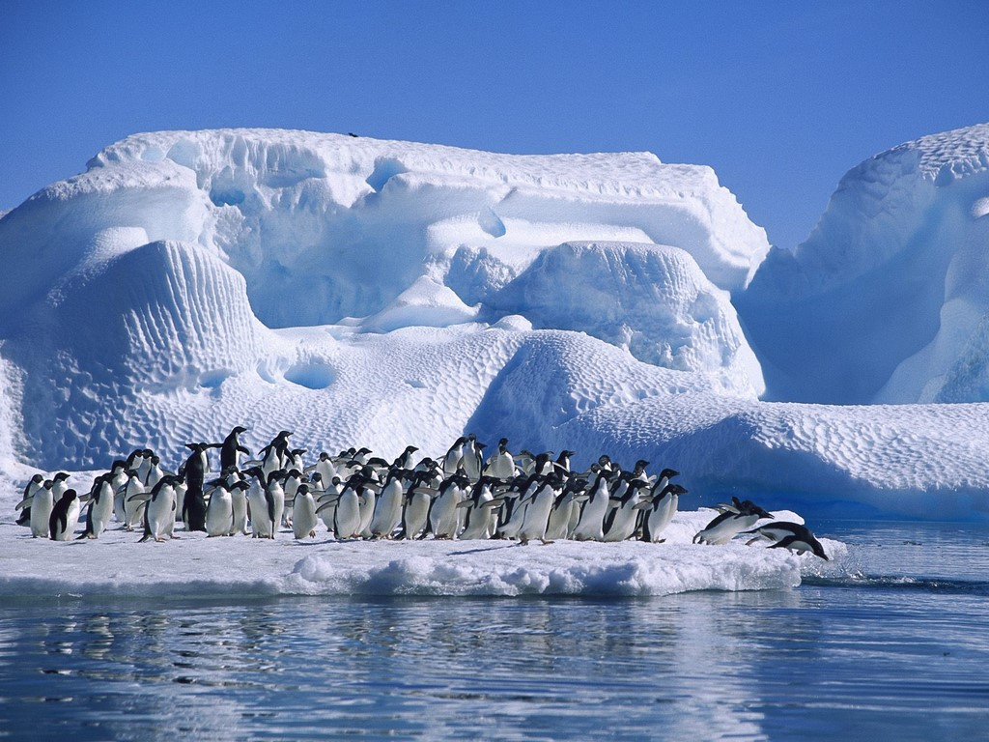
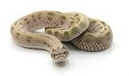
Poles Apart This half term, we will continue our learning about the Arctic and Antarctic
English  As readers we will be:  - Practising and using our phonics to read new words  - Reading the story: Penny Dreadful and the Rat and a non-fiction book about Polar Bears.  - Answering questions where we can find the answer in the text and questions where we have to think more about how the character is feeling or behaving. | Class Information  Van Gogh Class  PE will be on Mondays and Fridays. This half-term our PE is gymnastics and games  Please ensure your child keeps the correct P.E. kit in school.  Please remember your book bag, reading book and water bottle every day.  If you have any queries please do not hesitate to come and speak to us. We are always happy to help! | Theme  As Historians we will be: finding out about Roald Amundsen and Robert Scott and their Antarctic expedition. We will also be looking at more recent visits made to the Arctic and Antarctic.  As Geographers we will be: locating the Arctic and Antarctic using world maps. We will be thinking about continents, north and south hemispheres, the equator and weather. We will be looking at features of the Arctic and Antarctic and comparing them with where we live.  As scientists we will learn about: Life processes and understanding living, non-living and never been alive. Different habitats and what they provide We will also focus on the different types of animals that live in each habitat and why.  In RE we will be answering the big question:  How and why do we pray? We will also learn about Easter and why it is a special time for Christians. We are also going to visit a church.  In other subjects:  Computing – We will be focussing on data and information.  DT – We will be focussing on mechanisms.  PSHE – We will be focusing on rights and respect.  Music – We will be learning a reggae song called ‘Zootime’. We will also be learning how to play the recorder and glockenspiel. We will also be composing our own music.
As writers we will:
- Write statements, questions, commands and exclamation sentences
- Use a range of conjunctions to join sentences – and, but, because, or, when
- Spell the Spring common exception words correctly
- Continue to develop our letter formation to ensure our letters are formed correctly and we are using our joined handwriting
- Write letters, stories and a report
- Describe characters and settings using expanded noun phrases
- Add suffixes to spell longer words
Maths  As mathematicians we will learn to:  - Count forwards and backwards in 1s, 2s, 3s, 5s and 10s and linking this to our multiplication and division facts  - Use skip counting for multiplication and division  - Add and subtract using pictorial representations  - Add and subtract money  - Recognise coins and represent totals in different ways  - Understand fractions – half, quarter and a third  - Use mathematical vocabulary to explain our understanding and thinking  - Tell the time using half past and quarter past/to | Homework  Spellings will be given out every Friday, to be learnt at home for a spelling test the following Friday.  There will be no homework books sent home, instead, we would like you to focus on Numbots, Lexia and reading. Log in details can be found in your child’s reading record book.  Read with your child at least 3 times a week. Remember to write a comment and sign their Reading record – this is part of our homework policy and will be part of their pupil mentoring form.book at least once a week. | How could you help your child at home?  Research the Arctic and Antarctic – magazine and news articles, books and the internet.  Think about: Where is the Arctic and Antarctic? How would you get there? Who might live there? What would you do in the Arctic/Antarctic? Which animals would you find in the Arctic and Antarctic? What kind of house would you live in?  Find out about different expeditions that have taken place to the Arctic and Antarctic. What challenges did they face and how did they overcome them?  Please can you help your child to learn how to tell the time. By the end of Year 2, your child is expected to be able to tell the time by the hour, half past, quarter past and to and by the nearest 5 minutes.

