Van Gogh Class
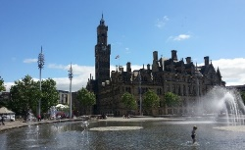
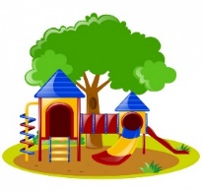
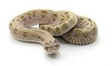

Proud to be from Bradford – A Walk in the Park
In this theme we will be learning about the history of Peel Park and other local parks in Bradford.
English  As readers we will:  Read stories and re-tell them through drama.  Think about the characters and how they overcome  their problems.  Improve our comprehension skills.  Practise and use our phonics to read new words.  Ensure we know the Year 1 common exception words. | Class Information  PE will be on Tuesday this term.  Our focus will be Dance this term.  Please ensure your child keeps the correct P.E. kit in school.  Please can you ensure all items of clothing are labelled with your child’s name.  If you have any queries please do not hesitate to come and speak to us. We are always happy to help! | As geographers we will be:  We will be focussing on the United Kingdom, naming and locating the four countries and their capital cities. We will also be talking about the location of Bradford and using compass points.  As historians we will be looking at the following questions:  Why was the opening of Peel Park historic?  Why is it called Peel Park?  Why is Bradford famous for factories and mills?  Why was Robert Peel’s factory act in 1844 significant?  Why doesn’t Titus Salt have a park named after him in Bradford?  As scientists we will learn about:  We will be focusing on materials and their properties and will be carrying out experiments thinking about waterproof materials.  As artists we will be:  Focussing on craft and design: Map it out. We will create a piece of art that represents our local area using a map of Peel park as our stimulus.  In RE we will be looking at:  How new life is welcomed.
As writers we will:
Write simple and interesting sentences using full stops and capital letters.
Use prefixes and suffixes in our writing including ‘un’, ‘er’, ‘ing’ and ‘ed’.
Use conjunctions ‘and’ and ‘because’ to join sentences.
Improve the formation and start to join our handwriting.
Use our phonics knowledge to improve our spelling.
Write recounts and stories.
Ensure we can spell the Year 1 common exception words.
Maths  As mathematicians we will learn to:  Recognise, read and write numbers to 100  Know that 1 ten is equivalent to 10 ones and multiples of 10 can be represented using their names or numerals.  Counting forward and backwards in 10s  Know facts for the numbers within 10.  To add three numbers together and choose the most efficient order.  Adding two numbers that bridge the 10s boundary using the ‘make 10’ strategy.  Subtract across the tens boundary. | Homework  Homework this year will be a little different.  Spellings will be given out every Friday, to be learnt at home for a spelling test the following Friday.  There will be no homework books sent home, instead, we would like you to focus on Numbots, Lexia and reading. Log in details can be found in your child’s reading record book.  Further information will be sent out later this week.  Read with your child at least 3 times a week. Remember to write a comment and sign their Reading record – this is part of our homework policy and will be part of their pupil mentoring form. | How could you help your child at home?  Talk about what they have learned in school.  Read a range of stories at home and ask questions about what you have read.  Learn to count forwards and backwards in 2s, 5s and 10s.  Please help your child to learn how to tell the time – this is key in Year 2. This half term we are focusing on o’clock and half past.  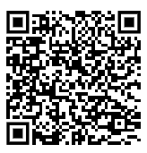  Visit as many parks as you can.  Don’t forget to practice your maths passport facts.  You can find all the objectives on our school website. Here is a link to the page:

