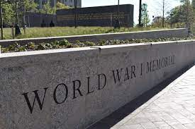
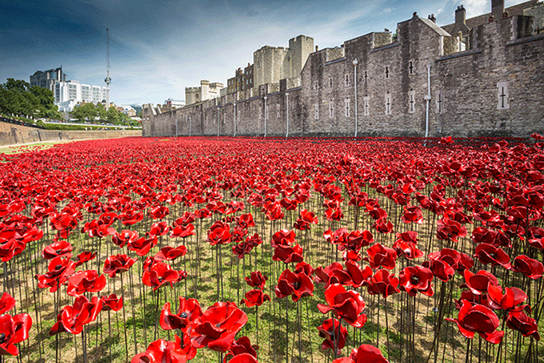
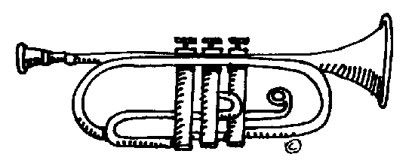
Mozart Class

Bradford Remembers…

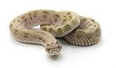
In this theme, we will be learning about the different ways in which we remember the fallen in war.
English  As readers we will be:  Writing a short explanation from the viewpoint of either a soldier delivering a telegram or a family receiving a telegram.  Answering questions about the texts we read focussing on inference and retrieval questions.  Rehearsing and performing a piece of poetry.  Write a short story based on the amination “The Piano” | Homework  Homework is handed out every Friday and must be returned to school or completed online by the following Wednesday.  We are loving reading our Reading Planet books. Please listen to your child read regularly at home. Please also ensure your child has their Reading Planet books in school every day.  Please ensure that your child’s planner is signed weekly as this will be being checked every Wednesday.  Don’t forget we will be doing trumpets in class every Monday, please give your child chance to practice at home.  PE is every Thursday. Children can wear their P.E kits to school.  Important dates  Our Year 5 Ingleborough Residential is from Wednesday 8th – 10th November and the parents meeting is on Thursday 2nd November. | Theme  As historians we will: be learning about the causation and timeline of the First World War. We will be looking at the ways in which we currently remember the fallen and exploring the important role of women, children and animals in the First World War. We will be learning about the Battle of Somme, the Tomb of the Unknown Warrior and exploring the reasons why we wear poppies to show our respect on Remembrance Sunday.  In computing we will: know that media from different sources (stills, video, graphics, and animation) are used to enhance a presentation or communicate an idea. We will then use what we have learnt to create and edit a short film.  In art we will: be designing and creating our own sculptures as a personal memorial to the fallen in World War I.  As scientists we will: Learn about materials. We will compare different materials and investigate reversible and irreversible materials.  In music: We will learn about music through playing the trumpets.  In French: We will be learning our colours, countries and greetings.  P.E: We will be creating movements and balances in gymnastics.  R.E: We will be exploring why people have different beliefs.
As writers we will:
Use commas to accurately mark clauses.
Use appropriate synonyms to enhance our descriptive writing.
Use parenthesis to add extra information.
Use apostrophes correct for contractions and possessions.
Write emotively Meet our writing targets to improve our writing.
Punctuate speech correctly.
Maths  As mathematicians we will:  Practise our methods for addition, subtraction, multiplication and division.  Improve our mental strategies.  Learn which order we add, subtract, multiply and divide in number sentences.  Solve a range of real life word problems using a range of strategies. | Resources  If you have any objects, books or information that might help us with our history topic we would love to know about them!  Class Information  If you would like to pass a message to a member of the year 5 team or have any queries, please write in your child’s planner or email: year5@swainhouse.bradford.sch.uk  . | How could you help your child at home?  Ensure they complete their homework to the best of their ability.  Allow your child to research the First World War and war memorials for the First World War around the world.  Ensure your child is regularly practising the objectives for their continent/planet in maths – use the Times Tables Rockstars website.  Give opportunities for your child to practise their handwriting and spellings.  Practise reading with expression.  Listen to different types of music.  English  As readers we wil  Improve our reading skilsl thorough learning new  • To read two stories that deal with themes of overcoming worries and facing fears  • To compare and describe characters  • To write a letter  • To write an extended story  How could you help your child at home?  Read and talk about stories.  Talk about the characters in a story and describe their appearance and how they behave.  Look at how letters are written.
