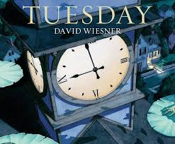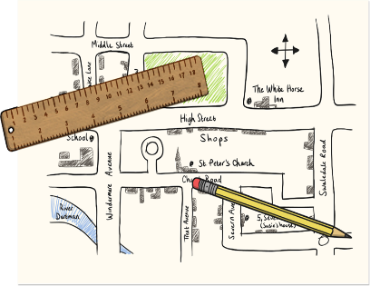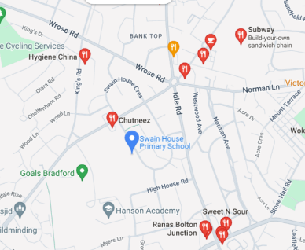

Michael Morpurgo class

If you have any queries, please contact the class teacher, Mrs Taylor.

How can you help your child at home?

Encourage them to talk about the learning they have been doing at school.

Practise number facts and all times tables.

Listen to them read and ask them about the text.

Help them to practise their weekly spellings.

Our other learning:

In Computing we will be focusing on computing systems and networks.

In R.E we will describe different festivals and understand the reasons for each one

In PSHE we will be learning about feelings and what makes a healthy relationship with others.

In PE we will learning and practising hockey skills.

In DT we will be making a slingshot car.

In Maths:

We will be exploring place value ensuring that the children have a clear understanding of the value of each digit.

We will be revising the children’s knowledge of addition and subtraction.

There will be a focus on applying number facts and learning and applying times tables facts.

In English:

We will be studying ‘Tuesday’ by David Wiesner and later using the film clip ‘Dragon Slayer’ as stimuli for our learning.

As readers we will be...

- responding by asking questions

- sequencing events

- responding with drama

- retrieving and inferring from pictures

- empathising with characters

As writers we will…

- use expanded noun phrases, powerful verbs and adverbs to describe characters’ appearance and movement.

- draft and write a sequel to a story

- use a range of punctuation, including speech punctuation

- organise our work using paragraphs

- proofread and edit our work

*How could you help your child at home?*

Please read with your child at home and sign their Reading Journal weekly when you have done so.

TT Rockstars will really help your child with their timestables and is a fun way to learn and take part in challenges with friends.

Geography:

We will use fieldwork to observe, measure, record and present the human and physical features in the local area using a range of methods, including sketch maps and digital technologies.

In Science:

We will…

-identify how sounds are made, associating some of them with something vibrating

-recognise that vibrations from sounds travel through a medium to the ear

-find patterns between the pitch of a sound and features of the object that produced it

-find patterns between the volume of a sound and the strength of the vibrations that produced it

-recognise that sounds get fainter as the distance from the sound source increases

**Homework**

**Maths**

As Year 4 are tested for the national Multiplication Tables Check in June, it is essential that your child practises their tables to 12 x 12. Logging onto Times Table Rock Stars will help your child learn their tables and improve their recall. Please ask staff if your child needs help logging on.

**English**

Your child will receive a list of spellings on a Friday to practise. They will be tested on these words the following Friday.

Please listen to your child read (either their school book or a book of their choice) and sign their reading record at least once a week.

PE Kit

PE for Michael Morpurgo class will be on **Thursdays** and children can come to school in their PE kit on that day. Please ensure your child has the correct kit at all times.

**Do you have any old photographs of the Swain House area in the past?**

**If so, please could you send them into school for us to observe as part of our learning!**

Proud to be from Bradford: Marvellous Maps