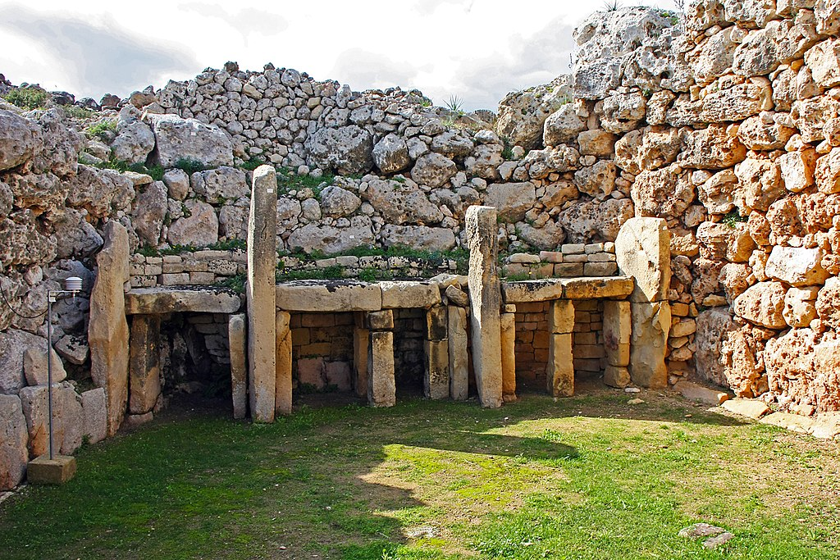
Anne Fine Class

Our new History topic is called ‘Stone Age to Iron Age – How did Early People go from Surviving to Thriving?’
English  As readers we will:  Read whole books to improve our comprehension skills.  Use dictionaries and thesaurus to learn new vocabulary.  Be able to identify and use features of non-fiction texts.  Increase our understanding of grammar.  Practise and use our phonics to read unfamiliar words. | Class Information  PE will be on a Wednesday. Please ensure your child keeps the correct P.E. kit in school all the time. Please make sure your child has a water bottle to use in school.  Homework  Maths  Each week children should log on and complete number facts and times tables practise on Numbots & Times Tables Rock Stars. Logins can be found inside your child’s reading record.  English  Your child will receive a list of spellings on a Friday to practise. They will be tested on these words the following Friday.  Please listen to your child read (either their school book or a book of their choice) regularly and sign their reading record at least once a week.  If you have any queries, please contact your child’s class teacher. | History  As historians we will learn:  When the Stone Age was and how the Stone Age people lived.  As Geographers we will be able to:  Name the four countries that make up the U.K and locate Skara Brae.  As artists we will be:  Using paint to create cave art.  As scientists we will learn to:  Compare and group together different kinds of rocks.  Describe in simple terms how fossils are formed when things that have lived are trapped within rock.  Recognise that soils are made from rocks and organic matter.  Learn about Mary Anning and her contribution to Science  Computing –We will be learning how to debug a series of commands.  PE – We will be learning how to play cricket.  R.E. – We will be learning how people express spirituality through art, music and dance  Music - Begin to recognise styles, find the pulse, recognise instruments and listen and discuss other dimensions of music.  French – We are learning to say hello and goodbye, the colours, days of the week and to say how we are feeling.  Art – We will learn about prehistoric cave art  Use simple shapes to build initial sketches.  Create a large scale copy of a small sketch  Use charcoal to recreate the style of cave artist  How could you help your child at home?  English  As readers we wil  Improve our reading skilsl thorough learning new  • To read two stories that deal with themes of overcoming worries and facing fears  • To compare and describe characters  • To write a letter  • To write an extended story  How could you help your child at home?  Read and talk about stories.  Talk about the characters in a story and describe their appearance and how they behave.  Look at how letters are written.  Encourage your child to talk about the learning they have been doing at school.  Ensure your child works on their Passport objectives (these can be found in the back of their homework book).  Give opportunities for your child to practise their handwriting and spellings.
As writers we will:
Write more complex and interesting sentences using different punctuation marks including inverted commas.
Make predictions about a text
Use our phonic knowledge to improve our spelling.
Use paragraphs.
Use conjunctions in our writing.
Improve our work through careful editing.
Develop the formation of our joined handwriting.
Write a setting description, diary entry and retell a story.
Write an encyclopaedia entry about Stone Age animals
Maths  As mathematicians we will learn to:  Use known facts to solve problems involving partitioning numbers  Use known facts to add or subtract to/from multiples of 100 in tens and ones  Add/subtract multiples of ten bridging 100  Find 10 more or less across any hundreds boundary  Practise our x2, x5, x10, x3 x4 and x8 times tables and division facts. | Resources  If you have any objects, books or information that might help us with our topic we would love to know about them!  If you have any talents or skills that may help us please share them to help us with our learning.

