Roald Dahl Class
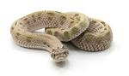
Proud to be from Bradford
Why did Titus Build Saltaire?
This half term we will be learning about Sir Titus Salt and the village of Saltaire.
English  As readers we will:  Read whole books to improve our comprehension skills.  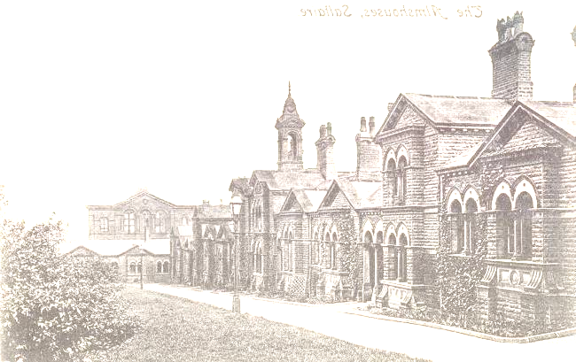  Use dictionaries and thesaurus to learn new vocabulary and  enhance our understanding.  Think about characters and how they overcome their trials.  Increase our understanding of grammar.  Practise and use our phonics to read unfamiliar words. | Class Information  PE will be on a Wednesday  Please ensure your child keeps the correct P.E. kit in school all the time.  Please make sure your child has a water bottle to use in school.  Homework  Maths  Each week children should log on and complete number facts and times tables practise on Times Tables Rock Stars. Logins can be found inside your child’s reading record.  English  Your child will receive a list of spellings on a Friday to practise. They will be tested on these words the following Friday.  Please listen to your child read (either their school book or a book of their choice) regularly and sign their reading record at least once a week.  If you have any queries, please contact your child’s class teacher. | Theme  As historians we will learn:  To develop a chronologically secure knowledge and understanding of local history.  To ask questions about how and why places change over time.  Our focus will be Saltaire and the life of Sir Titus Salt.  As geographers we will learn to:  Name and locate counties and cities of the United Kingdom including geographical regions.  Use maps and atlases to locate countries.  As scientists we will learn:  How to plan investigations; concentrating on fair tests, predictions, methods, results and how to present them.  What makes a balanced diet.  To identify that humans and some other animals have skeletons and muscles for support, protection and movement.  In computing we will learn:  To explain what a digital device is  To identify inputs and outputs  In PE we will be doing: Tag Rugby.  In R.E. we will learn: about God’s covenant with Moses and how Jewish people celebrate today  In DT we will learn:  How climate affects food growth  Which fruit and vegetables grow in the season of Autumn  To follow a recipe  In Music we will learn to:  Listen and respond to a range of music  Play and perform with increasing accuracy, fluency, control and expression.
As writers we will:
Write more complex and interesting sentences using a range
of punctuation.
Enrich our word choice by “borrowing” authors’ words.
Plan what we are going to write about before we begin.
Improve our work through editing carefully.
Develop the formation of our joined handwriting.
Use our phonic knowledge to improve our spelling.
Maths
As mathematicians we will learn to:
Add and subtract numbers across 10
Use the most efficient methods for adding and subtracting across 10.
Read and write numbers to 1000.
Understand the place value of numbers to 1000.
Order, compare and sequence 3-digit numbers.

Resources  If you have any objects, books or information that might help us with our topic we would love to know about them!  If you have any talents or skills that may help us please share them to help us with our learning. |  | How could you help your child at home?  Encourage your child to talk about the learning they have been doing at school.  Ensure your child learns ‘off by heart’ the 2, 3, 4, 5 and 10 times tables and number facts relevant to their maths passport.  Give opportunities for your child to practise their spellings.  Listen to your child read at least once a week.  Encourage them to practise reading with expression and ask questions about what they have read to check their understanding.  English  As readers we wil  Improve our reading skilsl thorough learning new  • To read two stories that deal with themes of overcoming worries and facing fears  • To compare and describe characters  • To write a letter  • To write an extended story  How could you help your child at home?  Read and talk about stories.  Talk about the characters in a story and describe their appearance and how they behave.  Look at how letters are written.

