Elgar Class
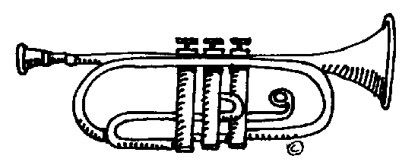

I'm a Victorian Child.... Get me out of here!

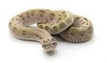
In this theme we will be learning about the life of a Victorian child.
English  As readers we will be:  Reading a classic novel, Street Child by Berlie  Doherty.  Empathising with characters from the story.  Answering detailed questions about a  character’s thoughts, feelings and actions. | Homework  Homework is handed out every Friday and must be returned to school or completed online by the following Wednesday.  We are loving reading our Reading Planet books. Please listen to your child read regularly at home. Please also ensure your child has their books in school every day and that your child’s planner is signed weekly as this will be being checked every Wednesday.  Don’t forget we will be doing trumpets in class every Monday, please give your child chance to practice at home.  PE kits will be used for street dance every Tuesday and for PE every Thursday.  Class Information  If you would like to pass a message to a member of the year 5 team or have any queries, please write in your child’s planner or email: year5@swainhouse.bradford.sch.uk | In History- We will be plotting the Victorian period on a timeline of British History. We will be learning all about the life of Victorian children from rich and poor backgrounds.  As scientists we will able to: identify and describe different forces and the effect they have on different objects.  In Music - We will learn about music through playing the trumpet.  In PE – Netball and street dance We will be learning the positions, passing and shooting techniques in netball and street dancing with our specialist coaches.  In R.E. – We will be exploring the question, ‘Why are certain places, people and times sacred?’  In Design Technology – We will be creating our own pop-up book.  PSHE – We will be focusing on ‘Keeping safe’. We will be learning about how we can evaluate and identify risks.  In Computing: will be introduced to a microcontroller (Crumble controller) and learn how to connect and program components (including output devices- LEDs and motors)
As writers we will:
Be using commas to accurately mark clauses.
Use appropriate synonyms to enhance our descriptive writing.
Write a story based on our class book set in Victorian London.
Be editing and improving our own writing.
Meet our writing targets to improve our writing.
Maths  As mathematicians we will:  Practise our methods for addition, subtraction, multiplication and division.  Solve problems involving area.  Add and subtract unlike fractions.  Convert improper fractions into mixed numbers.  Solve a range of real life word problems using a range of strategies. | Resources  If you have any objects, books or information that might help us with our topic we would love to know about them!  If you would like to help us with our class display and have any Victorian artefacts, we would love to see them. | How could you help your child at home?  Ensure they complete their homework to the best of their ability.  Allow your child to research the Victorian era including the life of children during this time and the difference between rich and poor families.  Ensure your child is regularly practising the objectives for their continent/planet in maths – use the Times Tables Rockstars website.  Give opportunities for your child to practise their handwriting and spellings.  Practise reading with expression.
