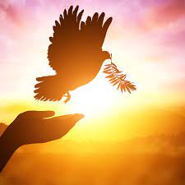
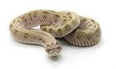
What is peace and why does it matter?
In this theme we will be learning about peace and why it is important.
Willow Class

In Literacy we will be learning:  - New letter sounds and how to write them  - How to hold a pencil and form letters  correctly  - To use our new letter sounds to read  and write simple words  - To write our name independently  - To share and discuss new stories linked to  our topic/Drawing Club  How could you help your child at home?  - Practise reading and writing new letter sounds and high frequency words  - Share books at home and talk about the story  - Practise writing their name | Class Information  Please remember your book bag and water bottle every day.  When your child starts bringing a book home, please share your child’s reading book with them and sign their reading record when you have done this so your child can achieve yellow or green on their pupil mentoring sheet. The time you spend sharing a book with your child is invaluable and makes a huge difference to their progress.  Please put your child’s name in all items of clothing.  Snack money this half term is £3.50. Please pay a member of the reception team; this can be paid in full or weekly. (50p per week).  If you have any queries please contact your child’s class teacher, Miss Nazir. | In our topic lessons we will be learning:  - About peace and why it is important  - About what peace smells, tastes, looks and feels like  - About what peace means and when we feel peaceful  - About conflict and how to resolve it  - About friendship and why it is important to be kind  - About the importance of sharing
How could you help your child at home?
- Go for a peaceful walk and ask your child how it makes them feel. What sounds can they hear? Is it loud or is it quiet?
- Talk about what peace means and why it is important.
- Complete some meditation or relaxing yoga

In mathematics we will be learning to:
- Find out how many objects there are altogether in a set when counting
- Compare the number of objects in two sets
- Explore the composition of numbers to 5- how numbers are made. For example, 5 is made of ‘1 and 4’, or of ‘2 and 3’.

How could you help your child at home?  - Counting everyday objects  - Noticing numbers in the environment  - Use objects at home to represent different numbers  - Practise forming numbers to ten | Any homework will be sent on a Friday and we ask it is returned on the following Wednesday. | Our Core books this half term are:  - ‘Supertato’ by Sue Hedra and Paul Linnet  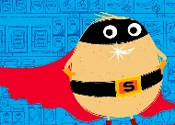  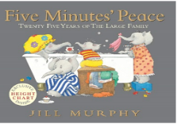  - ‘Five Minutes’ Peace’ by Jill Murphy

