**Swain House Primary School**

**Attendance Policy**



**September 2024**

**This policy will be reviewed in September 2025**

**Contents:**

Statement of intent

1. Legal framework
2. Roles and responsibilities
3. Definitions
4. Attendance expectations
5. Recording attendance
6. Authorised and unauthorised attendance
7. Reducing persistent and severe absence
8. SEND and health-related absence
9. Monitoring and analysing absence
10. Working with parents to improve attendance
11. Staff training
12. Monitoring and review

**Appendices**

1. Attendance Codes

2. Leave of absence request form

3. Half-termly attendance letters

**Statement of intent**

Swain House Primary School believes that in order to facilitate teaching and learning, good attendance is essential. Pupils cannot achieve their full potential if they do not regularly attend school.

We understand that barriers to attendance are complex, and that some pupils find it harder than others to attend school; therefore, we will continue to prioritise cultivating a safe and supportive environment at school, as well as strong and trusting relationships with pupils and parents.

We take a whole-school approach to securing good attendance, and recognise the impact that our efforts in other areas – such as the curriculum, behaviour standards, bullying, SEND support, pastoral support, and the effective use of resources such as pupil premium – can have on improving pupil attendance.

We are committed to:

* Promoting and modelling high attendance and its benefits
* Ensuring equality and fairness for all
* Ensuring this attendance policy is clear and easily understood by staff, pupils and parents
* Intervening early and working with other agencies to ensure the health and safety of our pupils
* Building strong relationships with families to overcome barriers to attendance
* Ensuring parents follow the framework set in section 7 of the Education Act 1996, which states that the parent of every child of compulsory school age shall cause them to receive efficient full-time education suitable to their age, ability and aptitude, and to any SEND they may have, either by regular attendance at school or otherwise
* Regularly monitoring and analysing attendance and absence data to identify pupils or cohorts that require more support
* Regularly inform parents about their child’s levels of attendance, absence and punctuality
* Ensuring that parents are aware of the benefits that regular attendance at school can have for their child educationally, socially and developmentally.

# Legal framework

This policy has due regard to all relevant legislation and statutory guidance including, but not limited to, the following:

* Education Act 1996
* Equality Act 2010
* The Education (Pupil Registration) (England) Regulations 2006 (As amended)
* The Children (Performances and Activities) (England) Regulations 2014
* Children and Young Persons Act 1963
* DfE (2024) ‘Working together to improve school attendance’
* DfE (2023) ‘Keeping children safe in education (KCSIE) 2024’
* DfE (2016) ‘Children missing education’
* DfE (2023) ‘Providing remote education’
* DfE (2024) ‘Summary table of responsibilities for school attendance’

This policy operates in conjunction with the following school policies:

* Child Protection and Safeguarding Policy
* Complaints Procedures Policy
* Behaviour Policy
* SEND Policy
* Supporting Pupils with Medical Conditions Policy
* Social, Emotional and Mental Health (SEMH) Policy

# Roles and responsibilities

The Governing Body has overall responsibility for:

* Monitoring the implementation of this policy and all relevant procedures across the school
* Promoting the importance of good attendance through the school’s ethos and policies
* Arranging attendance training for all relevant staff that is appropriate to their role
* Working with the LMT to set goals for attendance and providing support and challenge around delivery against those goals
* Regularly reviewing attendance data
* Ensuring that this policy, as written, does not discriminate on any grounds, including, but not limited to, ethnicity/national origin, culture, religion, gender, disability or sexual orientation
* Handling complaints regarding this policy as outlined in the school’s Complaints Procedures Policy
* Having regard to KCSIE when making arrangements to safeguard and promote the welfare of children
* Ensuring school staff receive adequate training on attendance

The Headteacher (Designated Senior Leader Responsible for Attendance) is responsible for:

* The overall strategic approach to attendance in school
* Developing a clear vision for improving attendance (in conjunction with LMT)
* Analysing attendance data and identifying areas of intervention and improvement (in conjunction with LMT)
* The day-to-day implementation and management of this policy and all relevant procedures across the school
* Appointing a member of the staff to the Attendance Officers role
* Ensuring all parents are aware of the school’s attendance expectations and procedures
* Ensuring that every pupil has access to full-time education and will act as early as possible to address patterns of absence

Staff are responsible for:

* Following this policy and ensuring pupils do so too
* Ensuring this policy is implemented fairly and consistently
* Modelling good attendance behaviour
* Using their professional judgement and knowledge of individual pupils to inform decisions as to whether any welfare concerns should be escalated
* Where designated, taking the attendance register at the relevant times during the school day

The Attendance Officers (Pastoral Team) are responsible for:

* Monitoring attendance and the impact of interventions
* Communicating with parents with regard to attendance
* Leading a compassionate approach when listening to parents and pupils regarding barriers to attendance
* Following up on incidents of persistent poor attendance
* Enforcing attendance through statutory interventions in cases of persistent poor attendance where other supports have not succeeded
* Informing the LA of any pupil being deleted from the admission and attendance registers
* Liaising with the LA Education Safeguarding Attendance Officer where there are concerns around attendance

The school’s Attendance Officers are Sarah Broadbent and Ellie Armitage, and can be contacted via the school office – 01274 639049 or via email - [office@swainhouse.bradford.sch.uk](mailto:office@swainhouse.bradford.sch.uk)

Pupils are responsible for:

* Attending their lessons and any agreed activities when at school

Parents are responsible for:

* Ensuring that their children of compulsory school age receive a suitable fulltime education (section 7 of the Education Act 21996)
* The attendance of their children at school
* Ensuring their child attends school on time
* Providing accurate and up-to-date contact details
* Providing the school with more than one emergency contact number
* Updating the school if their details change
* Promoting good attendance with their children
* Proactively engaging with any attendance support offered by the school and the LA
* Notifying the school as soon as possible when their child has to be unexpectedly absent
* Requesting leave of absence only in exceptional circumstances, and in advance
* Booking any medical appointments around school where possible
* Following any family-based support implemented by the school to improve attendance

# Definitions

The following definitions apply for the purposes of this policy:

**Absence:**

* Arrival at school after the register has closed (9am)
* Not attending the registered school for any reason

**Authorised absence:**

* An absence for sickness for which the school has granted leave
* Medical or dental appointments which unavoidably fall during school time, for which the school has granted leave
* Religious or cultural observances for which the school has granted leave
* An absence due to a family emergency

**Unauthorised absence:**

* Parents keeping children off school unnecessarily or without reason
* Truancy during the school day
* Absences which have never been properly explained
* Arrival at school after the register has closed (9am) without reasonable explanation
* Absence due to shopping, looking after other children or birthdays
* Absence due to day trips and holidays in term-time which have not been agreed
* Leaving school for no reason during the day

**Persistent absence (PA):**

* Missing 10% or more of schooling across the year for any reason

**Missing education**

* Not registered at a school and not receiving suitable education in a setting other than a school

# Attendance expectations

The school has high expectations for pupils’ attendance and punctuality, and ensures that these expectations are communicated regularly to parents and pupils.

Pupils will be expected to attend school punctually every day they are required to be at school, for the full day.

The school day starts at 8.30am, and pupils will be in their classroom, ready to begin lessons at this time.

Registers will be taken as follows throughout the school day:

* The morning register will be marked by 8.40am. Pupils will receive a late mark if they are not in their classroom by this time. Pupils attending after this time will receive a late mark
* The morning register will close at 9am. Pupils will receive a mark of absence if they do not attend school before this time
* The afternoon register will be marked in Reception and KS1 at 12.45pm and in KS2 at 1.15pm. Pupils will receive a late mark if they are not in their classroom by this time
* The afternoon registers will close at 1pm for Reception and KS1 and 1.30pm for KS2. Pupils will receive a mark of absence if they are not present

Pupils will be encouraged to communicate any concerns related to attendance and absence as soon as possible to the relevant member of staff.

# Recording attendance

**Attendance register**

The school uses SIMs to keep attendance registers to ensure they are as accurate as possible and can be easily analysed and shared with the appropriate authorities.

Designated staff members will take the attendance register at the start of each school day and at the start of the afternoon session. This register will record whether pupils are:

* Present
* Absent
* Attending an approved educational visit
* Unable to attend due to exceptional circumstances

The school will use the national attendance codes to ensure attendance and absence are monitored and recorded in a consistent way – see Appendix 1.

When the school has planned in advance to be fully or partially closed, the code ‘#’ will be used for the relevant pupils who are absent. This code will also be used to record year groups who are not due to attend because the school has set different term dates for different years, e.g. induction days.

Pupils who are absent from school but are receiving remote education for any reason will be marked as absent in the register.

All amendments made to the attendance register will include the original entry, the amended entry, the reason for the amendment, the date of amendment and the name and role of the person who made the amendment.

Every entry received into the attendance register will be preserved for six years.

# Unplanned absence

Where any pupil we expect to attend school does not attend, or stops attending, without reason, the school will:

* Call the pupil’s parent on the morning of the first day of unexplained absence to ascertain the reason. If the school cannot reach any of the pupil’s emergency contacts, a message will be left, asking parents to contact school
* Identify whether the absence is approved or not if contact made
* Call the parent on each day that the absence continues without explanation, to make sure proper safeguarding action is taken where necessary. On the 3rd day, if school have not made contact a home visit will be conducted. If absence continues, the school will consider involving the Education Safeguarding Attendance Officer. If there are other services already involved with the family, a home visit may be conducted earlier
* Where appropriate, offer support to the pupil and/or their parents to improve attendance
* Identify whether the pupil needs support from wider partners, as quickly as possible, and make the necessary referrals
* Provide the LA with the names and addresses of any pupils that school believe will miss 15 days consecutively or cumulatively because of sickness and have been recorded with code I. This is to help school and the LA agree any provision needed to ensure continuity of education for pupils who cannot attend school because of health needs

Parents will be required to contact the school office via telephone before 8.30am on the first day of their child’s absence – they will be expected to provide an explanation for the absence and an estimation of how long the absence will last, e.g. one school day.

The school will not request medical evidence in most circumstances where a pupil is absent due to illness; however, the school reserves the right to request supporting evidence where there is genuine and reasonable doubt about the authenticity of the illness. In these circumstances, the school may ask the pupil’s parent/carer to provide medical evidence, such as a doctor’s note, prescription, appointment card or other appropriate form of evidence. If the school is not satisfied about the authenticity of the illness or reason for absence, the absence will be recorded as unauthorised and parents/carers will be notified of this.

In the case of Persistent absence (PA), arrangements will be made for parents to speak to the Attendance Officers. The school will inform the LA, on a half-termly basis, of the details of pupils who fail to attend regularly, or who have missed 10 school days or more without authorisation.

If a pupil is a PA (attendance below 90%) they will be considered for referral to the Education Safeguarding Team. The Education Attendance Welfare Officer and school staff will then begin a programme of monitoring and support.

Where a pupil has not returned to school for ten consecutive school days after a leave of absence or is absent from school for reasons statistically recorded as unauthorised absence for twenty consecutive school days, the pupil’s name can be removed from the admission register when the school and the local authority have failed, after jointly making reasonable enquiries, to find out the location and circumstances of the child or have succeeded but agree there are no reasonable grounds to believe that they will attend the school again

# 

# Planned absence

Parents will be required to request certain types of absence in advance. All requests for absence will be handled by the Headteacher – the decision to grant or refuse the request will be at the sole discretion of the Headteacher, taking the best interests of the pupil and the impact on the pupil’s education into account. The Headteacher’s decision is not subject to appeal; however, the school will be sympathetic to requests for absence by parents, and will not deny any request without good reason.

**Illness and healthcare appointments**

Parents will be expected to make medical or dental appointments outside of school hours wherever possible. Where this is not possible, parents will be expected to obtain approval for their child’s absence to attend such appointments as far in advance as is practicable. Parents will be responsible for ensuring their child misses only the amount of time necessary to attend the appointment. Attending a medical or dental appointment will be counted as authorised as long as the pupil’s parent/carer notifies the school in advance of the appointment where possible. Parents are asked to show school confirmation of the appointment.

# Lateness and punctuality

A pupil who arrives late:

* Before the register has closed (9am) will be marked as late, using the appropriate code (L)
* After the register has closed will be marked as absent, using the appropriate code (U)

It is important that pupils are punctual so that they do not miss out of the beginning of each school day. This time can be important because information is often given out which allows for the smooth running of the day and helps pupils feel part of the school community.

* The school opens at 8.30am and pupils should be in school at this time
* All entrances with the exception of the main school entrance are closed at 8.40 am
* It is essential that pupils are ready for registration at 8.40 am
* Pupils arriving after this time will have to report to the office where their names will be entered into the ‘late book’ for safety reasons and monitoring of attendance

To improve punctuality we have implemented the following strategy:

* When pupils are late twice in a half term their parents are informed through a ‘late letter’
* If they are late again, they will be required to attend a punctuality discussion with a member of the Pastoral Team or Leadership Team and parents will be contacted to discuss any support that school can offer
* For all other subsequent lates within the half term, families will be referred to Local Authority Attendance Safeguarding Team

# Authorised and unauthorised absence

**Approval for term-time absence**

The Headteacher will allow pupils to be absent from the school site for certain educational activities, or to attend other schools or settings.

The Headteacher will only grant a **leave of absence** to a pupil during term time if the request meets the specific circumstances set out in the [2024 school attendance regulations](https://www.legislation.gov.uk/uksi/2024/208/made#:~:text=11.,an%20%E2%80%9Cauthorised%20person%E2%80%9D).&text=(b)regulated%20employment%20abroad.).

These circumstances are:

A leave of absence is granted at the Headteacher’s discretion, including the length of time the pupil is authorised to be absent for.

As a leave of absence will only be granted in exceptional circumstances, it is unlikely a leave of absence can be granted due to a family holiday. Leave of absence will not be granted for a pupil to take part in protest activity during school hours.

The school considers each application for term-time absence individually, taking into account the specific facts, circumstances and relevant background context behind the request.

Any request should be submitted as soon as it is anticipated and, where possible, at least 2 weeks before the absence. A leave of absence request form will need to be completed (Appendix 2). These forms are available from the school office. The Headteacher may require evidence to support any request for leave of absence.

Other valid reasons for **authorised absence** include (but are not limited to):

* Illness (including mental-health illness) and medical/dental appointments
* Religious observance – where the day is exclusively set apart for religious observance by the religious body to which the pupil’s parent(s) belong(s). If necessary, the school will seek advice from the parent’s religious body to confirm whether the day is set apart
* Parent(s) travelling for occupational purposes– this covers Roma, English and Welsh gypsies, Irish and Scottish travellers, showmen (fairground people) and circus people, bargees (occupational boat dwellers) and new travellers. Absence may be authorised only when a traveller family is known to be travelling for occupational purposes and has agreed this with the school, but it is not known whether the pupil is attending educational provision
* If the pupil is currently suspended or excluded from school (and no alternative provision has been made)

Other reasons the school may allow a pupil to be absent from the school site, which are not classified as absences, include (but are not limited to):

* Attending an offsite approved educational activity, sporting activity or visit or trip arranged by the school
* Attending another school at which the pupil is also registered (dual registration)
* Attending provision arranged by the local authority
* Attending work experience
* If there is any other unavoidable cause for the pupil not to attend school, such as disruption to travel caused by an emergency, a lack of access arrangements, or because the school premises are closed

**Sanctions**

Our school will make use of the full range of potential sanctions – including, but not limited to, those listed below – to tackle poor attendance. Decisions will be made on an individual, case-by-case basis.

**Penalty notices**

The Headteacher (or someone authorised by them), local authority or the police can fine parents for the unauthorised absence of their child from school, where the child is of compulsory school age, by issuing a penalty notice.

If the school issues a penalty notice, it will check with the LA before doing so, and send it a copy of any penalty notice issued.

Before issuing a penalty notice, the school will consider the individual case, including:

* Whether the national threshold for considering a penalty notice has been met **(10 sessions of unauthorised absence in a rolling period of 10 school weeks)**
* Whether a penalty notice is the best available tool to improve attendance for that pupil
* Whether further support, a notice to improve or another legal intervention would be a more appropriate solution
* Whether any obligations that the school has under the Equality Act 2010 make issuing a penalty notice inappropriate

A penalty notice may also be issued where parents allow their child to be present in a public place during school hours without reasonable justification, during the first 5 days of a suspension or exclusion (where the school has notified the parents that the pupil must not be present in a public place on that day).

Each parent who is liable for the pupil’s offence(s) can be issued with a penalty notice, but this will usually only be the parent/parents who allowed the absence.

The payment must be made directly to the local authority, regardless of who issues the notice. If the payment has not been made after 28 days, the local authority can decide whether to prosecute or withdraw the notice.

If issued with a **first** penalty notice, the parent must pay £80 within 21 days, or £160 within 28 days.

If a **second** penalty notice is issued to the same parent in respect of the same pupil, the parent must pay £160 if paid within 28 days.

A **third** penalty notice cannot be issued to the same parent in respect of the same child within 3 years of the date of the issue of the first penalty notice. In a case where the national threshold is met for a third time within those 3 years, alternative action will be taken instead.

**Notices to improve**

If the national threshold has been met and support is appropriate, but parents do not engage with offers of support, the school may offer a notice to improve to give parents a final chance to engage with support.

Notices to improve will be issued in line with processes set out in the local code of conduct for the local authority area in which the pupil attends school.

They will include:

* Details of the pupil’s attendance record and of the offences
* The benefits of regular attendance and the duty of parents under [section 7 of the Education Act 1996](https://www.legislation.gov.uk/ukpga/1996/56/section/7)
* Details of the support provided so far
* Opportunities for further support, or to access previously provided support that was not engaged with
* A clear warning that a penalty notice may be issued if attendance doesn’t improve within the improvement period, along with details of what sufficient improvement looks like, which will be decided on a case-by-case basis
* A clear timeframe of between 3 and 6 weeks for the improvement period
* The grounds on which a penalty notice may be issued before the end of the improvement period

**Bradford Council legal action**

As attendance is a significant issue for Bradford schools, with double the rate of absences due to unauthorised leave during term time being taken in Bradford compared to the national average, additional legal action through the magistrates court, as opposed to penalty notices, may be issued in the following situations:

1. A continuous period of unauthorised leave of 20 school days (40 sessions) or more
2. Two or more periods of unauthorised leave totalling 10 school days (20 sessions) or more within a 12 month period.

For more information please visit [**https://bso.bradford.gov.uk/content/penalty-notices**](https://bso.bradford.gov.uk/content/penalty-notices)

**Legal intervention**

The school will allow sufficient time for attendance interventions and engagement strategies to improve pupils’ attendance; however, where engagement strategies to improve attendance have not had the desired effect after one half-term, the Attendance Officer will consider:

* Holding a formal meeting with parents and the school’s point of contact in the School Attendance Support Team
* Working with the LA to put a parenting contract or an education supervision order in place
* Engaging children’s social care where there are safeguarding concerns

Where the above measures are not effective, a fixed penalty notice will be issued in line with the LA’s code of conduct. Where attendance still does not improve following a fixed penalty notice, the school will work with the LA to take forward attendance prosecution as a last resort.

**Education Supervision Orders (ESOs)**

Where interventions have not been successful, an ESO can be an alternative to provide formal legal intervention without criminal prosecution. ESOs are made through the Family or High Court and give the LA a formal role in supporting the pupil and parents to improve their attendance. LAs will issue parents with a notice of the intention to consider an ESO, set up a meeting to discuss with the parent and pupil, and decide whether the case will be taken forward.

Once an SEO is secured, a supervisor from the local authority will decide any actions or requirements. These may include:

* Requiring the parents to attend support meetings
* Requiring the parents to attend a parenting programme
* Requiring the parents to access support services
* Requiring an assessment by an educational psychologist
* Review meetings involving all parties to be help every 3 months

Failing to comply with an SEO will result in a fine and decisions will be made about whether further action is required.

# Reducing persistent and severe absence

Persistent absence is where a pupil misses 10% or more of school, and severe absence is where a pupil misses 50% or more of school. Reducing persistent and severe absence is central to the school’s strategy for improving attendance.

The school will:

* Use attendance data to find patterns and trends of persistent and severe absence
* Consider potential safeguarding issues and, where suspected or present, address them in line with Keeping Children Safe in Education
* Hold regular meetings with the parents of pupils who the school (and/or local authority) considers to be vulnerable or at risk of persistent or severe absence, or who are persistently or severely absent, to:
* Discuss attendance and engagement at school
* Listen, and understand barriers to attendance
* Explain the help that is available
* Explain the potential consequences of, and sanctions for, persistent and severe absence
* Review any existing actions or interventions
* Provide access to wider support services to remove the barriers to attendance, in conjunction with the local authority, where relevant
* Consider alternative support that could be put in place to remove any barriers to attendance and re-engage these pupils. In doing so, the school will sensitively consider some of the reasons for absence
* Implement sanctions, where necessary
* Work with the LA Education Attendance Safeguarding Team to implement programmes of monitoring and support if needed

If a pupil is a Persistent Absentee, they will be considered for referral to the Education Safeguarding Team. The Education Attendance Welfare Officer and school staff will then begin a programme of monitoring and support.

# SEND and health-related absences

The school recognises that pupils with SEND and/or health conditions, including mental health issues, may face greater barriers to attendance than their peers, and will incorporate robust procedures to support pupils who find attending school difficult.

School will make use of school nursing services and mental health support teams where they are available, and consider whether additional support from other external partners would be appropriate and make referrals. School will work together with external services to deliver any subsequent support.

In line with the SEND Policy and Supporting Pupils with Medical Conditions Policy, the school will ensure that reasonable adjustments are made for disabled pupils to reduce barriers to attendance, in line with any EHC plans or IHPs that have been implemented. The school will secure additional support from external partners to help bolster attendance where appropriate.

# Monitoring and analysing attendance data

# The school will monitor attendance and absence data (including punctuality) weekly, half-termly, termly and yearly across the school and at an individual pupil, year group and cohort level.

The school will:

* Look at weekly attendance and attendance to date for the whole school, year group and groups of children at the Leadership Team meeting
* Look at historic and emerging patterns of attendance and absence, and then develop strategies to address these patterns
* Analyse attendance and absence data weekly to identify pupils or cohorts that need additional support with their attendance, this analysis is used to provide targeted support to these pupils and their families
* If a child’s attendance drops below 93%, the Bradford Education Safeguarding Team will contact families to identify if there are any barriers to the child attending school. This is a preventative measure to support families from becoming a persistent absentee
* If a pupil’s attendance drops below 90% at the end of a half term they are classed as a persistent absentee. The school Attendance Team will work with Bradford Education Safeguarding Team to issue families with the relevant attendance letters
* Report individual pupil attendance at the end of each half term and issue relevant letters (See description of letters below) to families with an attendance print-out for the half term (See Appendix 3)

**Half termly Attendance letters**

***We send 5 different letters from school regarding attendance at the end of the half term***

***Letter 1****- Children who have 100% attendance. This is a 'well done' letter explaining how pleased we are with the child's attendance.*

***Letter 2****- Children who have attendance at 95% or above (yellow and green). This is a 'well done' letter for achieving yellow or green for attendance so far this year.*

***Letter 3****- Children who have attendance between 90% to 94.9%. This letter explains why attendance above 95% is so important and offers support to the families to increase the child's attendance.*

***Letter 4****- Children who have attendance at 90% or below and have previously been referred to the Education Safeguarding Team for attendance below 90% and there has been an improvement. This letter explains that we are pleased to see there has been an improvement, but attendance still needs to improve. We will monitor the child's attendance and if it hasn't improved before Easter, they will be referred to the Education Safeguarding Team again and they will put actions in place.*

***Letter 5****- Attendance letter for children who have SEND or medical needs. This letter will inform parents of the child's attendance and ask them to contact school if we can support with attendance or punctuality.*

*Any other child who has attendance at 90% or below and hasn't been previously referred to the Education Safeguarding Team and improved their attendance, will receive a letter from this team and not school.*

We share our daily attendance data with the DfE. Specific pupil information will be shared with the DfE on request. Data will be collected each term and published at national and local authority level through the DfE's school absence national statistics releases. The underlying school-level absence data is published alongside the national statistics. The school will benchmark its attendance data at whole school, year group and cohort level against local, regional, and national levels to identify areas of focus for improvement, and share this with the Governing Body.

# 10. Working with parents to improve attendance

The school will work to cultivate strong, respectful relationships with parents and families to ensure their trust and engagement. Open and honest communication will be maintained with pupils and their families about the expectations of school life, attendance and performance so that they understand what to expect and what is expected of them. The school will liaise with other agencies working with pupils and their families to support attendance, e.g. social services.

The school will ensure that parents are aware of their legal duty to ensure that their child attends school regularly and to facilitate their child’s legal right to a full-time education – parents will be made aware that this means their child must attend school every day that it is open, except in certain circumstances, e.g. sickness or absences that have been authorised by the Headteacher in advance. The school will regularly inform parents about their child’s levels of attendance, absence and punctuality, and will ensure that parents are aware of the benefits that regular attendance at school can have for their child educationally, socially and developmentally.

# 11. Staff training

The school recognises that early intervention can prevent poor attendance. Staff will receive regular and ongoing training as part of their development.

Training will cover at least the following:

* The importance of good attendance
* That absence is almost invariably a result of wider circumstances
* The legal requirements on schools, e.g. the keeping of registers
* The school’s strategies and procedures for monitoring and improving attendance
* The school’s procedures for multi-agency working to provide intensive support for pupils who need it

Staff will receive training to ensure they understand that increased absence from school could indicate a safeguarding concern, and know how such concerns should be managed.

# 12. Monitoring and review

Attendance and punctuality will be monitored throughout the year. The school’s attendance target is 96%.

This policy will be reviewed annually by the Headteacher and Full Governing Body. The next scheduled review date for this policy is September 2025.

Any changes made to this policy will be communicated to all relevant stakeholders

**Appendix 1 – Attendance codes**

|  |  |  |
| --- | --- | --- |
| **Code** | **Definition** | **Scenario** |
| **/** | Present (am) | Pupil is present at morning registration |
| **\** | Present (pm) | Pupil is present at afternoon registration |
| **L** | Late arrival | Pupil arrives late before register has closed |
| **Attending a place other than the school** | | |
| **K** | Attending education provision arranged by the local authority | Pupil is attending a place other than a school at which they are registered, for educational provision arranged by the local authority |
| **V** | Attending an educational visit or trip | Pupil is on an educational visit/trip organised or approved by the school |
| **P** | Participating in a sporting activity | Pupil is participating in a supervised sporting activity approved by the school |
| **W** | Attending work experience | Pupil is on an approved work experience placement |
| **B** | Attending any other approved educational activity | Pupil is attending a place for an approved educational activity that is not a sporting activity or work experience |
| **D** | Dual registered | Pupil is attending a session at another setting where they are also registered |
| **Absent – leave of absence** | | |
| **C1** | Participating in a regulated performance or undertaking regulated employment abroad | Pupil is undertaking employment (paid or unpaid) during school hours, approved by the school |
| **M** | Medical/dental appointment | Pupil is at a medical or dental appointment |
| **J1** | Interview | Pupil has an interview with a prospective employer/educational establishment |
| **S** | Study leave | Pupil has been granted leave of absence to study for a public examination |
| **X** | Not required to be in school | Pupil of non-compulsory school age is not required to attend |
| **C2** | Part-time timetable | Pupil is not in school due to having a part-time timetable |
| **C** | Exceptional circumstances | Pupil has been granted a leave of absence due to exceptional circumstances |
| **Absent – other authorised reasons** | | |
| **T** | Parent travelling for occupational purposes | Pupil is a ‘mobile child’ who is travelling with their parent(s) who are travelling for occupational purposes |
| **R** | Religious observance | Pupil is taking part in a day of religious observance |
| **I** | Illness (not medical or dental appointment) | Pupil is unable to attend due to illness (either related to physical or mental health) |
| **E** | Suspended or excluded | Pupil has been suspended or excluded from school and no alternative provision has been made |
| **Absent – unable to attend school because of unavoidable cause** | | |
| **Q** | Lack of access arrangements | Pupil is unable to attend school because the  local authority has failed to make access arrangements to enable attendance at school |
| **Y1** | Transport not available | Pupil is unable to attend because school is not within walking distance of their home and the transport normally provided is not available |
| **Y2** | Widespread disruption to travel | Pupil is unable to attend because of widespread disruption to travel caused by a local, national or international emergency |
| **Y3** | Part of school premises closed | Pupil is unable to attend because they cannot practicably be accommodated in the part of the premises that remains open |
| **Y4** | Whole school site unexpectedly closed | Every pupil absent as the school is closed unexpectedly (e.g. due to adverse weather) |
| **Y5** | Criminal justice detention | Pupil is unable to attend as they are:   * In police detention * Remanded to youth detention, awaiting trial or sentencing, or * Detained under a sentence of detention |
| **Y6** | Public health guidance or law | Pupil’s travel to or attendance at the school would be prohibited under public health guidance or law |
| **Y7** | Any other unavoidable cause | To be used where an unavoidable cause is not covered by the other codes |
| **Absent – unauthorised absence** | | |
| **G** | Holiday not granted by the school | Pupil is absent for the purpose of a holiday, not approved by the school |
| **N** | Reason for absence not yet established | Reason for absence has not been established before the register closes |
| **O** | Absent in other or unknown circumstances | No reason for absence has been established, or the school isn’t satisfied that the reason given would be recorded using one of the codes for authorised absence |
| **U** | Arrived in school after registration closed | Pupil has arrived late, after the register has closed but before the end of session |
| **Administrative codes** | | |
| **Z** | Prospective pupil not on admission register | Pupil has not joined school yet but has been registered |
| **#** | Planned whole-school closure | Whole-school closures that are known and planned in advance, including school holidays |

**Appendix 2 – Leave of Absence from School**

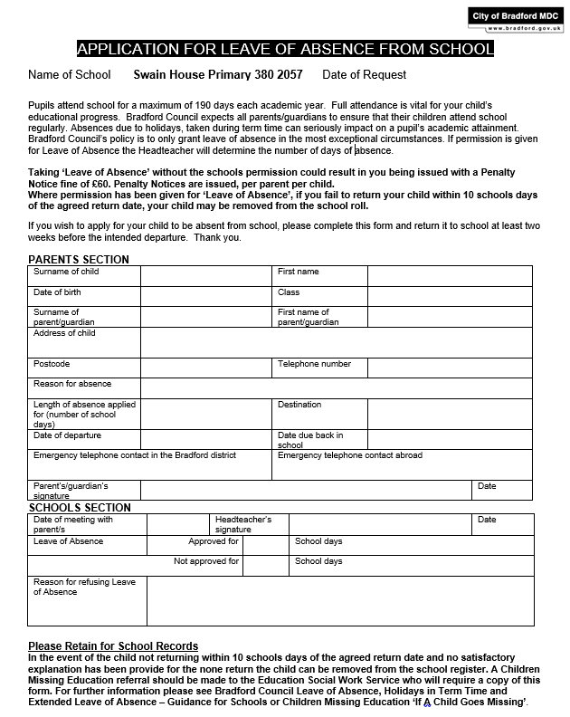

**Appendix 3 – Half-termly attendance letters**

**Letter 1**

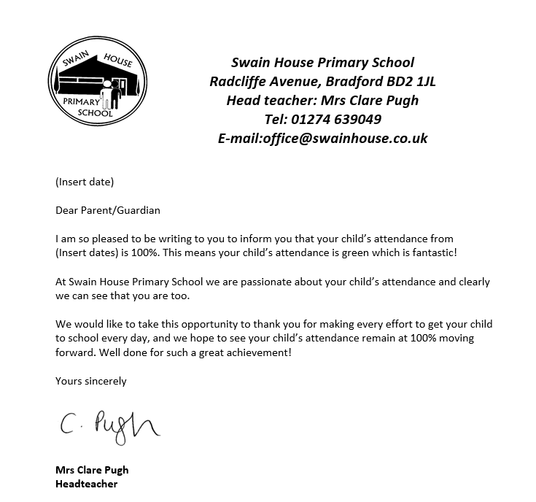

**Letter 2**



**Letter 3**

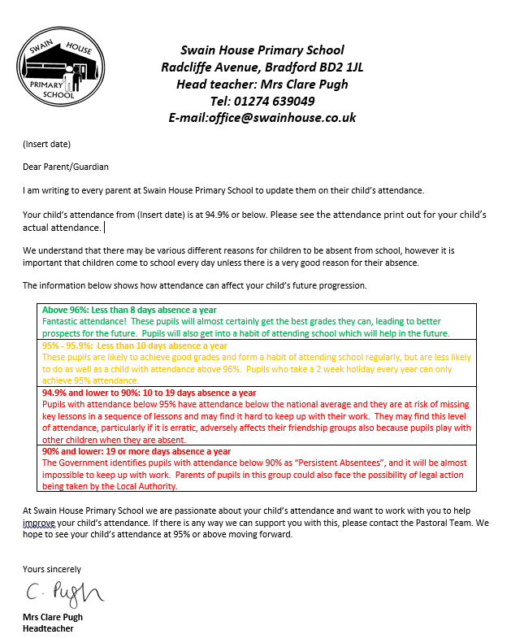

**Letter 4**

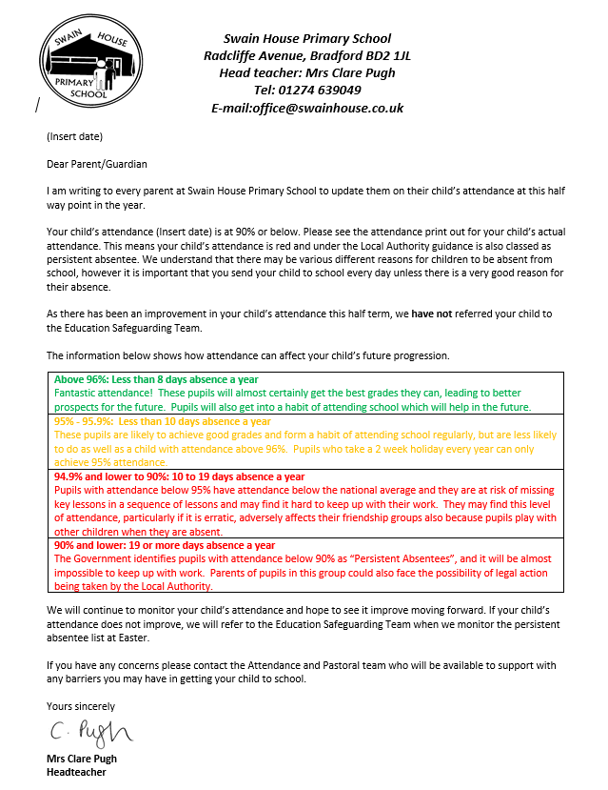

**Letter 5**

