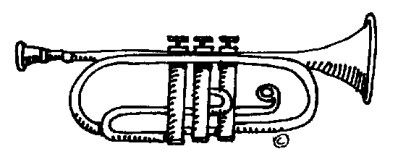
Elgar Class
Proud to be from Bradford!

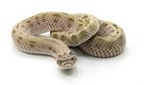
In this topic we will be learning about the Bradford City stadium fire
English  As readers we will:  Read ‘The Fib’ by George Layton and ’56 Story of the Bradford City Fire’ by Martin Fletcher  Use texts to answer questions.  Use drama to explore characters’ feelings.  Develop our vocabulary by “borrowing” authors’ words. | Class Information  Mozart class teacher is Mr Gibbs and the teaching assistants are Mrs Newton and Miss ward.  If you would like to pass a message to a member of the Year 5 team or have any queries, please write in your child’s planner or email:  Year5@swainhouse.bradford.sch.uk  We are reading on our Reading Planet scheme. Please read with your child three times a week and write this in their planner. | As historians  We will be finding out about the Bradford City fire including when it happened and how it started.  We will look at the impact it had on the local community  We will design and create our own stadiums.  As scientists:  We will explore the shape of the Earth, sun and moon.  We will understand the phases of the moon.  We will use graphs to compare data about the planets.  Computing – We will be developing our understanding of computer systems and how information is transferred between systems and devices.  Music - We will learn about music through playing the trumpet.  PE – We will play competitive games, modified where appropriate, and apply basic principles suitable for attacking and defending – hockey.  R.E. We will explore one key question this half term. What do you believe about God?  DT – We will be learning how to use a series circuit to create a doodler. We will be evaluating the successes of products.
As writers:
We will be writing a character description and writing a diary entry.
We will answer inference, retrieval and vocabulary style questions based on our text.
We will be writing a newspaper report about the Bradford City Fire
We will be creating a non-chronological report about the events that led to and came from the Bradford City Fire.

Maths  As mathematicians  We will be reviewing number and place value.  We will be learning about decimals and fractions.  We will also be looking at money including converting between pounds and pence, comparing and finding change. | PSHEE  We will be learning about Me and my relationships.  We will focus on working together, positive friendships and understanding our emotional needs. | How could you help your child at home?  Encourage your child to talk about the learning they have been doing at school.  Use TT Rockstars to practise their timetables and know them “off by heart”  Give opportunities for your child to practise their handwriting and spellings.  Read with you three times a week and whilst reading, ask your child questions about the text.  Sign your child’s planner weekly.  English  As readers we wil  Improve our reading skilsl thorough learning new  • To read two stories that deal with themes of overcoming worries and facing fears  • To compare and describe characters  • To write a letter  • To write an extended story  How could you help your child at home?  Read and talk about stories.  Talk about the characters in a story and describe their appearance and how they behave.  Look at how letters are written.  Allow your child time to practise playing the trumpet.
Homework
Homework is handed out every Friday and must be returned by the following Wednesday.
Please read with your child at least three times per week. Remember to write a comment and sign their planner.
Please encourage your child to practise the maths objectives for the continent they are working on.
