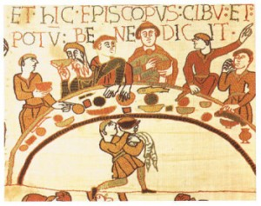
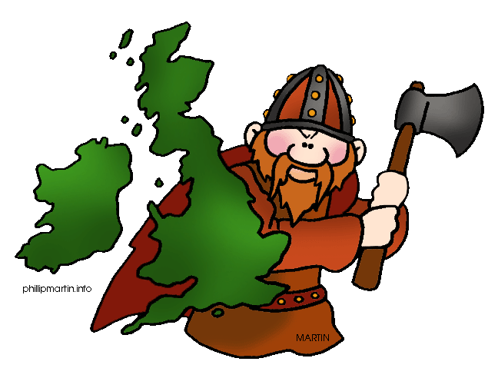
Year 4
J.K. Rowling Class
Spring 2 – Raiders and settlers.
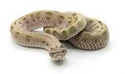
In this theme we will be learning about Anglo Saxon and Viking invasions.
English  As readers we will:  - Read whole books and short texts to improve our comprehension skills.  - Use drama to explore characters’ feelings.  - Develop our vocabulary by “borrowing” author’s words and using vocabulary mats to look for synonyms.  - Increase our understanding of year 4 grammar features. | Class Information  P.E will be in school on a Tuesday. Please can you make sure your child has indoor and outdoor PE kit for these lessons.  Wednesday we go swimming. Make sure your child has their swimming costumes/shorts, a towel and a snack for the bus. They may also bring goggles and swimming caps.  Please make sure your child has a full water bottle to use in school.  Resources  If you have any objects, books or information that might help us with our theme we would love to know about them!  MyHappy Mind – This half-term our focus will be Celebrate. We will be learning how to be positive about ourselves and be proud of our achievements. | 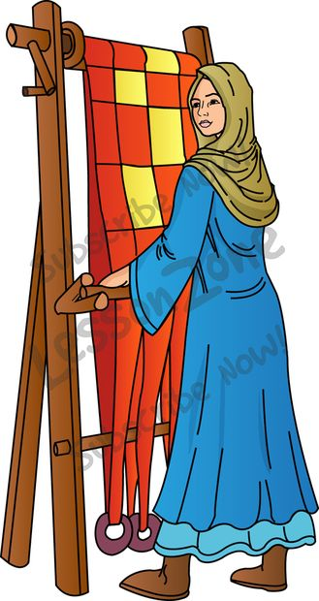  In History, we will:  - We will use timelines to place them in History  - and find out about who they were, where they  - settled and how they lived.  - We will be investigating…  - Was the Anglo-Saxon period really a dark age?  - Would the Vikings do anything for money?  As Scientists - We will learn about teeth, the digestive systems and food chains.  Computing – We will be learning how to programme shapes.  French – We will be learning days of the week, colours, counting to 20, naming countries, likes and dislikes.  P.E - We will be learning swimming skills and football.  PSHEE – We will be learning about how to keep ourselves safe- through lifestyle, choices and online.  R.E. – We will be looking at the question: What do different people believe about God?  Design Technology- We will be making stable free-standing structures. We will be making pavilions for our Anglo-Saxons.  Music –We will be learning about rap music. We will be writing, rhyming, creating and performing our own rap.
As writers we will:
- Use a range of punctuation marks accurately.
- Enrich our word choice by using “borrowed” words.
- Improve our work through editing carefully.
- Develop the formation of our joined handwriting.
- Use our knowledge of spelling patterns to improve our work.
- Write character and setting descriptions. Write an Anglo-Saxon hero story. Write various texts from the view points of Vikings.
- Meet our writing targets to improve our writing.
Maths  As mathematicians we will:  - Add and subtract like fractions.  - Find fractions of amounts.  - Calculate and learn what a prime number is.  - Multiply by 10 and 100.  - Divide by 10 and 100.  - Problem solve in a range of different mathematical contexts. | Homework  Homework is given out every Friday. Read with your child at least three times per week. Remember to write a comment and sign their reading record at least once a week.  Times tables are incredibly important to all aspects of maths, please remember that we have home access to Times Tables Rockstars, if you need your child’s password, please ask the class teacher. | How could you help your child at home?  - Ensure your child practises their times tables regularly on TT Rockstars.  - Ensure they practise their spellings in ready for their weekly spelling test.  - Your child should be reading a home at least three times a week. This should be recorded in your child’s reading record. When reading, please regularly ask your child questions about their book to check for understanding.

