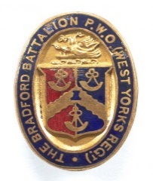
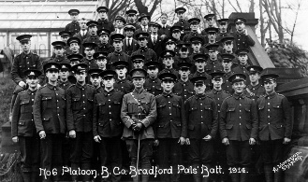
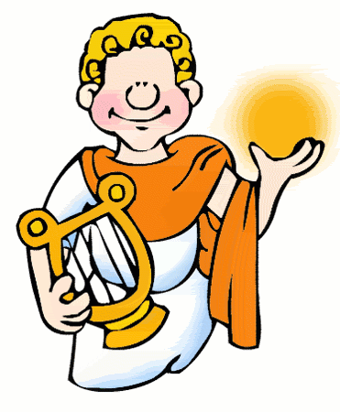
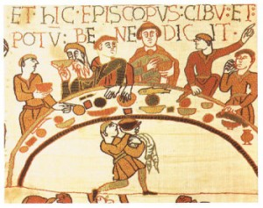
Beethoven Class
Bradford Remembers: Tommy’s Return
Our theme is history based. We will be learning all about the Bradford Pals during WW1.
English  As readers we will:  - Read whole books to improve our comprehension skills  - Skim and scan effectively to retrieve information  - Explain meanings of words in context  - Infer feelings through actions, dialogue and description  - Make predictions using our knowledge of the book  - Summarise parts of stories. | Class Information  If you would like to pass a message to a member of the year 6 team or have any queries, please write in your child’s planner or email:  year6@swainhouse.bradford.sch.uk  We are loving reading our Reading Planet books. Please listen to your child read regularly at home. Please also ensure your child has their Reading Planet books in school every day. | As historians we will:  Look at why people in Bradford signed up to fight in the war and the power of propaganda posters. What life was like for the Bradford Pals during WW1 and in particular the Battle of the Somme? Find out how the Pals were treated when they came back from war. Find out how the consequences of WW1 lead to the beginning of WW2.  Art and Design and Technology- Making and evaluating a product (a waistcoat for a teddy bear).  As scientists we will:  Be learning about evolution and inheritance.  R.E - We will be learning about Sikhism and how Sikhs practice their religion. We will be going on a trip to a local Gurdwara.  French - We will be learning to compare the French and English words for countries and continents. We will understand and talk about where animals can be found. We will discuss the geography and weather of countries and continents  Computing - We will develop their knowledge and understanding of using a computer to create web pages  PE – We will be learning about leading healthy, active lives. We will be taking part in hockey activities.  PSHE – We will understand and value that differences and similarities between people arise from a number of factors.
As writers we will:  - Write for longer periods of time on a range of text types  - Write more complex and cohesive paragraphs  - Use a range of punctuation marks accurately including semi-colons and colons  - Improve our work through editing carefully  - Develop the formation of our joined handwriting  - Use our knowledge of spelling patterns to improve our work. | Important dates:  Beethoven class assembly 23rd November 2023
Maths
In maths we will be:  - Multiplying and dividing by multiples of 10, 100 and 1000  - Converting units of measure (length, weight and capacity)  - Plotting coordinates  - Using the four operations to solve arithmetic problems | Please ensure your child brings a full water bottle to school every day.  Please remind your child to complete their homework on Google Classroom, as well as practising their spellings and times tables every week on TT Rockstars.  PE will be on Thursdays. Pupils in year 6 need to arrive at school in their PE kit. | How could you help your child at home?  - Ensure your child learns “off by heart“ the times tables and number facts so they can get all continents and planets passed in their maths passports  - Encourage them to develop their independence and get the items they need for school ready the night before  - Encourage them to log on to Google Classroom regularly to complete any tasks set.  English  As readers we wil  Improve our reading skilsl thorough learning new  • To read two stories that deal with themes of overcoming worries and facing fears  • To compare and describe characters  • To write a letter  • To write an extended story  How could you help your child at home?  Read and talk about stories.  Talk about the characters in a story and describe their appearance and how they behave.  Look at how letters are written.

