Kandinsky Class
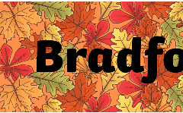
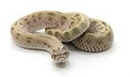

In this theme we will be learning about the Bradford Pals and World War One.
English  As readers we will:  •Read stories and re-tell them through drama and we will be thinking about the characters and describing what we see  •Read non-fiction books about places and about seasonal change  •Practise and use our phonics to read new words and sentences | Class Information  PE will be on Mondays this term.  Please ensure your child keeps the correct P.E. kit in school.  Please can you ensure all items of clothing are labelled with your child’s name.  If you have any queries please do not hesitate to come and speak to us. We are always happy to help! | As historians we will be:  • looking at World War One. We will focus on the Bradford Pals and why young men signed up for war.  As scientists we will learn about:  •Observe and compare different animals  • Learn about their habitats and what they eat  • Learn to investigate our ideas  • Use our senses to observe animals  • Map the changes in the seasons by observing a tree.  In RE we will be looking at:  How do we celebrate special events?
As writers we will:
• Practise forming our upper and lower case letters correctly
• Write labels and captions for pictures
• Write simple sentences using capital letters and full stops
• Use our phonics knowledge to improve our spelling
Maths  As mathematicians we will:  - Compare items using length, height, weight and capacity.  - Compare sets of objects  - Use equality and inequality symbols to compare sets of objects  - Explain what a whole is and that it can be split into parts.  - Looking at numbers 0 -5. | Homework  Homework this year will be a little different.  Spellings will be given out every Friday, to be learnt at home for a spelling test the following Friday.  There will be no homework books sent home, instead, we would like you to focus on Lexia, Numbots and reading. Log in details can be found in your child’s reading record book.  Further information will be sent out later this week.  Read with your child at least 3 times a week. Remember to write a comment and sign their Reading record – this is part of our homework policy and will be part of their pupil mentoring form. | How could you help your child at home?  Talk about what they have learned in school.  Read a range of stories at home and ask questions about what you have read.  Learn to count forwards and backwards to 50.  Talk in your family about how shops have changed.  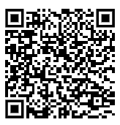  Don’t forget to practice your maths passport facts.  You can find all the objectives on our school website. Here is a link to the page:

