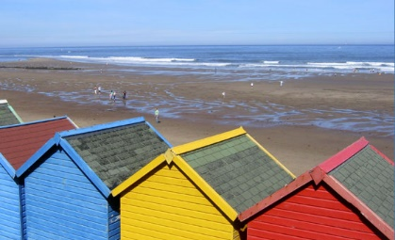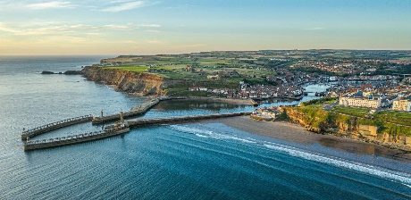

Roald Dahl Class

|  |  |  |
| --- | --- | --- |
| imagesJG8KHKA2imagesJG8KHKA2This half term our Geography topic is ‘From Coast to Coast.’  We will be learning all about the features of coasts, both in the UK and around the world. | | |
| English  As readers we will:  Read, listen to and discuss a range of fiction and non-fiction texts.  Understand what we have read by answering questions in a range of comprehension tasks.  Retell the stories we read.  Infer characters’ thoughts and feelings and reflect these through role play. | *Class Information*  P.E will be on **Tuesdays.**  Please ensure your child keeps the correct P.E. kit in school all the time and that all items are labelled.  Please make sure your child has a water bottle to use in school and wears a sun hat and sun cream on hot days. | Geography – we will be learning to recognise the physical and human features of coastal regions, both in the UK and around the world.  As scientists: we will be learning about George Washington Carver and the contribution he made to science. We will be investigating shadows and why the size changes at different times of the day. We will be making our own fossils and recapping about the fossilisation process.  In our Design & Technology lessons we will be designing and constructing castle using a range of tools, skills and materials.  Computing –We will be developing our understanding of programming.  PSHE – We will be focusing on ‘Growing and Changing’ We will be thinking about relationships we have with others and how our bodies change as we grow older.  PE – We will be enjoying some street dance lessons building up to a performance.  R.E. – We will be learning what the different creation stories tell us about the world.  Music - Begin to recognise styles, find the pulse, recognise instruments and listen and discuss other dimensions of music.  French – We are learning to count to 31, the months of the year and parts of the body. |
| As writers we will:  Compose and rehearse sentences orally  Write a story retell, based on our text, Dolphin Boy  Use a range of punctuation accurately, including speech punctuation.  Use devices such as powerful verbs, prepositions and subordinating conjunctions to write exciting sentences that interest the reader.  Organise non-fiction writing into paragraphs with headings and subheadings.  Improve our work through proofreading and editing carefully.  Develop the formation of our joined handwriting.  Use our knowledge of spelling patterns to improve our work.  Meet our writing targets to improve our writing. | *Homework*  Please encourage your child to use Times Tables Rock Stars regularly,  Please help your child to learn their weekly spellings. They should also aim to learn by heart the half termly words for Year 3.  This term’s spelling are:  actually, extreme, February, certain, height, history, imagine, increase, interest  Please read with your child each week. Remember to write a comment and sign their reading record. |
| Maths  As mathematicians we will:  Understand, identify and compare non-unit fractions.  Add and subtract non-unit fractions with the same denominator.  Investigate with polygons.  Identify parallel and perpendicular lines. | *Resources*  If you have any objects, books or information that might help us with our topics we would love to know about them!   If you have any talents or skills that may help us please share them to help us with our learning. | *How could you help your child at home?*  Encourage your child to talk about the learning they have been doing at school.  Ensure your child works on their Maths Passport objectives.  Encourage your child to tell the time and allow them to experience using coins.  Give opportunities for your child to practise their handwriting and spellings.  Listen to your child read their Reading Planet book  **English**  **As readers we wil**  **Improve our reading skilsl thorough learning new**  • **To read two stories that deal with themes of overcoming worries and facing fears**  • **To compare and describe characters**  • **To write a letter**  • **To write an extended story**      ***How could you help your child at home?***    Read and talk about stories.  Talk about the characters in a story and describe their appearance and how they behave.  Look at how letters are written.  Practise reading with expression and fluency. |

