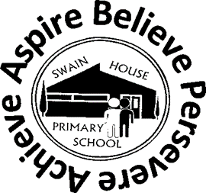
Swain House Primary School

Resourced Provision Newsletter
02/07/2026

Role models
This term we had Deaf adults come into school to share their life experiences with the children,  Susie Farrar who is our Senior Deaf Instructor came and shared her story of how she grew up in a family of many Deaf people and how she became a Deaf Instructor.  Susie is based at Hanson school, which is our secondary school provision.  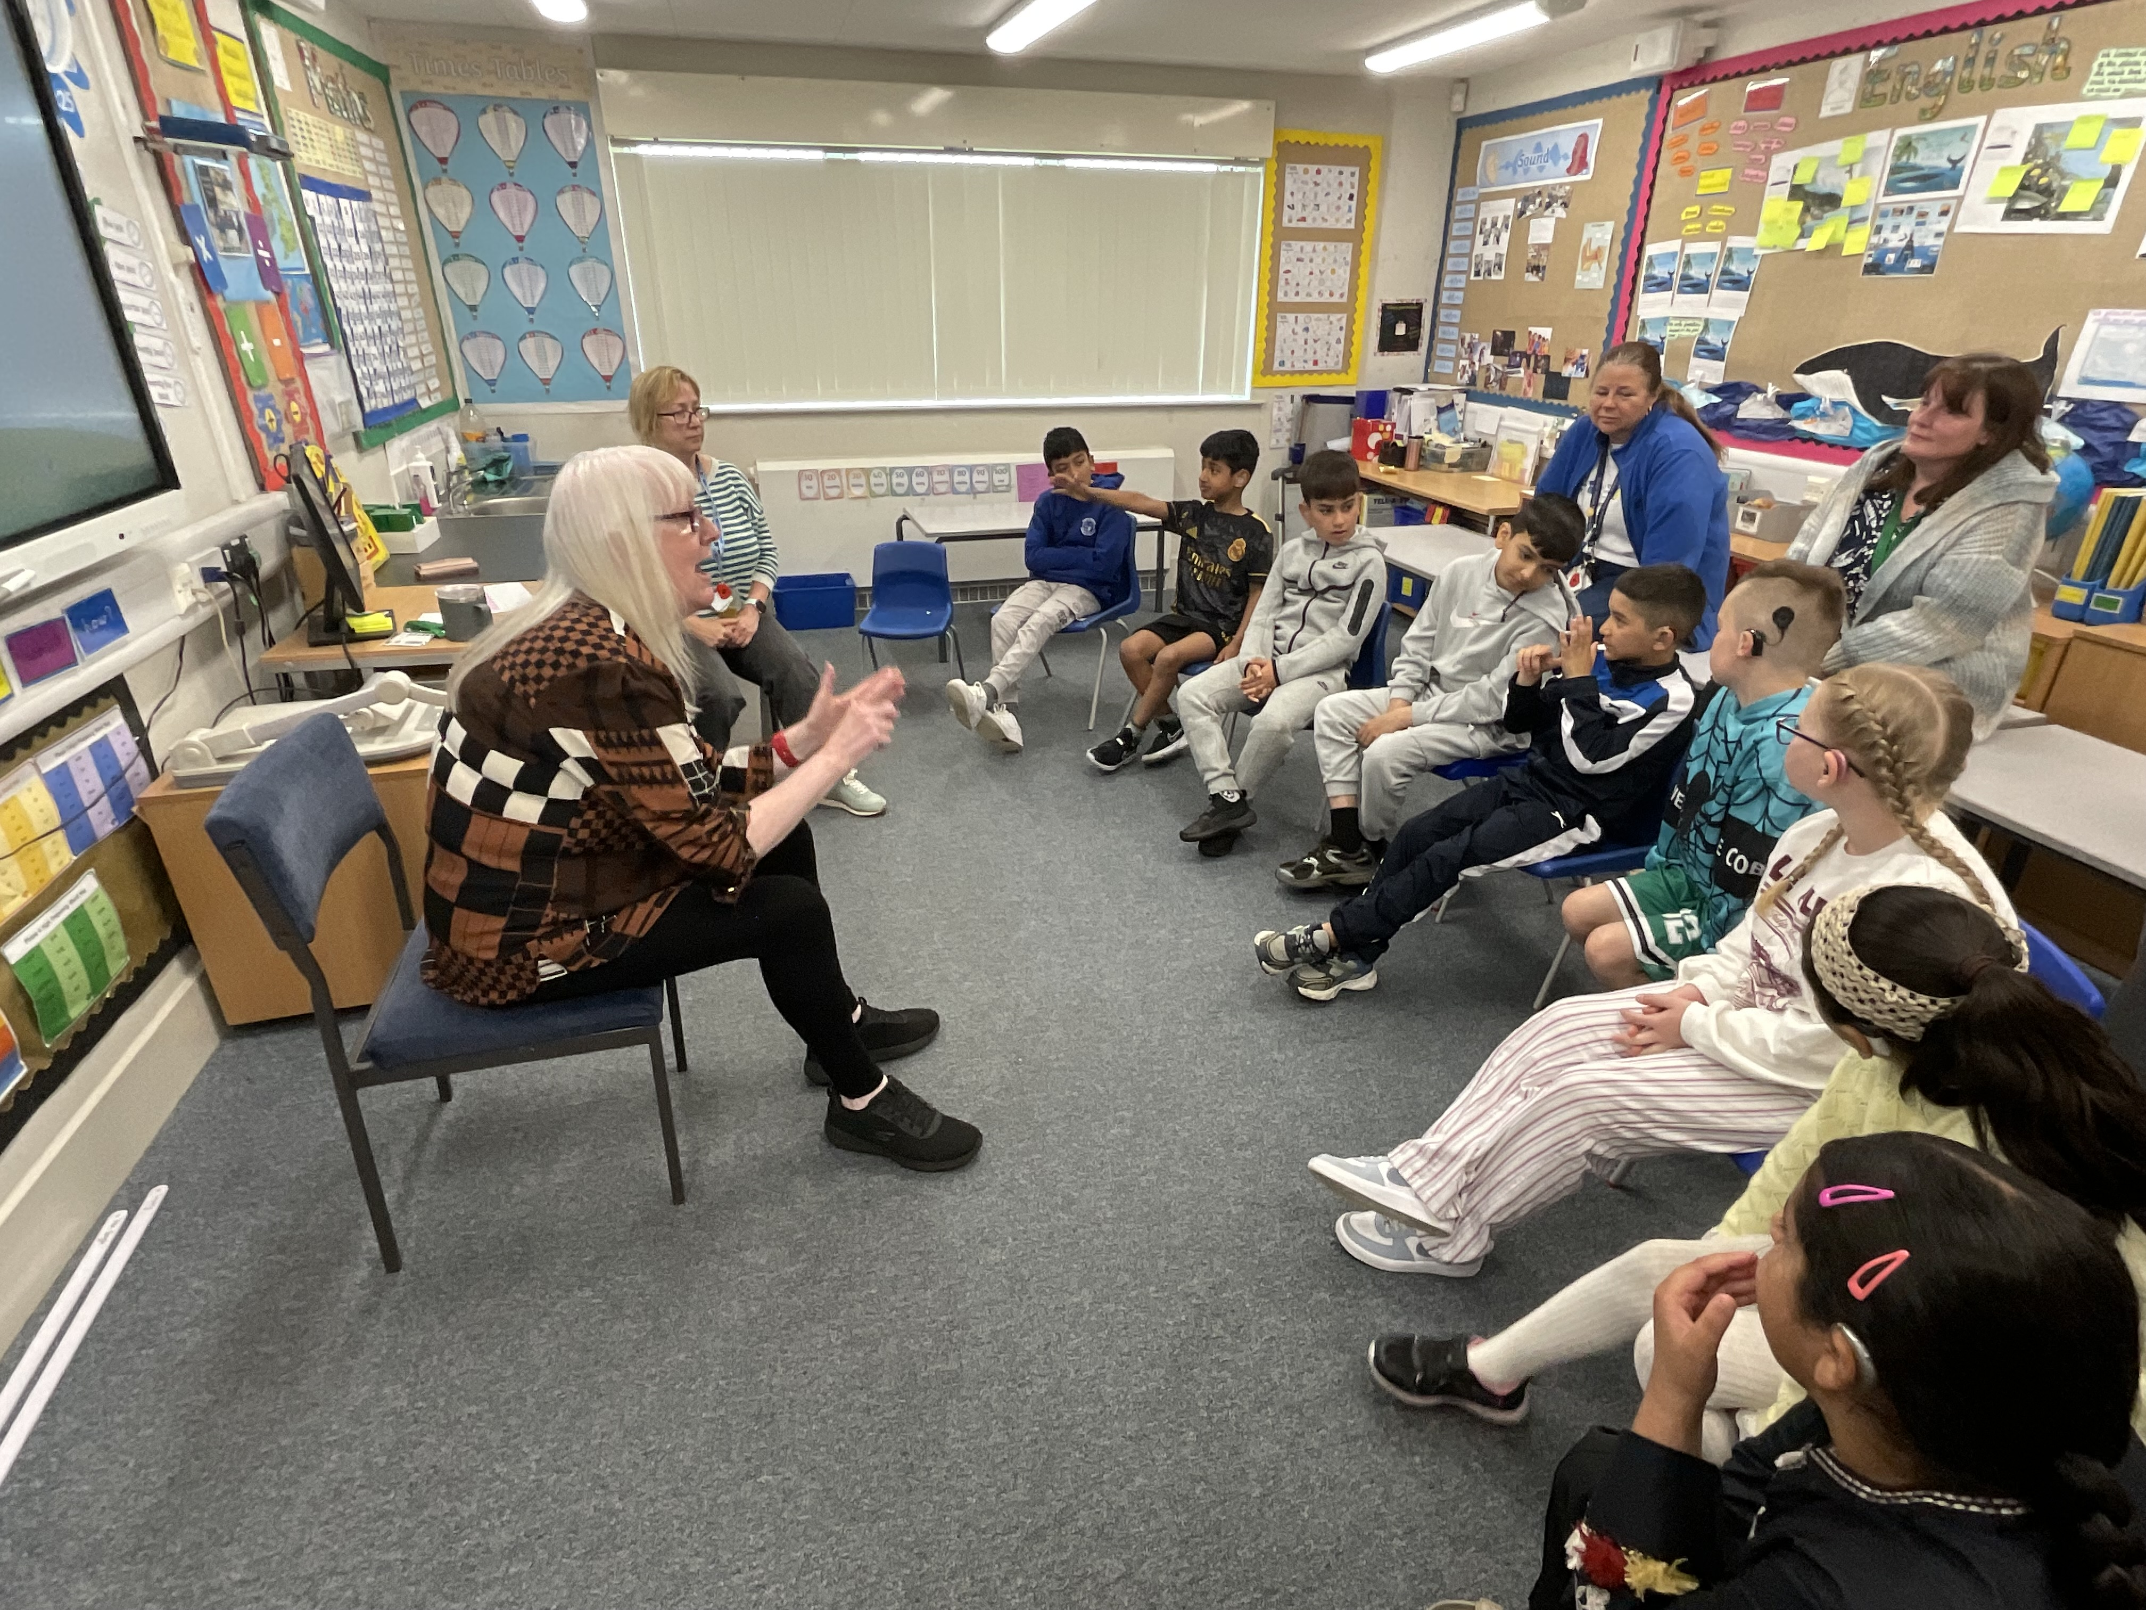  The children were engaged throughout the visit and asked lots of interesting questions. |  | 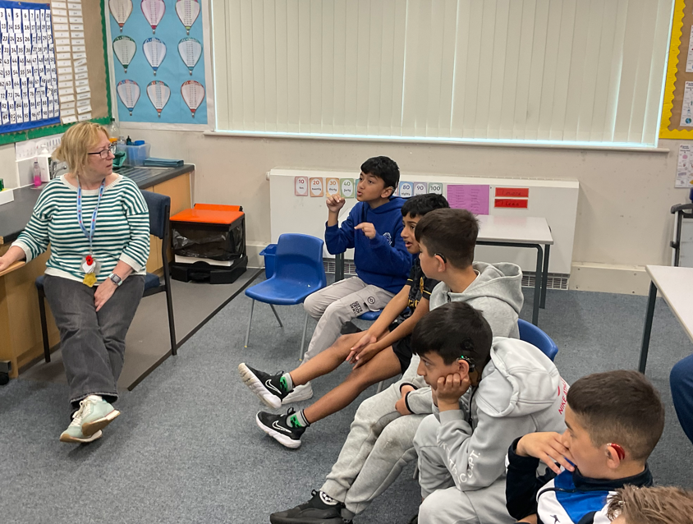  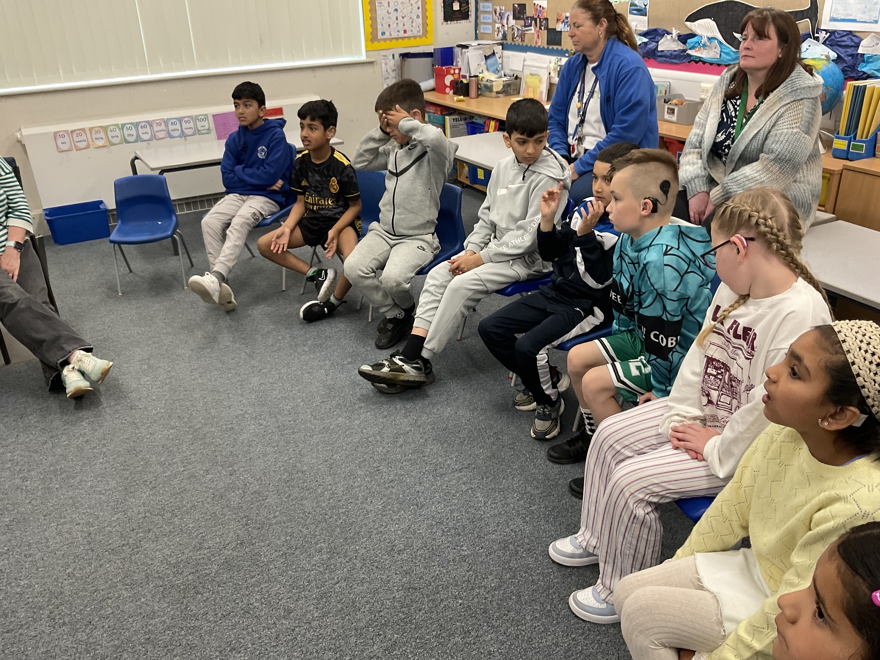
“Our vision is to provide high quality support for all Bradford children and young people using a collaborative approach through transformational learning experiences so that they can flourish and make excellent holistic progress and successfully transition to responsible citizens”

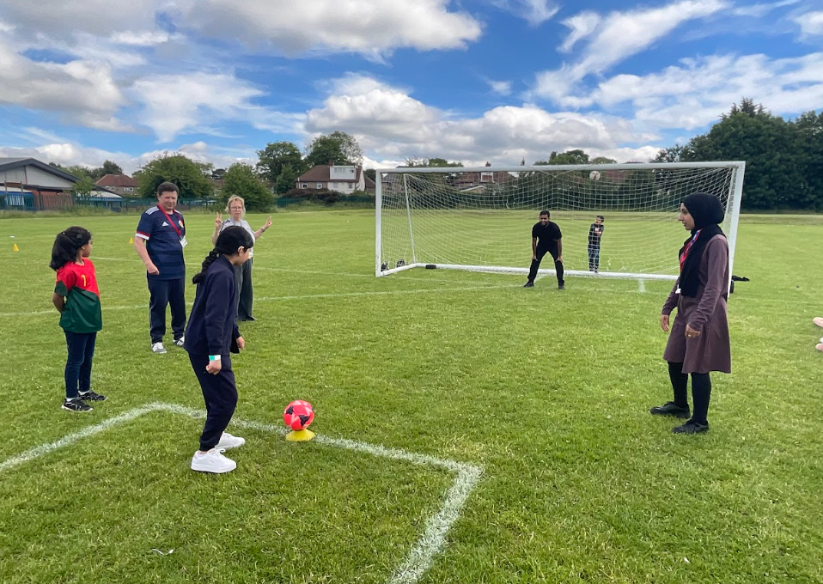
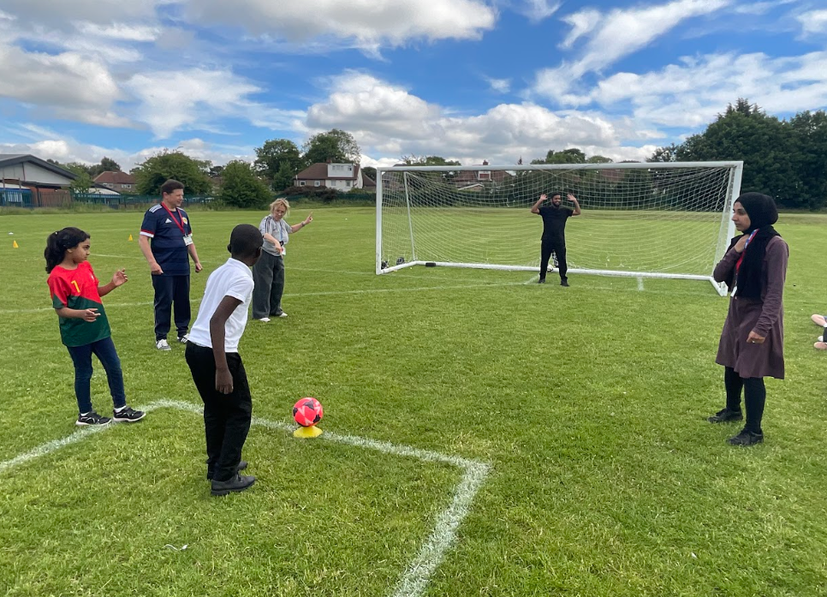

Deaf Role Models in Sports
We were delighted to welcome Mr Rayment, a former Great Britain and Scotland Deaf footballer, to our school. He talked to the children about his experiences as a Deaf footballer, from his early years in junior school and attending a Deaf school in Surrey, through to playing football in secondary school competitions. He was later selected to represent Great Britain and then Scotland in Deaf football matches.  During his visit, Mr Rayment taught the children football skills such as ball control and passing. He also taught them football vocabulary, including terms such as defence and attack. We organised activities on the school field and the children had a football match against Girlington School who came to Swain House for Mr Rayment’s visit. |  |  | 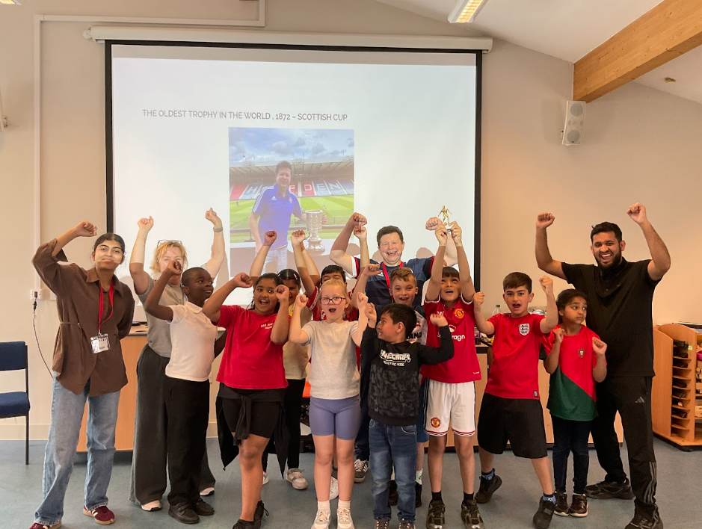
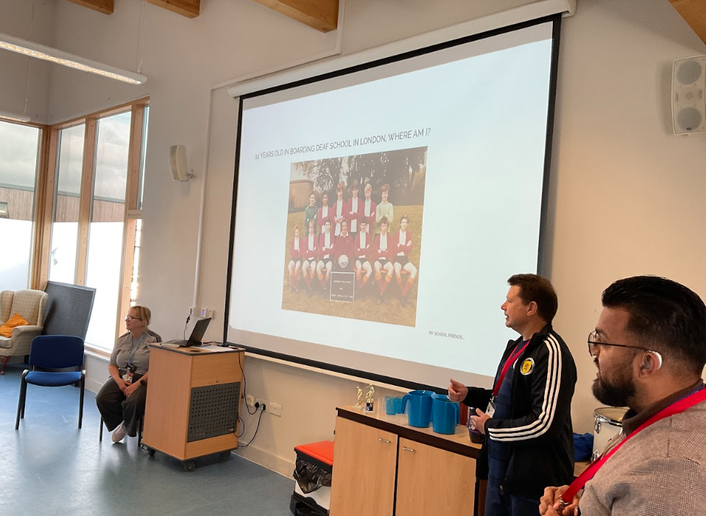
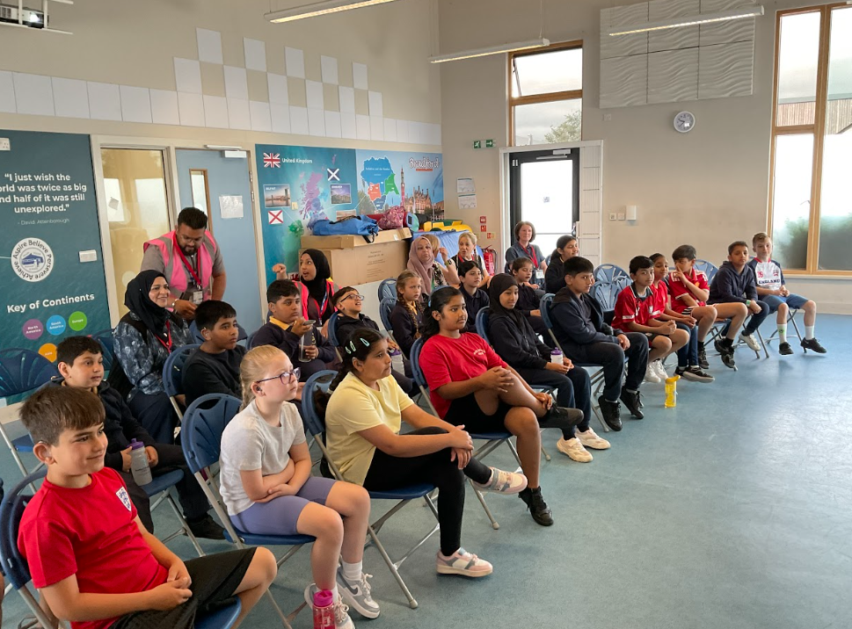
y
Whole service Sports Day

RP pupils from Swain House joined the RP pupils from Girlington school for a fantastic Sports Day at Hanson School. We all met on the field, where the children took part in a variety of relay races and running activities. Thankfully, there was plenty of water available to keep everyone hydrated.

We then moved into the main sports hall to enjoy even more fun events, including the egg and spoon race, sack race and other exciting team challenges. The children showed great enthusiasm, teamwork and determination throughout the day. After all the activities, everyone enjoyed a delicious lunch in the main dining hall, with chicken burgers followed by chocolate cake.

We also received a medal each. We came back to Swain House feeling exhilarated, exhausted and overheated after such a brilliant day!

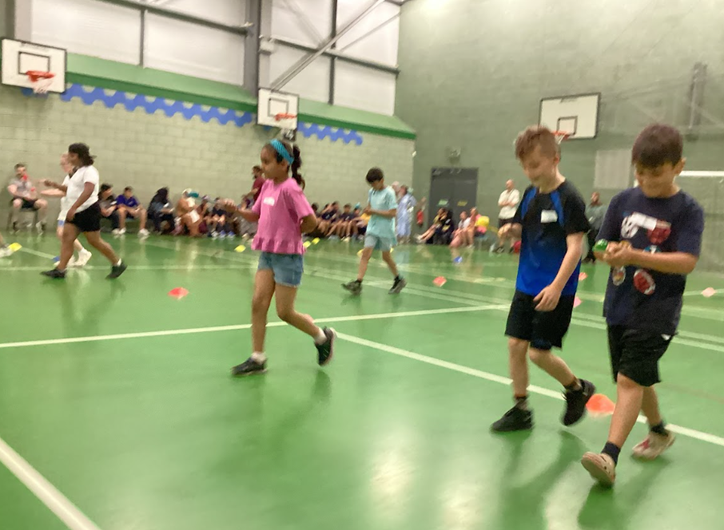
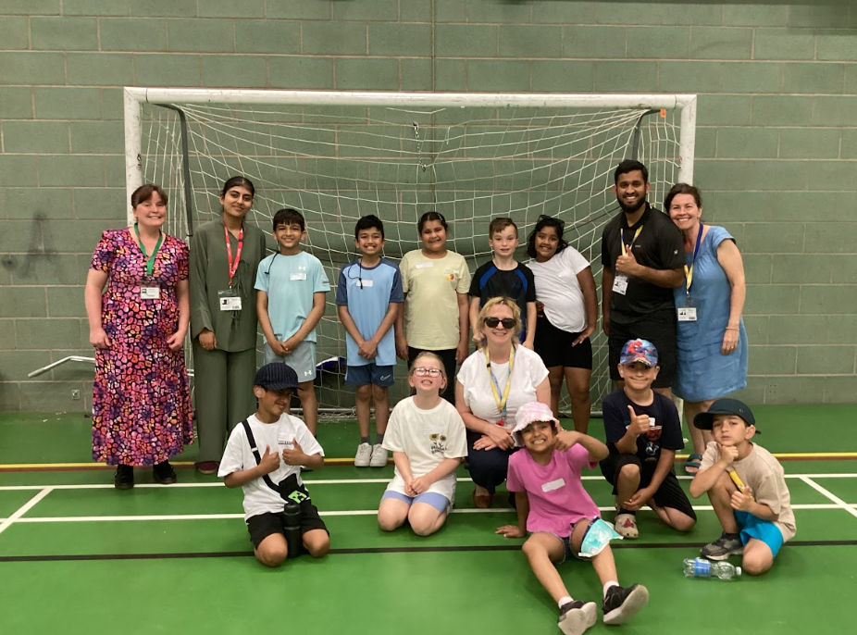

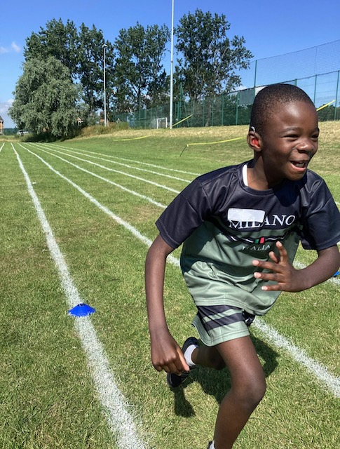

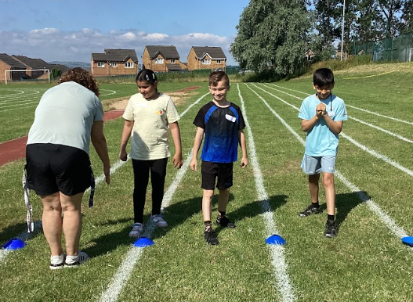
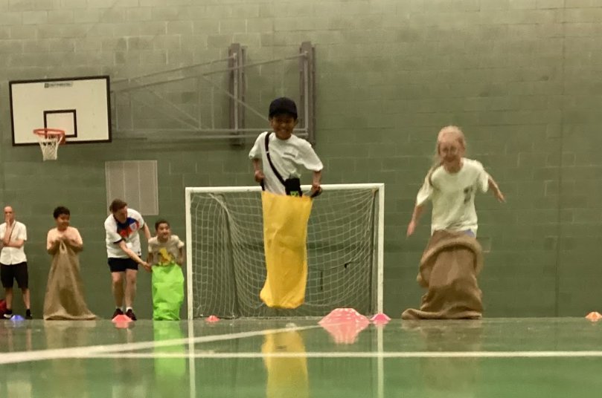

Yorkshire Wildlife Park

Year 5 had an amazing time at the Yorkshire Wildlife Park. They learnt about all the different animals and their diet. We saw lions, monkeys, meerkats, wallabies, giraffes, polar bears and so much more.

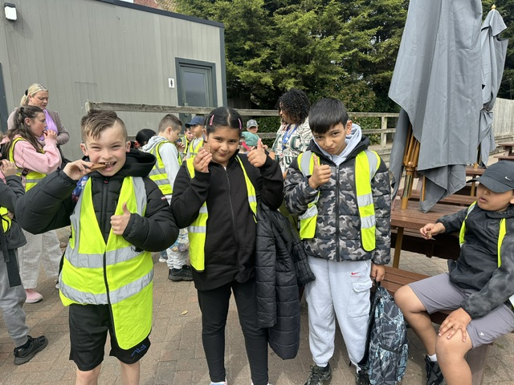
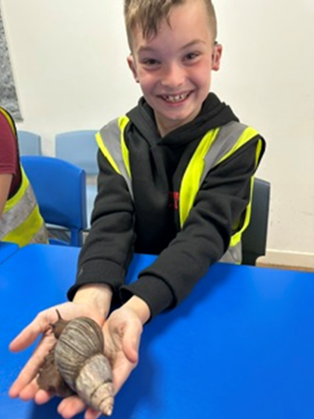

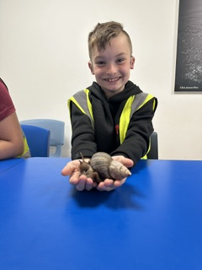

Cricket

During their mainstream PE lessons, the RP children (PW) have been joining their Mozart classmates for cricket sessions led by an external cricket coach. The children have thoroughly enjoyed learning the game, particularly the ball-handling and batting activities, that helped develop their skills, before playing a full game of cricket. It has been wonderful to see their enthusiasm, growing confidence and teamwork throughout the sessions. They have had so much fun while learning a new sport.

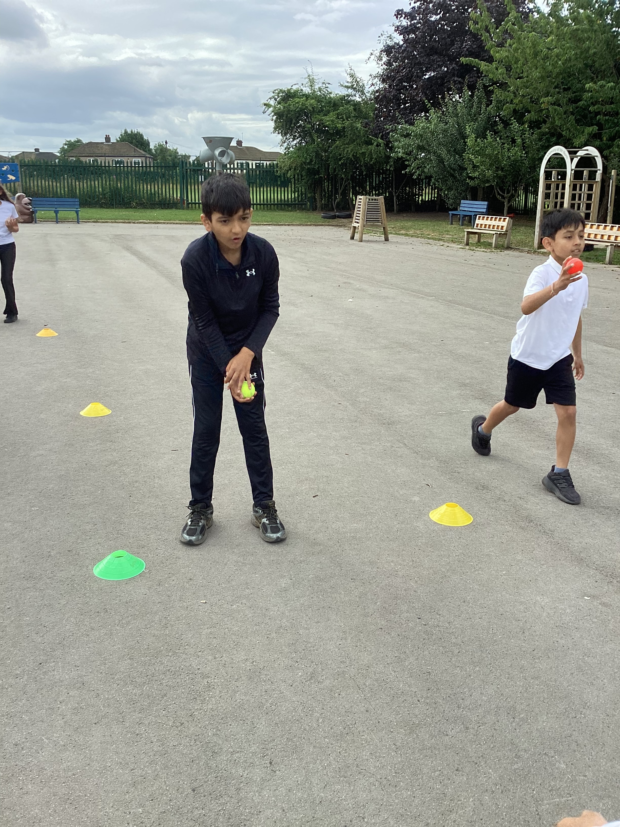
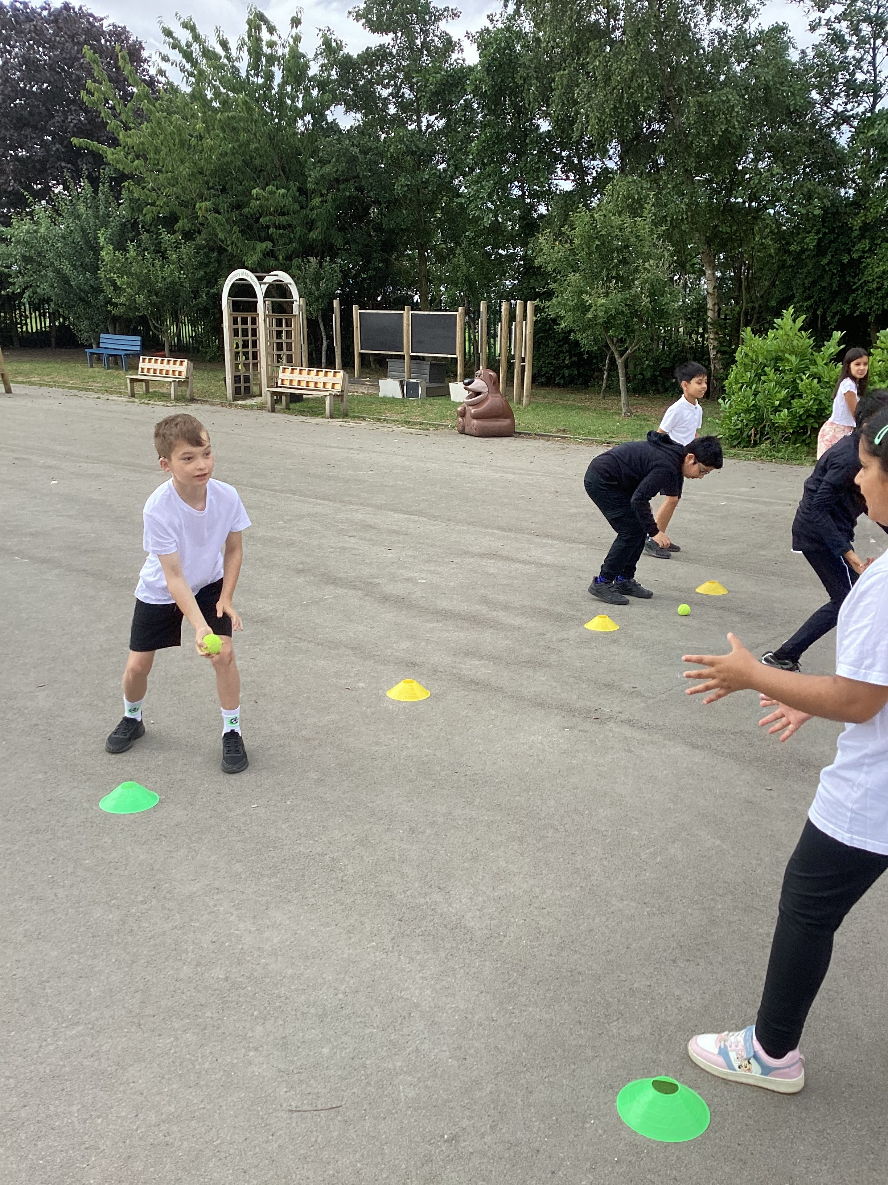
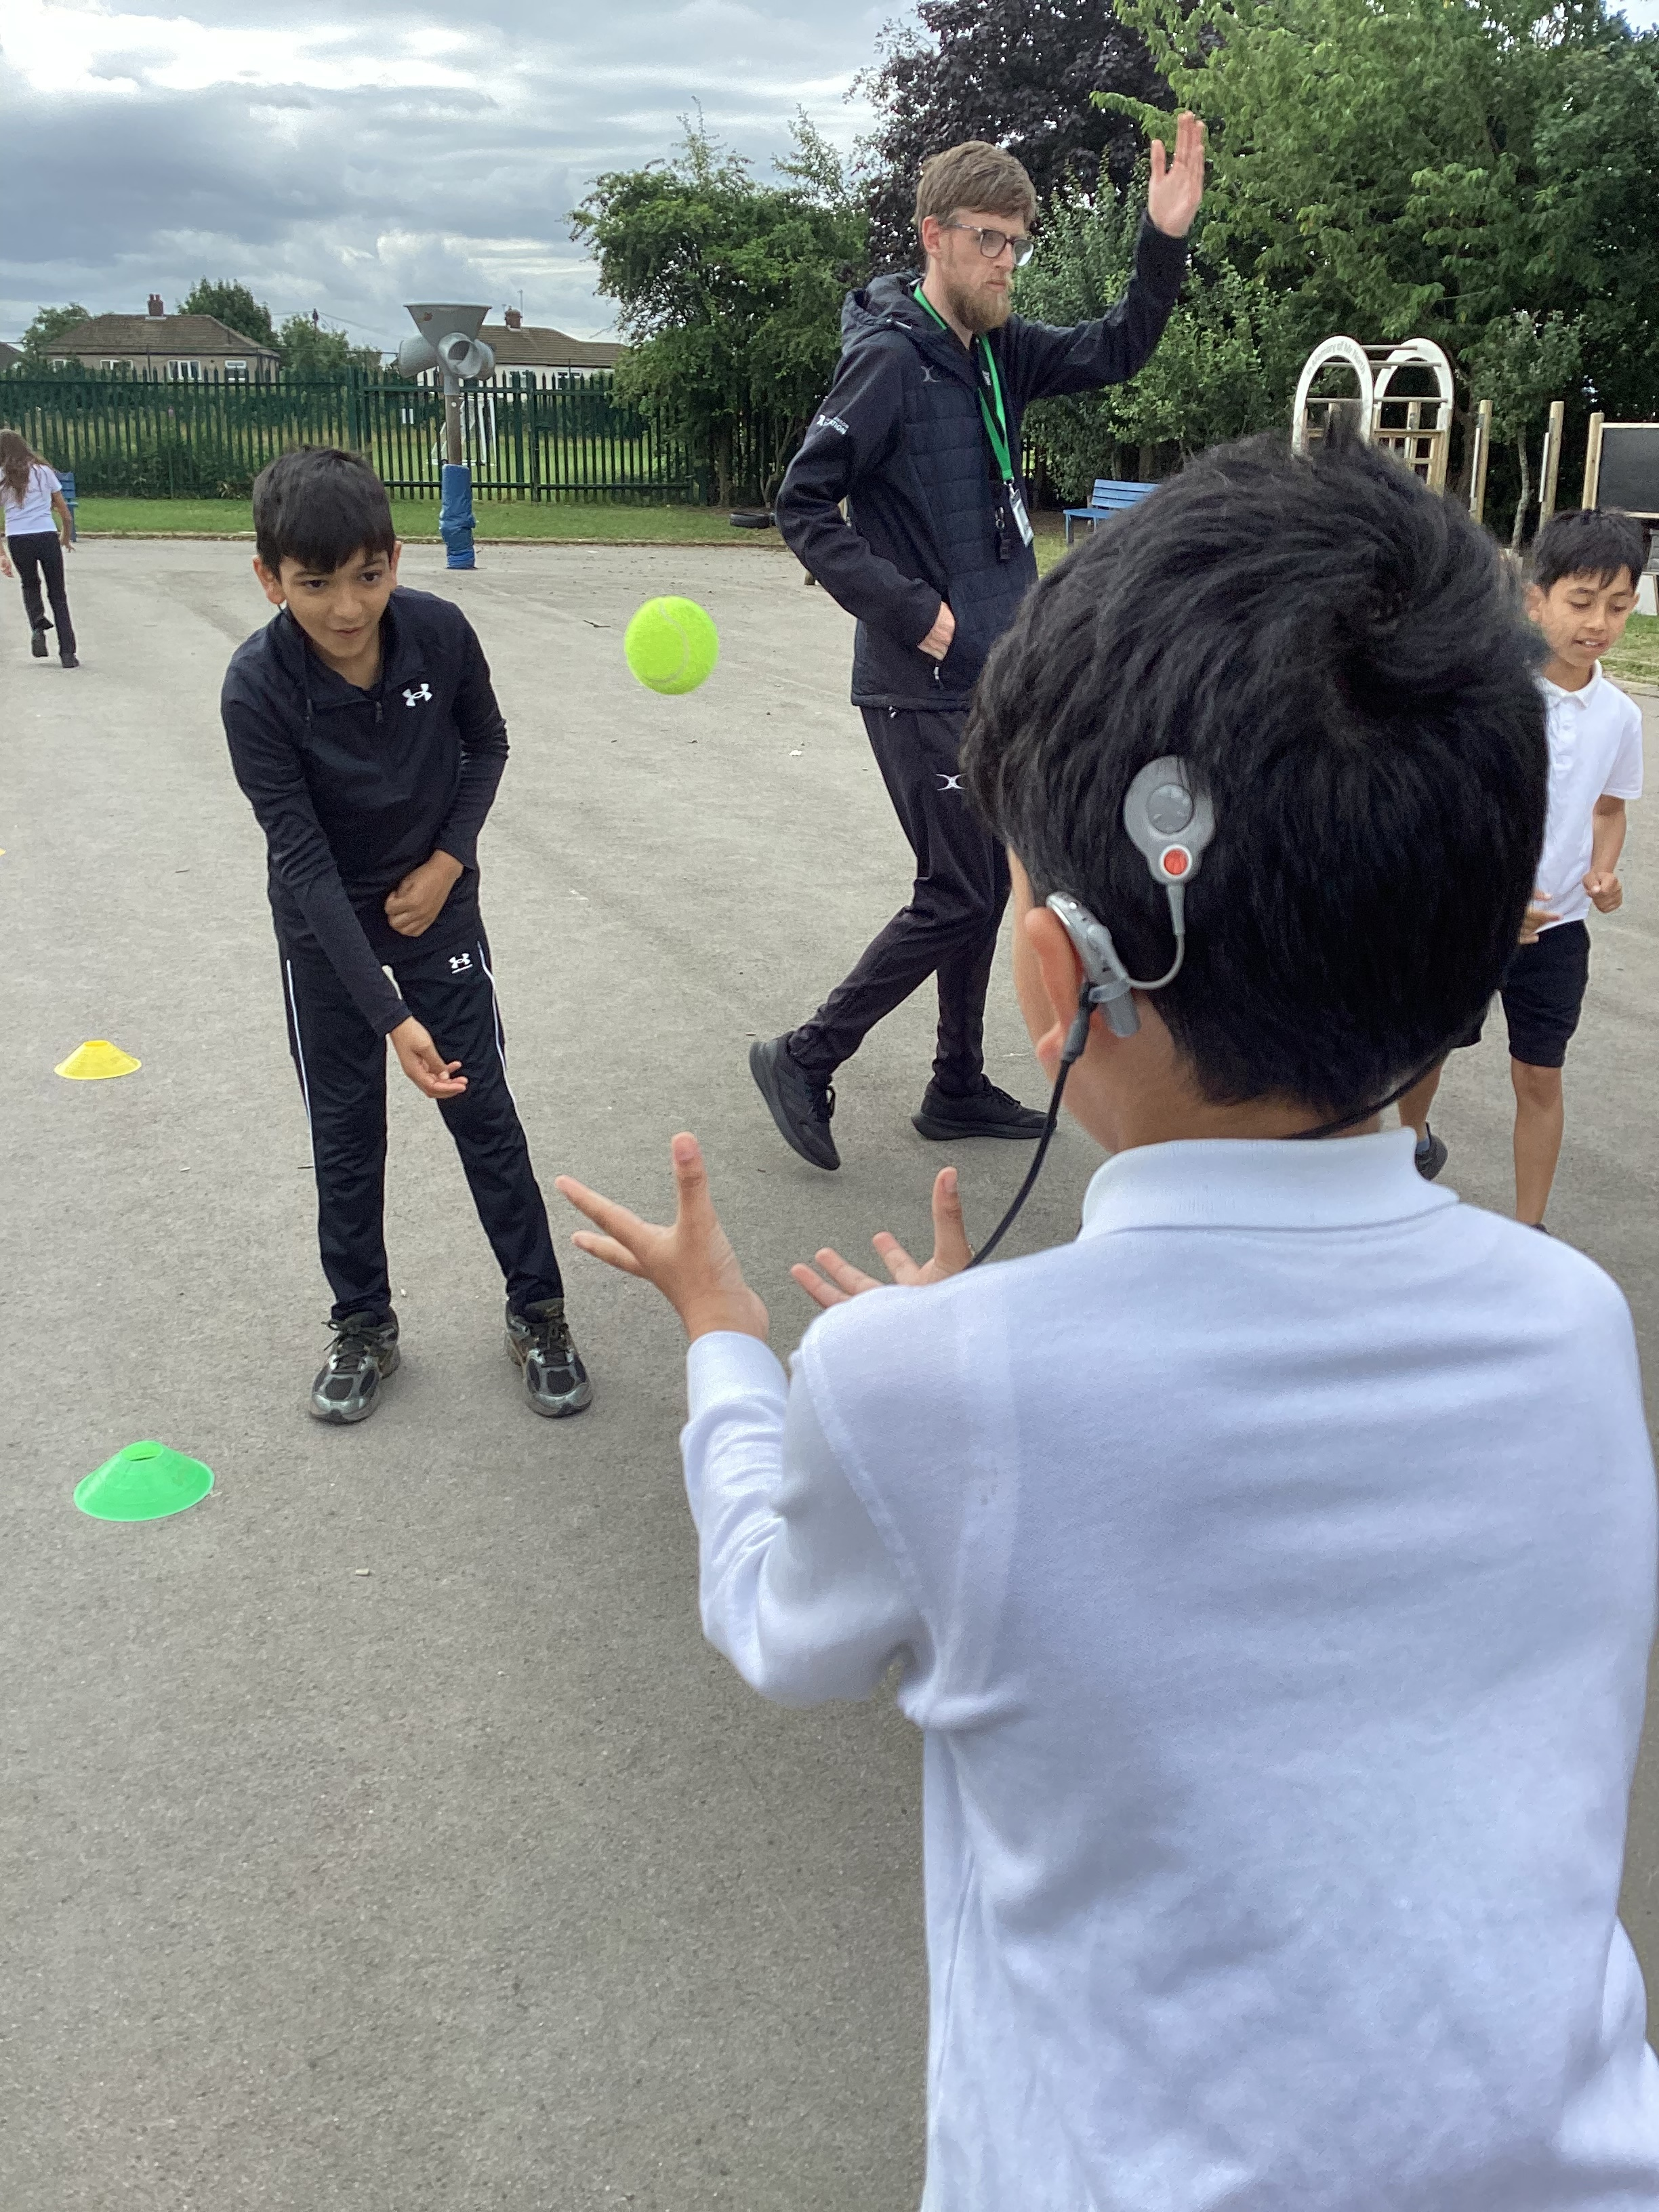

PSHE

Throughout Summer 2 (2026), we have been fortunate to take part in a series of engaging PSHE workshops led by external visitors. The sessions have covered a range of important topics, including looking after our physical and mental wellbeing, building healthy friendships, treating others with kindness and respect, understanding stereotypes and prejudice, recognising hate crime, challenging misogyny in an age-appropriate way, and learning about growing up, relationships and the changes our bodies experience as part of Relationships and Health Education.
The workshops have been interactive, thought-provoking and really enjoyable. The children have listened respectfully, asked some excellent questions and shown maturity when discussing topics that can sometimes be challenging. These sessions have encouraged everyone to reflect on how to keep themselves safe, make positive choices and show empathy and respect towards others. It has been wonderful to see the children engaging so thoughtfully and confidently

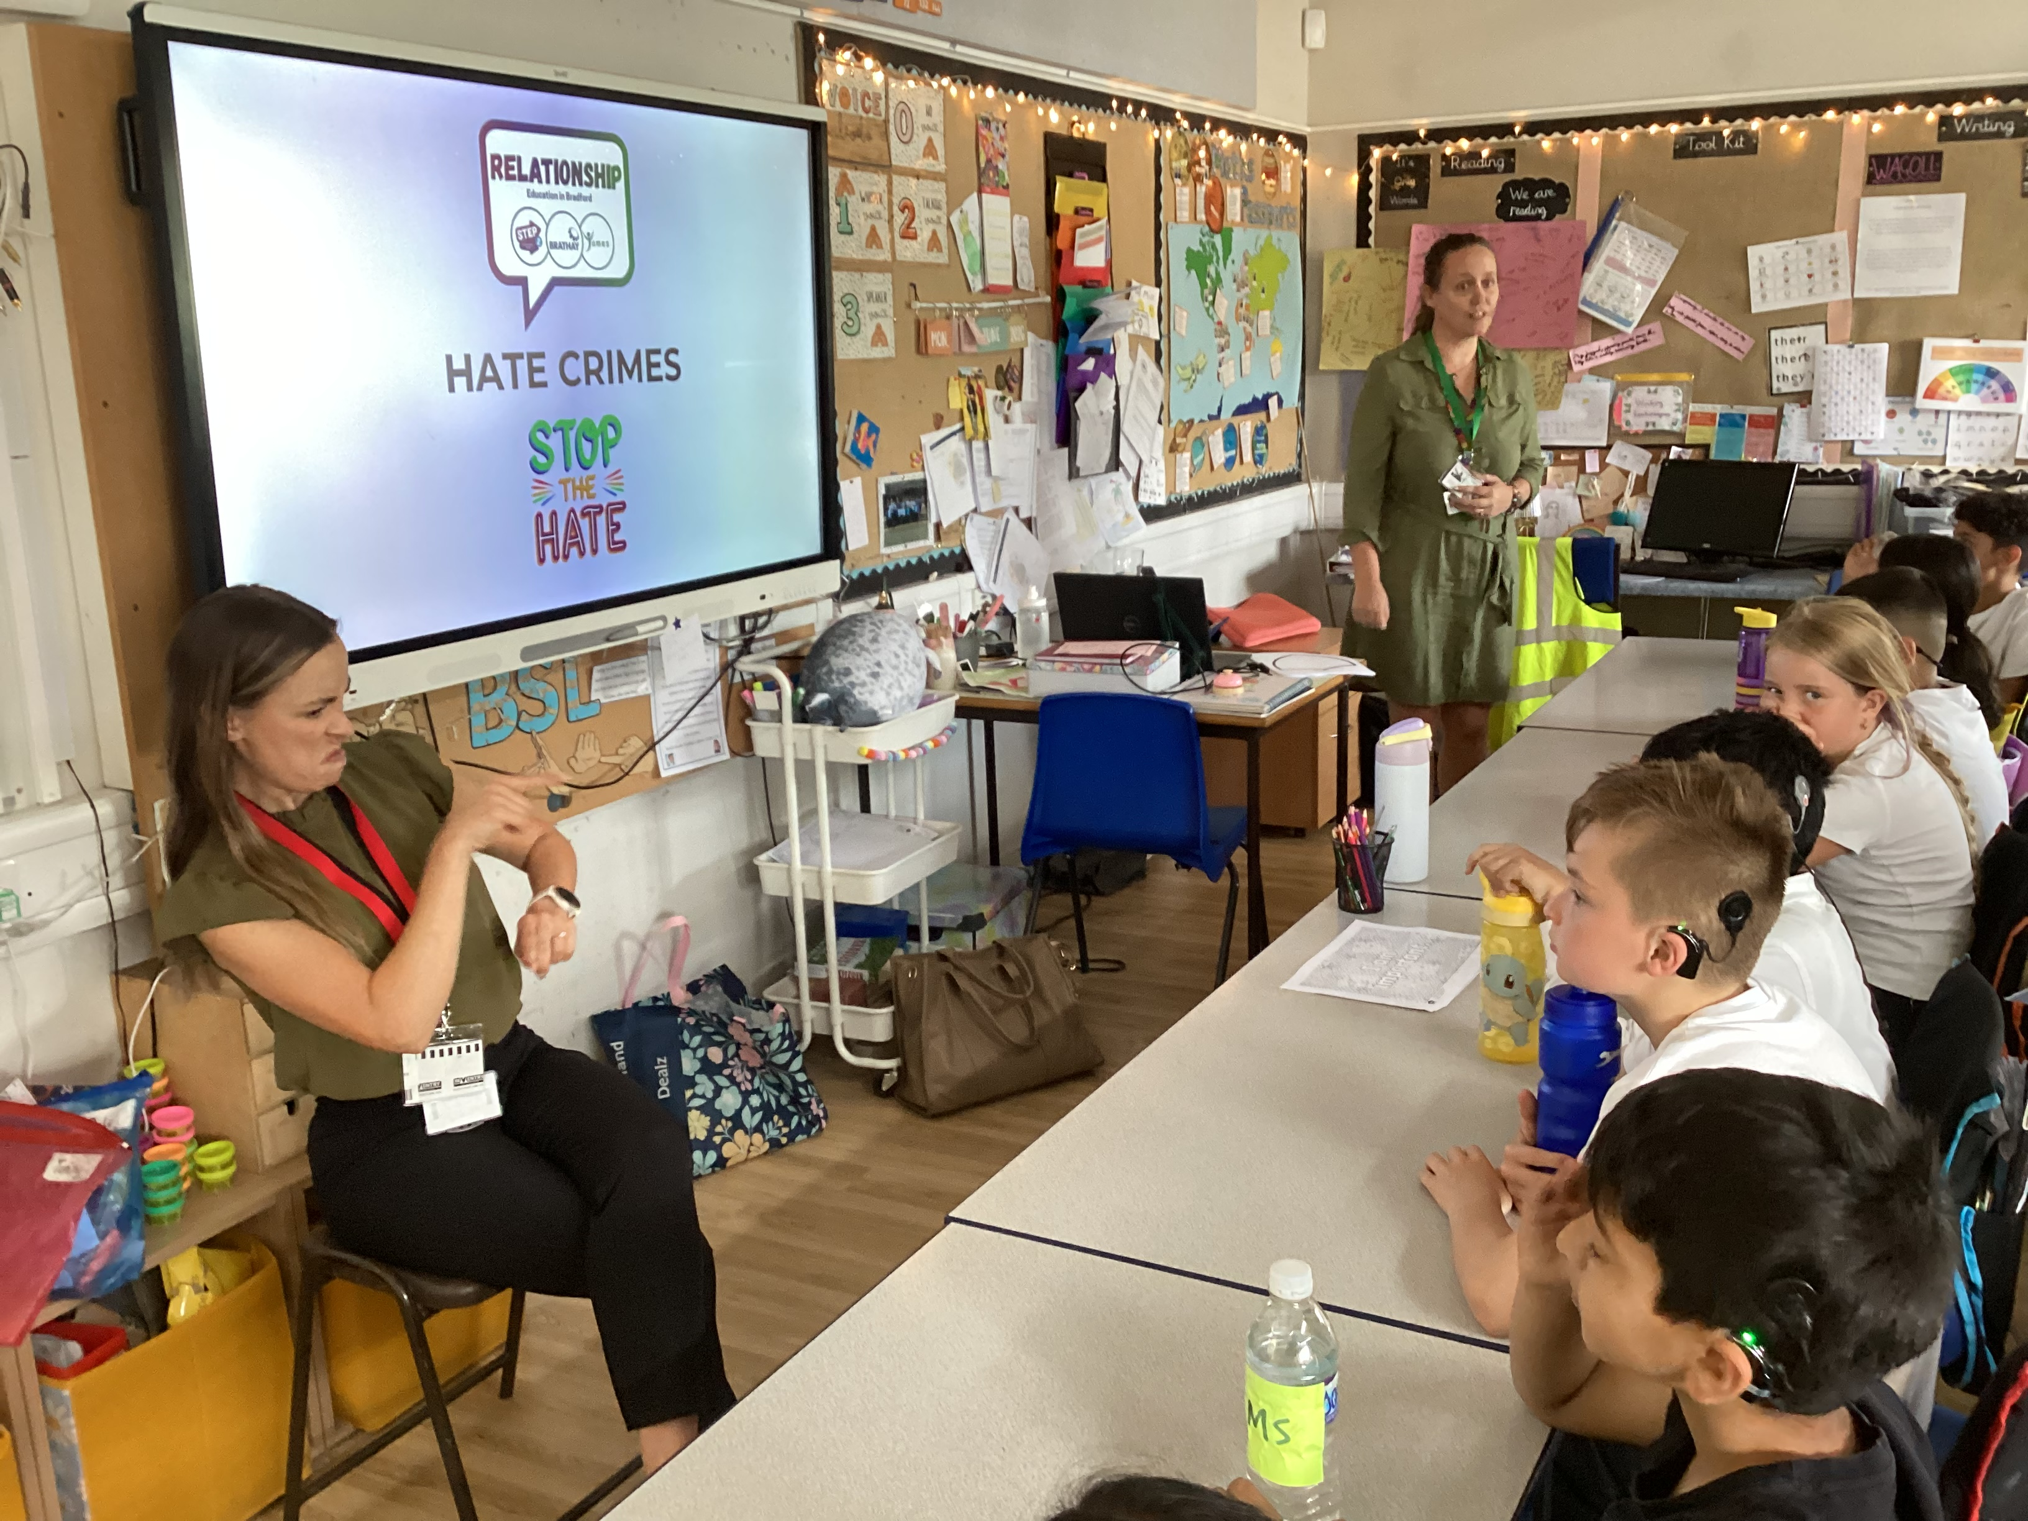

Careers Week

Week beginning 29th June 2026
As part of Careers Week, the RP children attended an inspiring talk from Gareth Thompson of Kingdom of Wrestling, who shared his journey into professional wrestling. Gareth spoke about how he developed his career, the hard work and training involved, and proudly showed the trophies and championship belts he has won along the way. He also shared stories about meeting many well-known people throughout his career.
The children especially enjoyed watching the wrestling demonstrations on the mat. Gareth explained that professional wrestling requires extensive training and a strong focus on safety. They were fascinated to learn that many of the moves are carefully choreographed and exaggerated to make them look painful, when in reality they are performed in a controlled and safe way.
The session was a huge hit with the RP children, who left with a greater understanding of the dedication, discipline and teamwork involved in a career in professional wrestling. We are looking forward to hearing from many more visitors from a range of careers throughout the rest of the week.

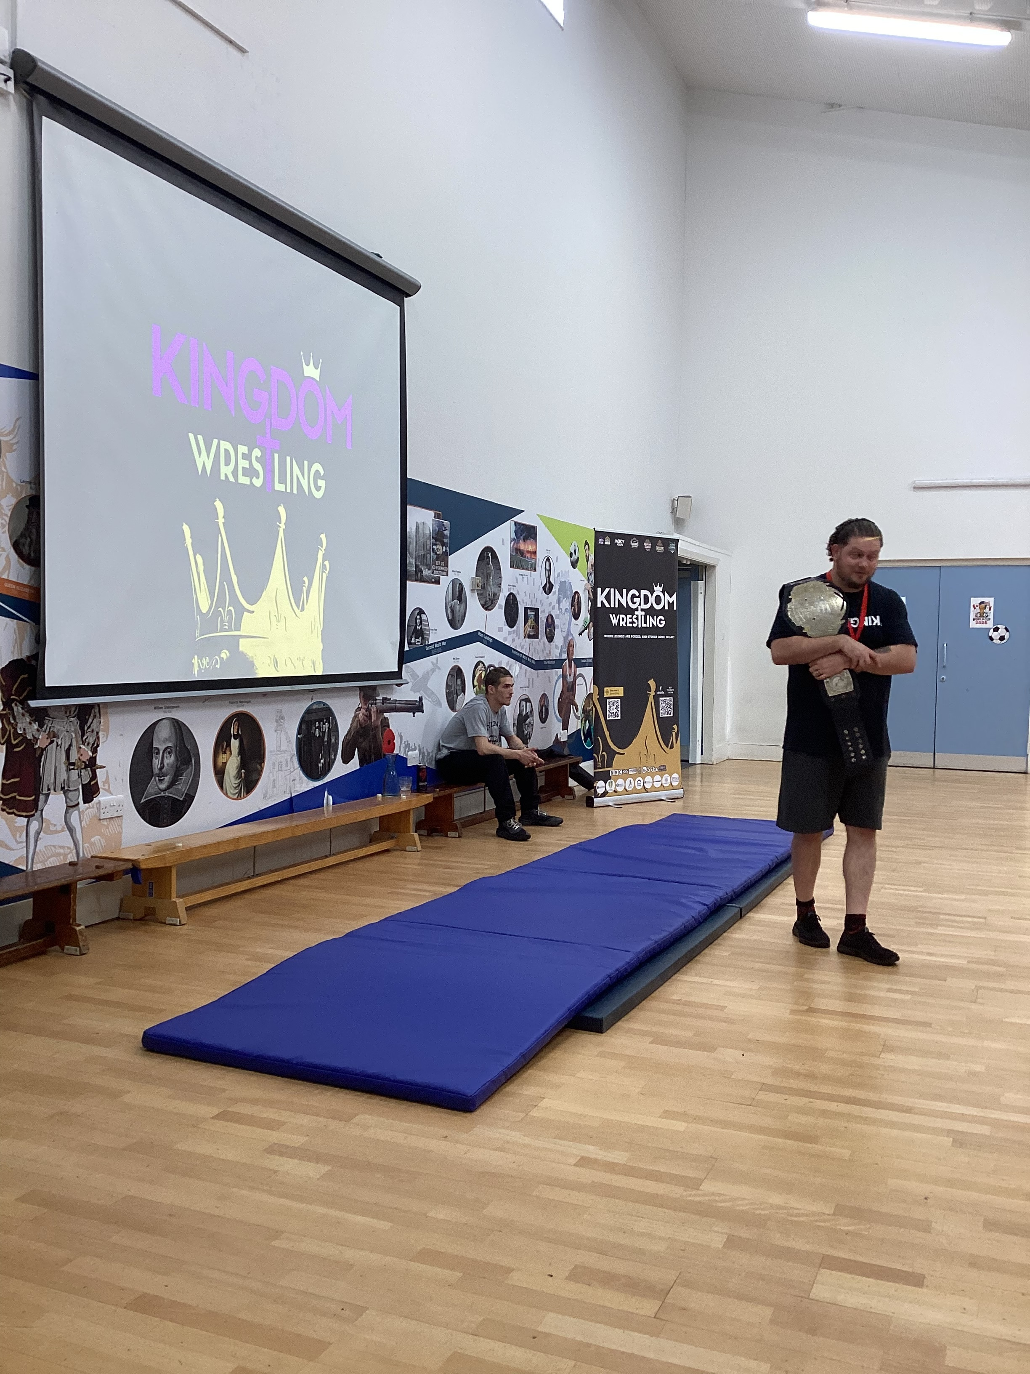
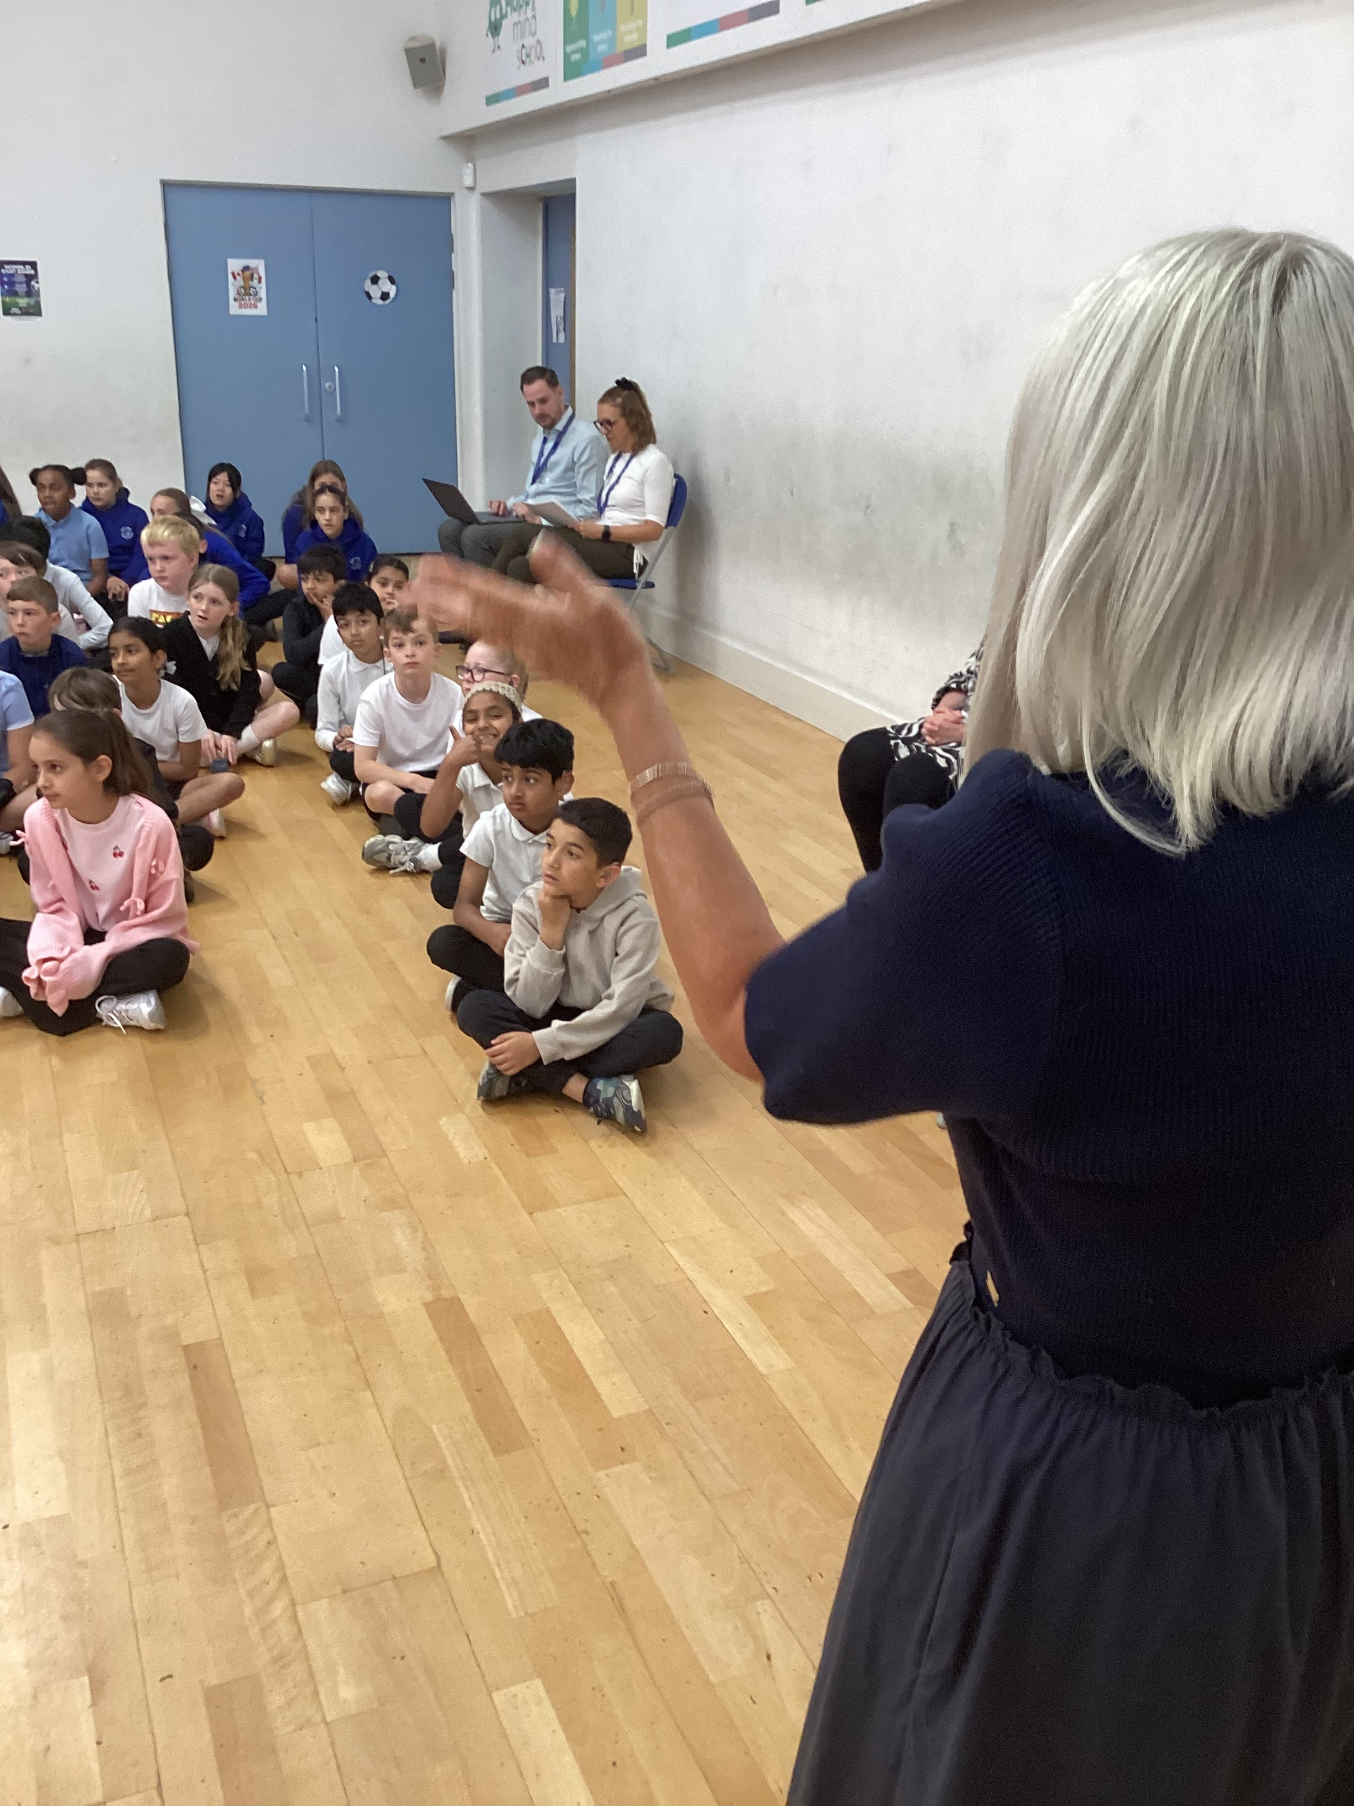

As part of our work on The Snail and the Whale, HK and PW classes joined forces to make and bake their own snail biscuits today.

Baking

Inspired by the snail’s winding trail, the children carefully followed each step of the recipe, rolling and shaping the dough into snails before choosing a setting for their finished biscuit. Despite the very warm weather, everyone worked brilliantly, listening carefully to instructions, working together and taking great pride in their creations.
Once the biscuits had cooled, the children tasted them and gave some constructive feedback, commenting that they were “delicious!” It was a lovely way to bring our class book to life.

