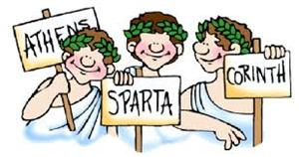
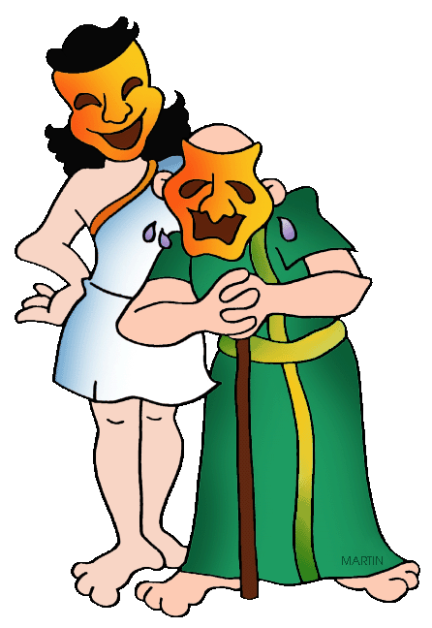
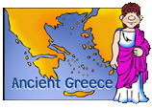
Beethoven Class
Who Let the Gods Out!
How did a volcano change the course of history?
Our theme is history based. We will be learning all about the Ancient Greeks.
English  As readers we will:  - Read whole books to improve our comprehension skills  - Skim and scan effectively to retrieve information  - Explain meanings of words in context  - Infer feelings through actions, dialogue and description  - Make comparisons  - Write a summary about what I have read | Class Information  If you would like to pass a message to a member of the year 6 team or have any queries, please write in your child’s planner or email:  year6@swainhouse.bradford.sch.uk  PE is on Thursdays.  Please ensure your child comes to school in the correct PE kit – plain white shirt; plain black, navy blue or grey hoodie/top and plain black, blue or grey trousers/shorts/leggings.  Trainers are needed for outdoor PE.  Please make sure your child has a water bottle in school. | History:  - Say when the Greek era was and the influence they had on modern society.  - Understand how the Greeks lived and how trade was influential in their society  - Learn about the different Greek Gods and Goddesses  - Compare and contrast different areas of Ancient Greece  DT:  - Create five apparatus designs, applying the design criteria to their work.  - Make suitable changes to their work after peer evaluation.  - Make roughly three different structures from their plans using the materials available.  Science:  - Describe how living things are classified into broad groups according to common observable characteristics and based on similarities and differences, including micro-organisms, plants and animals  - Give reasons for classifying plants and animals based on specific characteristics  R.E – Practices: Why are certain people, places and times sacred?  French – We will be learning vocabulary for when we are out and about, directions, clothes and places around town.  Computing –  - Explain that formulas can be used to produce calculated data  - Apply formulas to data, including duplicating  - Create a spreadsheet to plan an event  PE – We will be learning the rules and skills involved with netball and playing competitive games.  PSHE – Rights and Responsibilities - Define the terms 'fact', 'opinion', 'biased' and 'unbiased', explaining the difference between them.  Describe the different ways money can be saved, outlining the pros and cons of each method  Suggest sale prices for a variety of items, taking into account a range of factors  Music –  - We will listen and appraise music  - Learn about the interrelated dimensions of music  - Perform and share our music with others
As writers we will:
Use words and phrases for cohesion within and between paragraphs.
Use active and passive voice
Use prepositional phrases
- Prepositional phrases
- Subordinating clauses
- Use consistent tense
- Use parenthesis – brackets, dashes and commas

Maths  In maths we will be:  - Convert fractions to decimals and percentages  - Interpret and represent data in graphs and charts  - Understand, calculate and simplify ratio problems.  - Solve problems involving algebra | Homework  Homework is set every Friday in yellow homework books or on Google Classroom; it is due in the following Wednesday. Children will receive English, maths and reading homework every week. On occasion, other pieces will be given as a task to help with our themes in class. Please read with your child three times a week. Please remember to write a comment and sign their planner weekly

