Swain House Primary School

Attendance Policy



March 2023

This policy was discussed, reviewed and agreed by the Governing Body on Thursday 16th March 2023
This policy was discussed, reviewed and agreed by all staff on Wednesday 22nd March 2023
This policy will be reviewed in March 2024.
Contents
1. Aims 1
2. Legislation and guidance 1
3. Roles and responsibilities 2
4. Recording attendance 5
5. Authorised and unauthorised absence 7
6. Strategies for promoting attendance 8
7. Attendance monitoring 8
8. Monitoring arrangements 9
9. Links with other policies 9
Appendix 1: attendance codes 9

1. Aims
We are committed to meeting our obligation with regards to school attendance through our whole-school culture and ethos that values good attendance, including:
- Promoting good attendance
- Reducing absence, including persistent and severe absence
- Ensuring every pupil has access to the full-time education to which they are entitled
- Acting early to address patterns of absence
- Building strong relationships with families to ensure pupils have the support in place to attend school
We will also promote and support punctuality in attending lessons.

2. Legislation and guidance
This policy meets the requirements of the working together to improve school attendance from the Department for Education (DfE), and refers to the DfE’s statutory guidance on school attendance parental responsibility measures. These documents are drawn from the following legislation setting out the legal powers and duties that govern school attendance:
- Part 6 of The Education Act 1996
- Part 3 of The Education Act 2002
- Part 7 of The Education and Inspections Act 2006
- The Education (Pupil Registration) (England) Regulations 2006 (and 2010, 2011, 2013, 2016 amendments)
- The Education (Penalty Notices) (England) (Amendment) Regulations 2013
This policy also refers to the DfE’s guidance on the school census, which explains the persistent absence threshold.

3. Roles and responsibilities
3.1 The Governing Body
The Governing Body is responsible for:
- Promoting the importance of school attendance across the school’s policies and ethos
- Making sure school leaders fulfil expectations and statutory duties
- Regularly reviewing and challenging attendance data
- Monitoring attendance figures for the whole school
- Making sure staff receive adequate training on attendance
- Holding the Headteacher to account for the implementation of this policy

Our Link Governor for attendance is Craig Pounder
3.2 The Headteacher
The Headteacher is responsible for:
- Implementation of this policy at the school
- Monitoring school-level absence data and reporting it to governors
- Supporting staff with monitoring the attendance of individual pupils
- Monitoring the impact of any implemented attendance strategies
- Issuing fixed-penalty notices, where necessary
3.3 The Designated Senior Leader responsible for attendance
The designated senior leader is responsible for:
- Leading attendance across the school
- Offering a clear vision for attendance improvement
- Evaluating and monitoring expectations and processes
- Having an oversight of data analysis
- Devising specific strategies to address areas of poor attendance identified through data
- Arranging calls and meetings with parents to discuss attendance issues
- Delivering targeted intervention and support to pupils and families

The designated senior leader responsible for attendance is Clare Pugh and can be contacted via the school office – 01274 639049
3.4 The attendance officers
The school attendance officers are responsible for:
- Monitoring and analysing attendance data (see section 7)
- Benchmarking attendance data to identify areas of focus for improvement
- Providing regular attendance reports to school staff and reporting concerns about attendance to the designated senior leader responsible for attendance and Headteacher
- Working with education welfare officers to tackle persistent absence
- Advising the Headteacher when to issue fixed-penalty notices to the Education Safeguarding Team
The attendance officers are Sarah Broadbent and Ellie Armitage and they can be contacted via the school office – 01274 639049 or via email – office@swainhouse.bradford.sch.uk
3.5 Class teachers
Class teachers are responsible for recording attendance on a daily basis on SIMs. Class teachers are also responsible for completing the green fire registers and returning these to the Pastoral Office by 8.50am.
3.6 School office staff
School office staff will:
- Take calls from parents about absence on a day-to-day basis and record it in the absence book
- Record in the late book, any pupils who arrive after the classroom doors close at 8.40am
3.7 Parents/carers
Parents/carers are expected to:
- Make sure their child attends every on time
- Call the school to report their child’s absence before 8.40am on the day of the absence (and each subsequent day of absence if appropriate), and advise when they are expected to return
- Provide confirmation of any appointments taken during the school day
- Provide confirmation of attendance at a medical appointment/consultation to enable an authorised absence
- Provide the school with more than 1 emergency contact number for their child
- Ensure that, where possible, appointments for their child are made outside of the school day
3.8 Pupils
Pupils are expected to:
- Attend school every day on time

4. Recording attendance
4.1 Attendance register
We will keep an attendance register, and place all pupils onto this register.
We will take our attendance register at the start of the first session of each school day and once during the second session. It will mark an attendance code for every pupil using the DfE attendance codes.

Any amendment to the attendance register will include:
- The original entry
- The amended entry
- The reason for the amendment
- The date on which the amendment was made
- The name and position of the person who made the amendment

We will also record:
- Whether the absence is authorised or not
- The nature of the activity if a pupil is attending an approved educational activity
- The nature of circumstances where a pupil is unable to attend due to exceptional circumstances
We will keep every entry on the attendance register for 3 years after the date on which the entry was made.

Pupils must arrive in school by 8.30am on each school day.
The register for the first session will be taken at 8.45am and will be kept open until 9.30am.
The register for the second session will be taken at 12.45pm for Early Years and Key Stage 1 and 1.15pm for Key Stage 2.
4.2 Unplanned absence
The pupil’s parent/carer must notify the school of the reason for the absence on the first day of an unplanned absence by 8.40am or as soon as practically possible by calling the school office.
We will mark absence due to illness as authorised unless the school has a genuine concern about the authenticity of the illness or if there is a concern about the child’s attendance.
If the authenticity of the illness is in doubt, the school may ask the pupil’s parent/carer to provide medical evidence, such as a doctor’s note, prescription, appointment card or other appropriate form of evidence.
If the school is not satisfied about the authenticity of the illness or reason for absence, the absence will be recorded as unauthorised and parents/carers will be notified of this.
4.3 Planned absence
Attending a medical or dental appointment will be counted as authorised as long as the pupil’s parent/carer notifies the school in advance of the appointment where possible. Parents are asked to show school confirmation of the appointment.
However, we encourage parents/carers to make medical and dental appointments out of school hours where possible. Where this is not possible, the pupil should be out of school for the minimum amount of time necessary.
The pupil’s parent/carer must also apply for other types of term-time absence as far in advance as possible of the requested absence. Go to section 5 to find out which term-time absences the school can authorise.
4.4 Lateness and punctuality
A pupil who arrives late:
- Before the register has closed (9.30am) will be marked as late, using the appropriate code (L)
- After the register has closed will be marked as absent, using the appropriate code (U)

It is important that pupils are punctual so that they do not miss out of the beginning of each school day. This time can be important because information is often given out which allows for the smooth running of the day and helps pupils feel part of the school community.
- The school opens at 8.30 a.m. and pupils should be in school at this time to change from outdoor clothing
- All entrances with the exception of the main school entrance are closed at 8.40 a.m.
- It is essential that your child is ready for registration at 8.40 a.m
- Pupils arriving after this time will have to report to the office where their names will be entered into the “late book” for safety reasons and monitoring of attendance

To improve punctuality we have implemented the following strategy:

- When pupils are late twice in a term their parents are informed through a ‘1st Late’ and ‘2nd Late’ letter
- If they are late again they will be required to attend a punctuality discussion with a member of the Pastoral Team or Leadership Team
- At the third late, and all other subsequent lates in that term pupils, will once again, attend a punctuality discussion and there will be a follow-up conversation with parents/guardians
- At the start of a new term the “slate is wiped clean” and all pupils start the term with no lates

4.5 Following up unexplained absence
Where any pupil we expect to attend school does not attend, or stops attending, without reason, the school will:
- Call the pupil’s parent/carer on the morning of the first day of unexplained absence to ascertain the reason. If the school cannot reach any of the pupil’s emergency contacts, the school may conduct a home visit
- Identify whether the absence is authorised or not
- Identify the correct attendance code to use and input it as soon as the reason for absence is ascertained
- Call the parent/carer on each day that the absence continues without explanation to ensure proper safeguarding action is taken where necessary. If absence continues, the school will consider involving the Education Safeguarding Team

4.6 Reporting to parents/carers
The school will regularly inform parents about their child’s attendance and absence levels half-termly via letters home with attendance print-outs and at termly Parent Consultation meetings

5. Authorised and unauthorised absence
5.1 Approval for term-time leave of absence
The headteacher will only grant a leave of absence to a pupil during term time if they consider there to be 'exceptional circumstances'. A leave of absence is granted at the headteacher’s discretion, including the length of time the pupil is authorised to be absent for.
The school considers each application for term-time absence individually, taking into account the specific facts, circumstances and relevant context behind the request.
Any request should be submitted as soon as it is anticipated and, where possible, at least four weeks before the absence, and in accordance with any leave of absence request form, availbale from the school office. The headteacher may require evidence to support any request for leave of absence.
Valid reasons for authorised absence include:
- Illness and medical/dental appointments (see sections 4.2 and 4.3 for more detail)
- Religious observance – where the day is exclusively set apart for religious observance by the religious body to which the pupil’s parents belong. If necessary, the school will seek advice from the parents’ religious body to confirm whether the day is set apart
- Traveller pupils travelling for occupational purposes – this covers Roma, English and Welsh gypsies, Irish and Scottish travellers, showmen (fairground people) and circus people, bargees (occupational boat dwellers) and new travellers. Absence may be authorised only when a traveller family is known to be travelling for occupational purposes and has agreed this with the school, but it is not known whether the pupil is attending educational provision
5.2 Legal sanctions
The school or local authority can fine parents for the unauthorised absence of their child from school, where the child is of compulsory school age.
If issued with a fine, or penalty notice, each parent must pay £60 within 21 days or £120 within 28 days. The payment must be made directly to the local authority.
Penalty notices can be issued by a headteacher, local authority officer or the police.
The decision on whether or not to issue a penalty notice may take into account:
- The number of unauthorised absences occurring within a rolling academic year
- One-off instances of irregular attendance, such as holidays taken in term time without permission
- Where an excluded pupil is found in a public place during school hours without a justifiable reason

If the payment has not been made after 28 days, the local authority can decide whether to prosecute or withdraw the notice.

6. Strategies for promoting attendance
- Attendance and punctuality will be displayed for the week on the school website and in school
- Attendance Matters display in the entrance to school giving parents information about the importance of their pupils attending school every day
- Attendance and punctuality for each class will be shared in the Friday Well Done assembly and the class with the best attendance and punctuality will be celebrated. In EYs and KS1 the class with the best attendance and punctuality will each be presented with the school attendance/punctuality teddies and in KS2 with an attendance/punctuality trophies entitling them to extra playtime the following week
- Each half term, an attendance treat will be organised for pupils who have 100% attendance
- Headteacher and/or Leadership Team and Pastoral Team to be visible on the playground each morning celebrating pupils that are on time and in school (Additional attention given any pupils that can often be late or absent)

7. Attendance monitoring
7.1 Monitoring and analysing attendance data
The school will:
- Look at weekly attendance and attendance to date for the whole school, year group and groups of children at the Leadership Team meeting
- Look at historic and emerging patterns of attendance and absence, and then develop strategies to address these patterns
- Analyse attendance and absence data weekly to identify pupils or cohorts that need additional support with their attendance, this analysis is used to provide targeted support to these pupils and their families
- If a pupil’s attendance drops below 90% at the end of a half term they are classed as a persistent absentee. The school Attendance Team will work with Bradford Education Safeguarding Team to issue families with the relevant attendance letters
- monitor individual attendance at the end of each half term (Attendance Team). Relevant letters (See description of letters below) issued to families with an attendance print-out for the half term (See Appendix 2)

Half termly Attendance letters
We send 5 different letters from school regarding attendance at the end of the half term

Letter 1 - Children who have 100% attendance. This is a 'well done' letter explaining how pleased we are with the child's attendance.
Letter 2 - Children who have attendance at 95% or above (yellow and green). This is a 'well done' letter for achieving yellow or green for attendance so far this year.
Letter 3 - Children who have attendance between 90% to 94.9%. This letter explains why attendance above 95% is so important and offers support to the families to increase the child's attendance.
Letter 4 - Children who have attendance at 90% or below and have previously been referred to the Education Safeguarding Team for attendance below 90% and there has been an improvement. This letter explains that we are pleased to see there has been an improvement, but attendance still needs to improve. We will monitor the child's attendance and if it hasn't improved before Easter, they will be referred to the Education Safeguarding Team again and they will put actions in place.
Letter 5 - Attendance letter for children who have SEND or medical needs. This letter will inform parents of the child's attendance and ask them to contact school if we can support with attendance or punctuality.

Any other child who has attendance at 90% or below and hasn't been previously referred to the Education Safeguarding Team and improved their attendance, will receive a letter from this team and not school.

Pupil-level absence data will be collected each term and published at national and local authority level through the DfE's school absence national statistics releases. The underlying school-level absence data is published alongside the national statistics. The school will compare attendance data to the national average, (obtained through FFT and the DfE and share this with the Governing Body.
7.2 Reducing persistent and severe absence
Persistent absence is where a pupil misses 10% or more of school, and severe absence is where a pupil misses 50% or more of school.
The school will:
- Use attendance data to find patterns and trends of persistent and severe absence
- Hold regular meetings with the parents of pupils who the school (and/or local authority) considers to be vulnerable, or are persistently or severely absent, to discuss attendance and engagement at school
- Provide access to wider support services to remove the barriers to attendance
If a pupil is a Persistent Absentee, they will be considered for referral to the Education Safeguarding Team. The Education Attendance Welfare Officer and school staff will then begin a programme of monitoring and support.
Step 1 – Parent/Guardian will receive a letter from the Education Safeguarding Team, advising them of their child’s attendance and the details of their monitoring period.
Step 2 – At the end of the 3 week monitoring period attendance will be reviewed and if no improvements are made parents will be invited to a panel meeting, where an attendance plan will be agreed. A letter summarising the discussion and a copy of the action plan is posted to the parent/guardian.
Step 3 – After 6 weeks the attendance printout is reviewed by school staff and the Education Attendance Welfare Officer and the following actions taken -
- if the percentage has improved to above 90% half-termly monitoring is implemented.
- if the percentage remains below 90% the parent/guardian is invited to a second meeting with school staff and the Education Attendance/Welfare Officer to discuss the absences where further, more formal, actions are outlined.

If parents fail to engage with support and their child continues to have unsatisfactory attendance, a request may be made to the Local Authority to pursue legal proceedings. Parents found guilty in a Magistrates’ Court of failing to secure their child’s regular attendance at school under the provisions of the Education Act 1996, will receive a criminal record and a maximum penalty of a £1000 fine under a Section (1) offence and a £2500 fine and up to a 3 month prison sentence, under a Section (1a) offence.

8. Monitoring arrangements
This policy will be reviewed as guidance from the local authority or DfE is updated, and as a minimum annually. At every review, the policy will be approved by the Full Governing Body.

9. Links with other policies
This policy links to the following policies:
- Child protection and safeguarding policy
- Behaviour policy

Appendix 1: attendance codes
The following codes are taken from the DfE’s guidance on school attendance.
Code | Definition | Scenario
/ | Present (am) | Pupil is present at morning registration
\ | Present (pm) | Pupil is present at afternoon registration
L | Late arrival | Pupil arrives late before register has closed
B | Off-site educational activity | Pupil is at a supervised off-site educational activity approved by the school
D | Dual registered | Pupil is attending a session at another setting where they are also registered
J | Interview | Pupil has an interview with a prospective employer/educational establishment
P | Sporting activity | Pupil is participating in a supervised sporting activity approved by the school
V | Educational trip or visit | Pupil is on an educational visit/trip organised, or approved, by the school
W | Work experience | Pupil is on a work experience placement

Code | Definition | Scenario
Authorised absence
C | Authorised leave of absence | Pupil has been granted a leave of absence due to exceptional circumstances
E | Excluded | Pupil has been excluded but no alternative provision has been made
H | Authorised holiday | Pupil has been allowed to go on holiday due to exceptional circumstances
I | Illness | School has been notified that a pupil will be absent due to illness
M | Medical/dental appointment | Pupil is at a medical or dental appointment
R | Religious observance | Pupil is taking part in a day of religious observance
S | Study leave | Year 11 pupil is on study leave during their public examinations
T | Gypsy, Roma and traveller absence | Pupil from a traveller community is travelling, as agreed with the school
Unauthorised absence
G | Unauthorised holiday | Pupil is on a holiday that was not approved by the school
N | Reason not provided | Pupil is absent for an unknown reason (this code should be amended when the reason emerges, or replaced with code O if no reason for absence has been provided after a reasonable amount of time)
O | Unauthorised absence | School is not satisfied with reason for pupil's absence
U | Arrival after registration | Pupil arrived at school after the register closed

Code | Definition | Scenario
X | Not required to be in school | Pupil of non-compulsory school age is not required to attend
Y | Unable to attend due to exceptional circumstances | School site is closed, there is disruption to travel as a result of a local/national emergency, or pupil is in custody
Z | Pupil not on admission register | Register set up but pupil has not yet joined the school
# | Planned school closure | Whole or partial school closure due to half-term/bank holiday/INSET day

Appendix 2: half-termly attendance letters
Letter 1
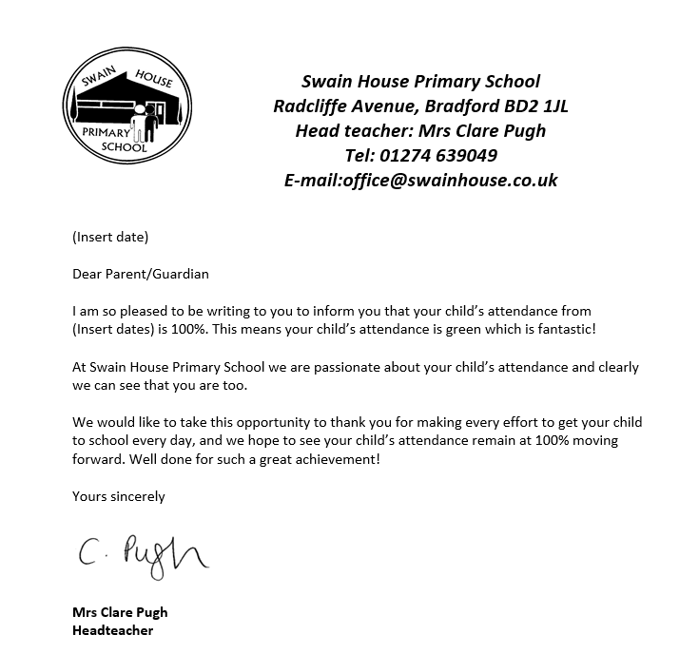

Letter 2



Letter 3
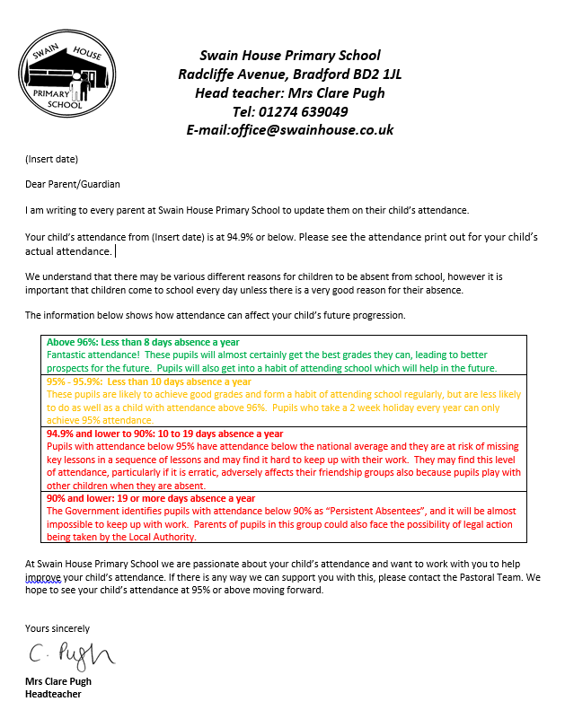

Letter 4

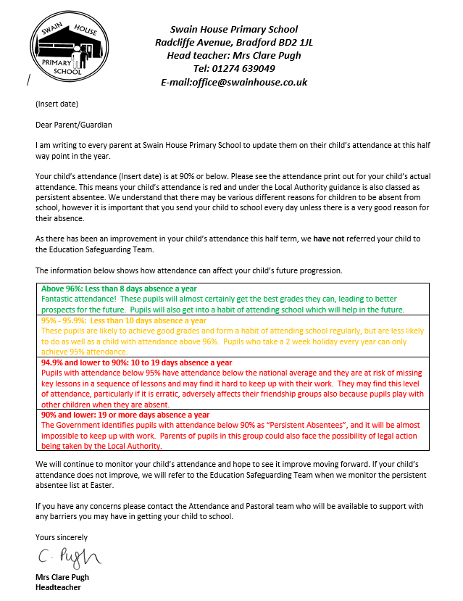
Letter 5



