Swain House Primary School

Little Acorns Nursery
Admission Policy

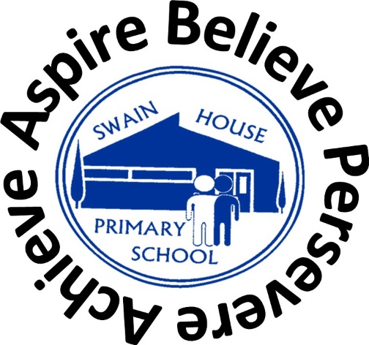

November 2024

The Government funds up to 570 hours of free childcare per year for eligible 2 year olds. This works out as 15 hours a week if your child takes up the childcare during term time.

https://www.gov.uk/help-with-childcare-costs/free-childcare-2-year-olds-claim-benefits

All eligible two year olds are able to take a place the term after their birthday.

Swain House Primary School is a community school, which seeks to serve the needs of the local community. Our Little Acorn Nursery for 2 Year Olds provides part-time places for 20 children. The free entitlement can be taken over five days term time only.

We understand that making the decision to send your child to a nursery can be a big step for some parents and carers, and it is natural to have some concerns, but what are the benefits of sending your child to a nursery?
- Children develop quickly in their earliest years, and early education supports their development and overall wellbeing
- Research shows that good quality early education and childcare from an early age makes a real difference to how well a child does in the future
- Early years and childcare settings are wonderful places for your child to learn, develop new skills, make new friends and have fun
- It will also free up your time to support you to take up training, start, or return to work, and support you to reduce your childcare bill

If your child is two, you are eligible if you are claiming any one of the following:
- Income Support
- Income-based Jobseeker’s Allowance
- Income related Employment and Support Allowance
- Support under part VI of the Immigration and Asylum Act 1999
- The Guaranteed element of State Pension Credit
- Child Tax Credit with earnings from employment below £16,190
- Working Tax Credit with earnings from employment below £16,190
- Universal Credit - if you and your partner are on a low income from work (this usually means a combined income of less than £15,400 a year after tax)

Or if your child:
- is a looked after child
- has left care - a child who has left care through a child arrangement order (formerly known as special guardianship) or an adoption or residence order
- has special educational needs, and/or disabilities - but only if he/she has a current SEN statement or an Education, Health and Care plan or receives Disability Living Allowance

For families with no recourse to public funds (NRPF) your family's annual household income must be no higher than the following:
- £26,500 for families with one child
- £30,600 for families with two or more children

You cannot have more than £16,000 in savings or investments.

Children will be admitted to Nursery having taken into account the following criteria (which is the same as the City of Bradford MDC’s admissions policy for Reception):

- Looked after children and all previously looked after children, including those children who appear (to the admissions authority) to have been in state care outside of England and ceased to be in state care as a result of being adopted
- Children who have exceptional social or medical needs, supported by a written recommendation from the child’s paediatrician/consultant or professional from Children’s Services. The letter must explain why the school is the only suitable school to meet the child’s needs and why no other school could provide the appropriate support for the child
- Sisters and brothers of children living at the same address, who are at present on roll at the school, and will still be attending the school at the time of admission
- All other children

We will endeavour to accommodate emergency placements requested by social services or other outside
agencies if vacancies are available.

All eligible two year olds are able to take a place the term after their birthday.

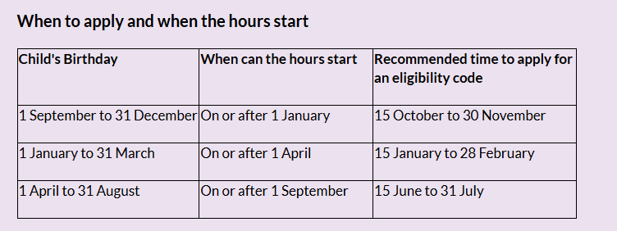

Parents will be notified by letter if their child has been offered a place in our 2 Year Old provision and asked to come into school to complete the admissions form.

Arrangements will be made for new children to visit the setting before they formally start. Children are invited to attend stay and play sessions in the 2 Year Old provision.

Children who are accessing 2 Year Old provision who are on extended holidays or out of the country for some time will be taken off the register after the agreed return date. Therefore this may result in reserved places being lost.

Please note:
The offer of a place at a nursery class attached to a primary school does not guarantee the child a place in the reception class at the same school. A fresh application will be required in accordance with the criteria for admission to reception classes.

Little Acorns Nursery Application Form
Child Details:
First Name(s) |  |  |  |  | Surname
Date of Birth |  |  |  |  | Gender
Address
Postcode |  |  |  |  | Telephone No.
Pre School currently attending (if any):
Please tick the relevant box showing which eligibility criteria you meet. You will need to provide the office staff with original documentation for them to photocopy and keep on file.
Eligibility criteria |  |  |  |  | Documents provided (office staff only)
A) Eligibility criteria also used for free school meals

B) Child who is looked after (written confirmation from Social Worker by email or letter)
C) Low income families
D)Special Education Needs /Disabilities (SEND)
E)Disability Living Allowance
F)Left Care
Does your child have an older sibling in school? |  |  |  |  | Yes/No
If so, please list details of siblings names and dates of birth:

Name of Parent/Guardian at home address:
Relationship: |  |  |  |  | Title:
First Name |  |  |  |  | Surname
Home telephone number |  |  |  |  | Mobile/work telephone number
Preferred Sessions: |  | AM |  |  |  | PM
Signature of Parent/Guardian: |  |  |  |  |  |  |  | Date:
Once you have fully completed this form please hand it in to the school office.
The information on this form will be used only for the purposes of allocating nursery places. The data will be processed in compliance with the Data Protection Act.

